PRCT 353: Clinical Placement 1
Image Critique Introduction

MRT Program


Overview
- Purpose of image critique

- Image critique in clinical placement

- Resources that will help you

- Critiquing practice

Purpose of Image Critique
- Present images, evidence of work

- Review diagnostic value and quality of image(s)
  - Anatomy best demonstrated
  - Evaluation criteria
  - Technical factors
  - Pathology
- Opportunity to learn from preceptors & site liaisons

- Opportunity to learn from mistakes

- Achieve logbook lines


Process of Image Critique
- Perform case without preceptor assistance

- Supervising technologist verifies performance

- Prepare for image critique session
  - Review
  - Prioritize

- Present images to site liaison / instructor

- Only very high quality images will be approved for your logbook.
  - Not all cases will qualify for logbook entry

Important Information for Students
- ALWAYS follow site protocols

- Lead numbered markers must be visible on all images

- Markers must be placed lateral or anterior to anatomy

- Avoid turning the collimator when possible

- Never delete or repeat images without preceptor supervision.

- Document, document, document!

Resources

- Use Image Critique Handbook – available for download to your iPad in D2L Brightspace

- Required Textbook & Workbook:
  - “Radiographic Image Analysis” – Kathy McQuillen Martensen
- iPad app by iCat Solutions if available:
  - iRad X-rays
  - X-ray Anatomy
- Lange: Radiographic Positioning Flashcards

- Practice! Practice! Practice!

Include In Your Presentation
- Introduction of the important facts of the case
- Identify each view
- Identify the anatomy best demonstrated & what anatomy must be included on image.
- Collimation, Marker Placement, Technical Factors
- Comment on positioning & centering (i.e. – is there evidence of rotation, why or why not?)
- Identify any pathology or artifacts
- Suggest improvements, if necessary
- If your image is excellent, say so!

I’ll Go First!

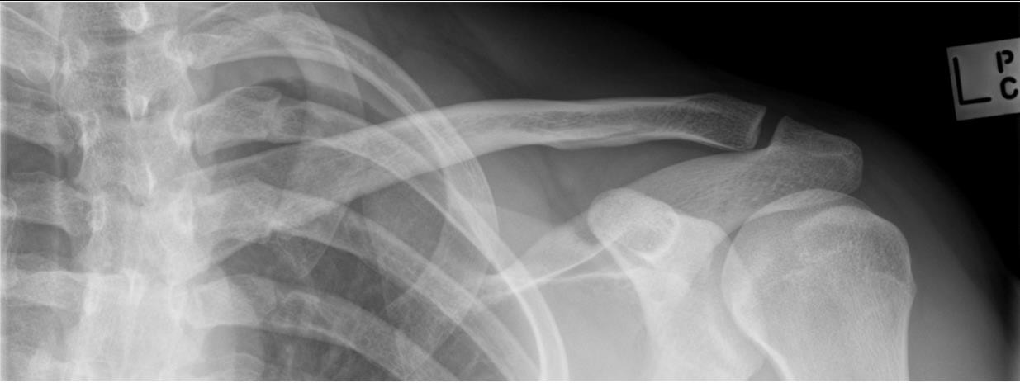
Case courtesy of Jessica Hui Shi Ng, Radiopaedia.org, rID: 71804

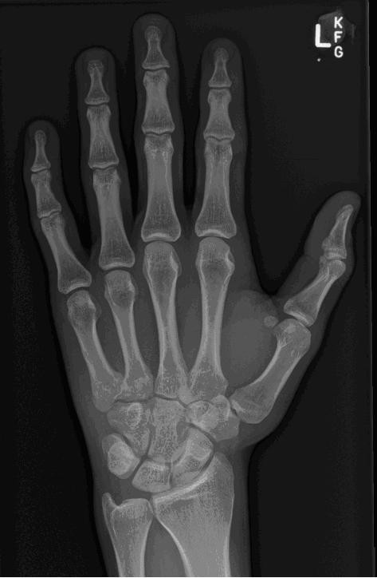
Case courtesy of Kellie Grant, Radiopaedia.org, rID: 40336

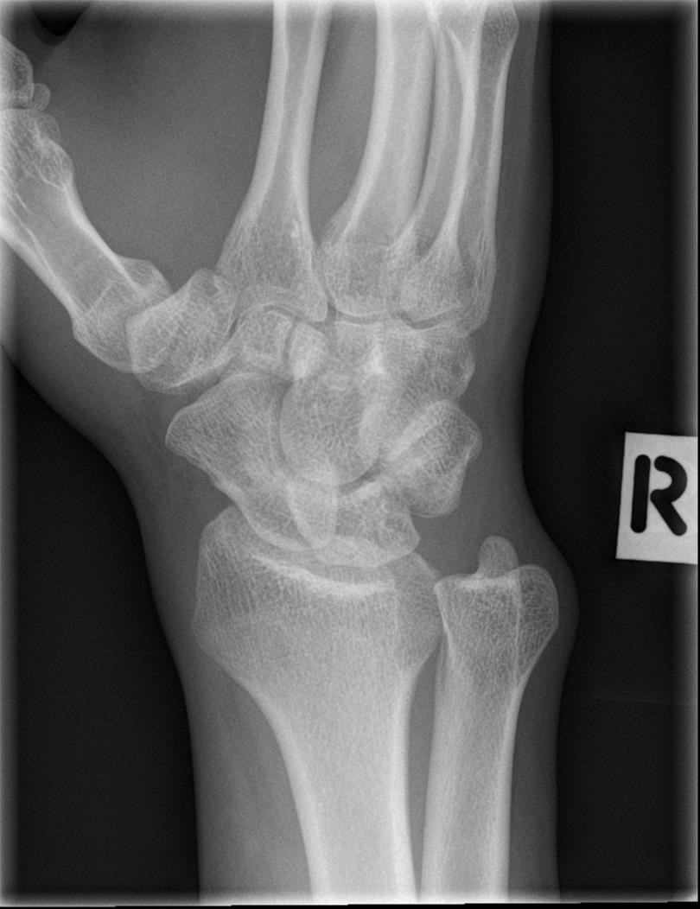

Case courtesy of Assoc Prof Craig Hacking, Radiopaedia.org, rID: 37482

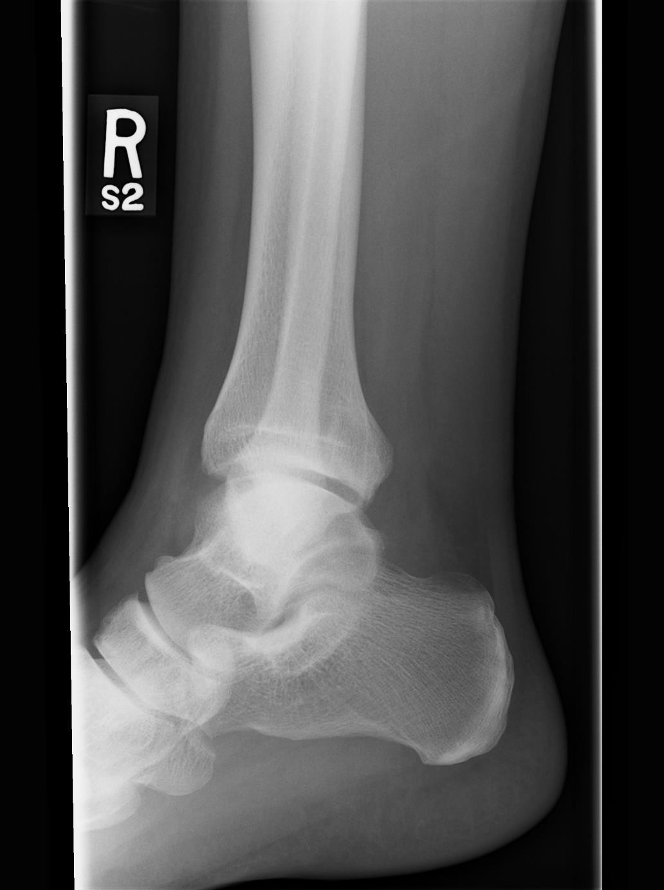
Image courtesy of AHS

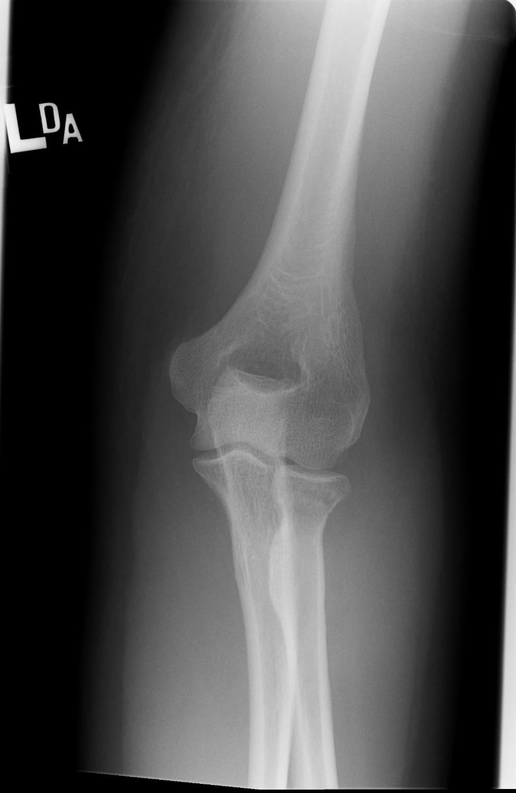
Image courtesy of AHS

Summary

Takes practice and preparation!
- Formal & Informal
  - As much of both as you can

Resources
  - Image Critique Handbook
  - Radiographic Image Analysis
  - Online apps & websites

In clinical placement
  - Site liaisons & instructors
  - Learning moments vs. evaluation
  - Great place to start!

