In-class assignment: Patient Dose and ESE Calculations
Student Name: Student ID:

Instructions
This assignment is to be completed independently in class
Textbooks, notes and a calculator are allowed to be used for the completion of this assignment.
Use the space provided to show your calculations.

Marking Criteria
Weight: 30% Marks: /20
Question 1

Completion of chart | /2

Question 2

Use of table | /2
Use of formula | /2
Correct answer | /2
Question A | /2
Question B | /2

Question 3

Use of graph | /2
Use of formula | /2
Correct answer | /2
Question C | /2

Question 1

Complete the following chart (provide answer in whole numbers) (1 mark each)

SID (cm) | IR to TT (cm) | Body part (cm) | SSD (cm)
 | 10 | 17 | 103
180 | 6 | 36

Question 2

Intensity Chart

mGy/mAs chart at 110 cm
kVp | mGy/mAs
50 | 0.010
60 | 0.018
70 | 0.026
80 | 0.036
90 | 0.046
100 | 0.057
110 | 0.070
120 | 0.080

Using the intensity chart above to calculate the ESE for technique 1 and technique 2 for the following AP abdomen exam (Answer must include units and be rounded to the nearest 100th.)

Body part thickness: 27 cm.
Distance from the patient to the IR: 5 cm. SID: 150cm

Technique 1: 70 kVp @ 20 mAs Technique 2: 80 kVp @ 10 mAs

ESE for technique 1: ESE for technique 2: _

Space below provided for calculations (use back of page if more room is required):

Answer the following questions related to the abdomen case above:

- Is image density maintained? Why or why not?

- Explain 1 other way of reducing dose for the exam and include rationale.

Question 3
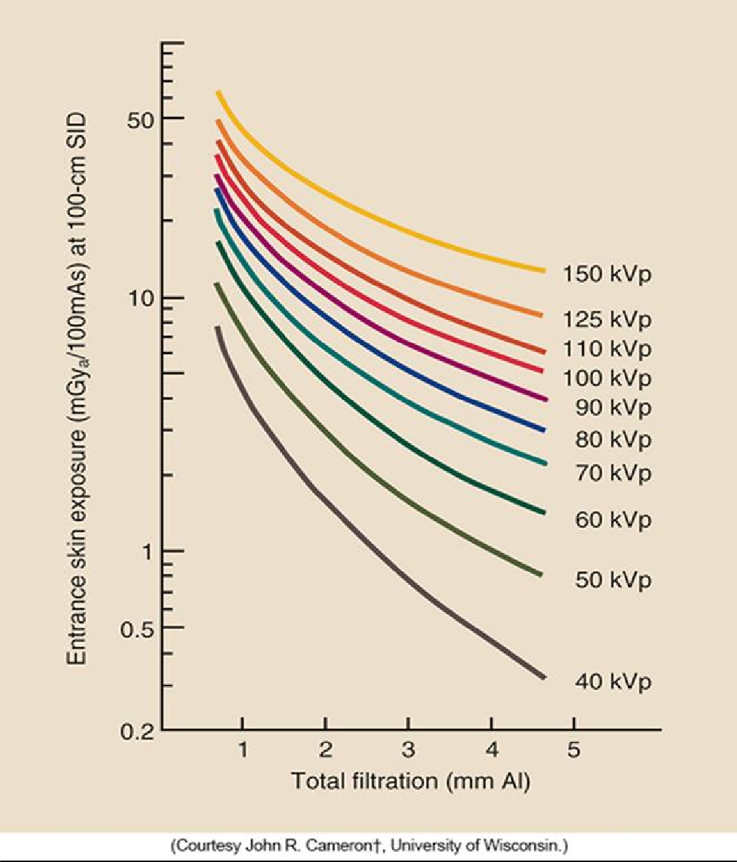

Complete the following chart using the nomogram provided (Answer must include units and be rounded to the nearest 100th.)

 | kVp | mAs | Al (mm) | SSD (cm) | Estimated ESE
1. | 60 | 10 | 2 | 110
2. | 110 | 20 | 3 | 131
Space below provided for calculations exam (use back of page if more room is required):

Answer the following question:
- According to the nomogram how does an increase in filtration effect entrance skin dose? Provide rationale.

