Handout - Ultrasound Guided Pain Management Injections
Some pain management injections cannot be done under fluoroscopy as the structures being injected cannot be visualized radiographically. Ultrasound can be used to guide needle placement in some soft tissue structures
Below are three examples of common ultrasound guided procedures:
- Baker’s Cyst
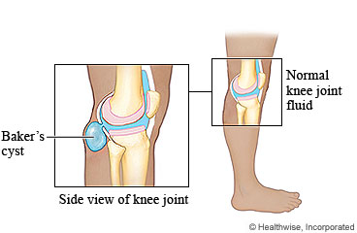

https://myhealth.alberta.ca/health/AfterCareInformation/pages/conditions.aspx?HwId=uh5176
- A collection of fluid arising from the posterior aspect of the knee joint.
- The fluid can be aspirated before injection to remove pressure from surrounding structures.
- Corticosteroid is injected to prevent reoccurrence.

- Ganglion Cyst
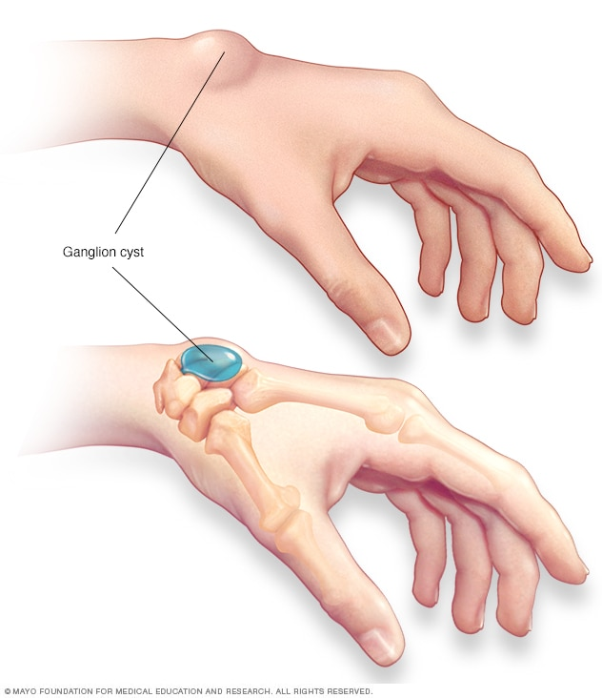
https://www.mayoclinic.org/diseases-conditions/ganglion-cyst/symptoms-causes/syc-20351156
- Small cyst arising from a joint. Usually on the wrist or dorsal aspect of the foot.
- Used to be called a “bible cyst” as the common treatment was to smack it with the heaviest book a patient owned, usually the family bible.
- As with the Baker’s cyst, aspiration will be attempted before injection of corticosteroid.
- Even with the injection of steroid, reoccurrence is common.

- Carpal Tunnel
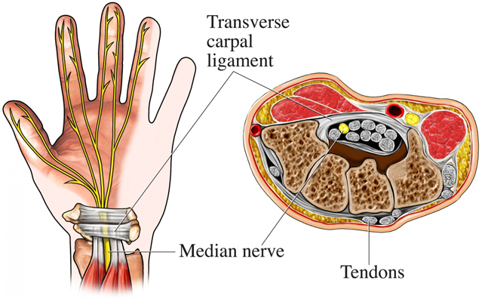
https://www.insideradiology.com.au/carpal-tunnel-ultrasound-injection/
- Median nerve become impinged by the carpal tunnel.
- Causes pain and/or numbness of first 3 digits.
- Injection of corticosteroid around the median nerve can alleviate these symptoms.

