INFC 215 – Infection Prevention and Control

Module One: Characteristics of Microorganisms

Topic 1.2: Bacteria

Shapes of Bacteria
Most of the disease-causing microorganisms found in the hospital setting are bacteria. Bacteria can be placed in three groups based on their shape. Their shape is maintained by the rigid cell wall.
- Cocci (pleural), coccus (singular)  - Spherical or round cells | Figure 1.2.1
- Rods or bacilli (bacillus)  - Rectangular shaped boxes | Figure 1.2.2
- Spirilla (spirillum)  - Curved or spiral shaped rods | 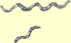  Figure 1.2.3

Gram Reaction of Bacteria

Gram Stain
Bacteria can be divided into two groups on the basis of the Gram stain. The stain has been used for over 100 years to stain bacteria and make them more visible when viewed under the microscope. Once the staining procedure is carried out, one group of bacteria appear as dark bluish-black colour and are called Gram positive. All the other bacteria are a pink to red colour and are called Gram negative.
Let us see a couple of pictures related to the Gram Stain.
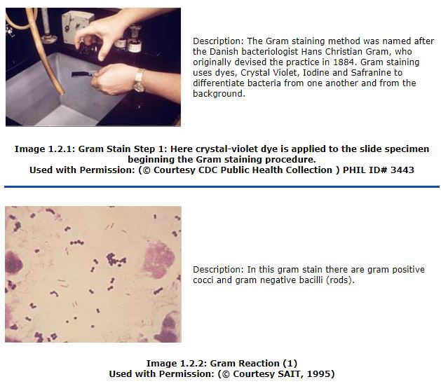
The Importance of Gram Reaction
- Looking at the Gram reaction and shape of bacteria is often the first step in identifying them in the laboratory. Using the Gram reaction and the shape of the cells, bacteria can be divided into six groups:
- Gram positive cocci
- Gram negative cocci
- Gram positive rods
- Gram negative rods
- Gram positive spirilla
- Gram negative spirilla
- The Gram reaction determines the effectiveness of certain antibiotics. Penicillin G, for example, is quite effective in killing Gram positive bacteria but is relatively ineffective against Gram negative bacteria. Gram stain results assist the physician in initial selection of an appropriate antibiotic.
- The Gram reaction determines the effectiveness of certain disinfectants. Some disinfectants are more effective against Gram positive than Gram negative bacteria.
box 2
How the Gram Stain may be of use - Real Life Story
A laboratory performed a gram stain on the cerebrospinal fluid (CSF) of a newborn. Gram negative bacilli were seen when it was examined under the microscope. CSF is normally sterile and no microorganisms would be seen. A phone call was made to the unit clerk in the nursery with the report “Gram negative bacilli present”. A request was made that she contact the baby’s doctor with the result and ask him to contact the laboratory as soon as possible as other tests were being performed and more information would be available. After several hours, the laboratory staff called the nursing unit, as the doctor had not called the lab. When asked, the unit clerk indicated that she had not called the doctor with the report because she thought that the test was “negative”, when in fact it was “gram negative” bacilli. Her unfamiliarity with the terms used resulted in a serious medical error.

Gram Results:

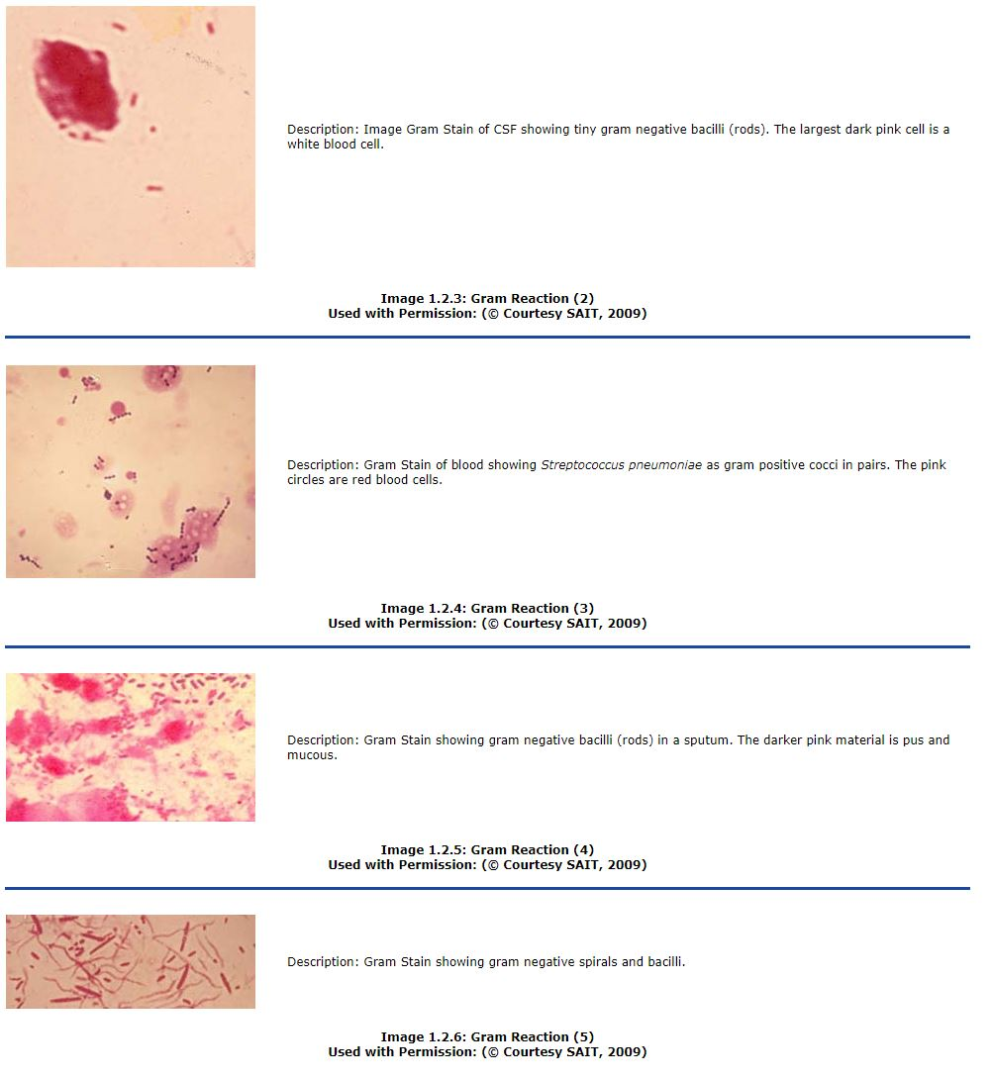

Bacterial Endospores
A small number of bacteria (a few Gram positive rods) are able to produce a special type of spore within the bacterial cell. These spores are usually called endospores to differentiate them from fungal spores borne on the ends of hyphae.
Bacterial cells that do not contain endospores are often referred to as vegetative cells. Even Gram positive rods that are able to form spores exist as vegetative cells when they are actively growing and multiplying.
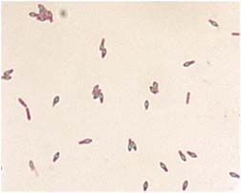 | Description: This is the microscopic appearance of a spore stained preparation of a bacillus bacteria. The endospores are the green, oval within the bacilli. The plain pink bacilli are still in the vegetative stage.
Image 1.2.7: Endospores
Used with Permission: (© Courtesy CDC Public Health Collection) PHIL ID# 1934
Sporulation seems to take place when certain nutrients are depleted. One copy of the genetic material and a tiny amount of cytoplasm is enclosed by a layer of insulating material and the whole structure is covered with several compact layers of spore coat.
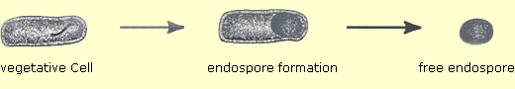
Figure 1.2.4: Sporulation
Endospores may remain dormant for days, months and even years without nutrients or moisture. Many of the bacteria found in dust, cereals, grains and soil exist as endospores.
A “viable” endospore is able to germinate (grow) into a vegetative cell when moisture and nutrients are provided. One spore will germinate into one vegetative bacterium.
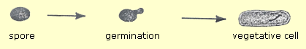
Figure 1.2.5: Germination
The following three Images show diseases caused by spore forming organisms. The spores are found ubiquitously (everywhere) in the soil and normally do not cause infections as they require special conditions to vegetate, such as lack of oxygen. Gangrene and tetanus result when spores are introduced deep into injured tissue where blood flow has been disrupted and oxygen levels are low. Unlike gangrene and tetanus, anthrax will grow in the presence of oxygen, but requires other pre-disposing conditions such as damaged tissue or inhalation in to the lungs.
Infections with Spore Forming:
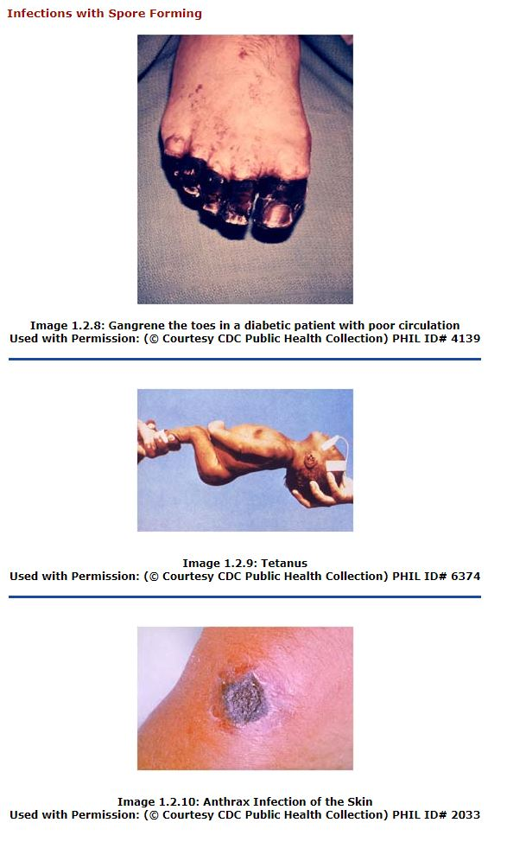
The significance of endospores in sterilization and disinfection:
- Endospores are quite resistant to heat. Most vegetative bacteria are killed by exposure to moist heat at 60-80°C for 10 minutes, but spores will survive these high temperatures. Some spores are killed by boiling, but others require a temperature of 121°C for 12-15 minutes for destruction.
- Endospores are more resistant to disinfectants than vegetative bacteria. Low level disinfectants may not kill endospores and high-level disinfectants require extended exposure times.
- Endospores are also very resistant to destruction by cold (viable spores have been discovered in the intestines of mammoths found in Siberian glaciers.
- Endospores are also resistant to Ultraviolet light, acids, alkalis and detergents.

Growth of Bacteria

Binary Fission
Almost all bacteria reproduce by a process called binary fission as shown in Figure 1.2.6.
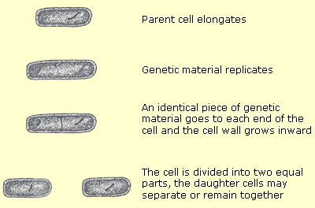
Figure 1.2.6
The time it takes for binary fission to occur is called the generation time. This is the time it takes for the population to double. For example:
- One bacterium becomes two bacteria
- Forty bacteria become eighty bacteria
Generation time is not the same for all bacteria and is also affected by temperature and available nutrients. Rapidly growing bacteria under ideal conditions have a generation time of 15-30 minutes.
The generation time is related to the rate at which bacteria cause disease. The bacteria responsible for gas gangrene have a very short generation time, believed to be about 8 minutes. Once infection is established in human tissue, a whole limb may be destroyed in a day. The bacteria responsible for tuberculosis, on the other hand, have a long generation time (12-24 hours) and take weeks to produce disease.
To see binary fission of bacteria under a microscope, follow the link below: http://www.cellsalive.com/ecoli.htm
The generation time also determines the amount of time required for bacteria to form visible growth on culture media. A colony is a visible mass of bacteria that develops on the surface of a solid culture medium after a period of time and represents all the descendants of a single bacterial cell. The culture medium provides necessary nutrients for bacterial growth. Rapidly growing bacteria will form colonies within 18-24 hours.
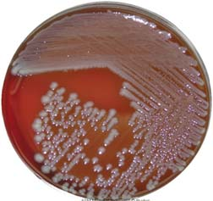
Image 1.2.11: An agar plate showing colonies of E. coli
Used with Permission: (© Courtesy SAIT, 2009)

Bacterial Growth Curve
Bacteria do not go on growing at their maximum generation time forever. There would be no room for anything else on the surface of the earth if they did. If one cell divided every 20 minutes for 24 hours, there would be 1 x 10²¹ cells with a mass of 4,000 tons. Fortunately, reproduction is curtailed due to lack of nutrients, space and the build up of toxic waste products. The maximum number of bacteria possible is about 1 x 10⁹ per mL or gram.
When bacteria are introduced into a new medium or environment, they go through four specific phases of growth. These phases make up the bacterial growth curve, as shown in Figure 1.2.7 below.
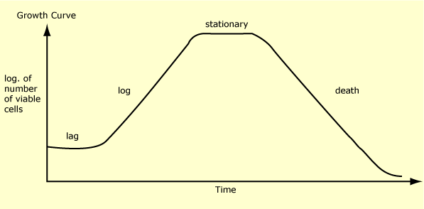
Figure 1.2.7

- Lag Phase
When bacterial cells are placed in a new environment, there is little or no increase in numbers for a short period of time. This time is necessary for the cells to adapt to the new environment. The lag phase is usually a few hours but may be much shorter or much longer in some situations.
The lag period for bacteria in food is considered to be about two hours. This allows foods to be left out on a serving table for that long without much worry of bacterial growth and possible food poisoning.
- Log Phase
This is a period of maximum growth of bacteria. All the cells are dividing at a constant rate.
- Stationary Phase
The bacteria eventually exhaust their supply of nutrients and stop growing and multiplying. Even if nutrients are not used up, the end products of bacterial growth may accumulate and prevent further growth. The number of live bacteria stays constant during this period.
- Death Phase (also called the Phase of Decline)
Eventually the bacterial cells start to die and the number of live cells decreases. In some cases, most of the bacteria die in a short period of time but in other cases, some live bacteria can linger for weeks, months or even years. The bacteria that can survive the longest are those that form spores.

The Growth Curve Related to Infection
Growth curves are plotted using laboratory cultures but the same sequence of events often takes place when a microorganism invades a host:
- There are usually no disease symptoms for a period of time immediately following introduction of the Microorganisms into the host. This represents the incubation period of the disease and corresponds to the lag phase of the growth curve.
- This is followed by the onset of symptoms which may be fever, sore throat, swollen lymph glands, rash, vomiting or diarrhea depending on the infectious microbe involved. This is the acute stage of the disease and corresponds to the log phase. With the assistance of the patient's defenses and medical intervention, most patients recover. However, if these fail, the patient dies during this period of the disease.
- Then follows a period of time during which the symptoms are no worse but still no sign of recovery. This would be the stationary phase.
- Finally the symptoms subside and recovery is on the way. This is the death phase (phase of decline) – death of the Microorganism but not the host. The convalescent period of the disease covers the time needed for complete recovery. This length of time will vary with different diseases and infectious microorganisms often continue to be discharged during this period. Figure 1.2.8 shows the growth curve related to infection.
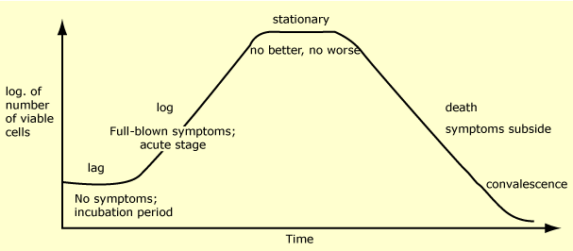
Figure 1.2.8

