QUAL 370: Quality Assurance and Control

Equipment Testing Procedures

MRT

Test: Visual Inspection

Reference
Papp, 6th ed. pp. 101-102

Purpose
To become familiar with the safety procedures, daily care and safety routines of the x-ray units as per the SC35 and department requirements.

Objective
Complete the verification checklist for DI equipment required for the safe operation of the x-ray units.

Annual Verification Checklist for DI Equipment

This report is for: Acceptance Compliance

Department: Room: Generator Model: Manufacturer: Country:
Serial #: Equipment Type:

Tube Information
Description: Serial #:
Model:
Date Manufactured: Country Manufactured:
Focal Spot: Large: mm Small: mm
Inherent Filtration: mm Al

General Information and Facility Requirements

Yes No N/A

- There is a certificate for the room.
- If (1) is "yes", the certificate must be posted in or close to the room.
Location:
- Radiation shielding is adequate and meets regulatory standards.
- X-ray warning signs are posted on all entrance doors to the room.
- Protective apparel is available to patients and individuals in the radiation area
- A QA program exists for the department.
- A quality maintenance program exists for the department.

Labelling
Generator
Yes No N/A

X-ray Tube
Yes No N/A

General Requirements

- Name of the Manufacturer
- Model Designation
- Serial Number
- Date of Manufacture
- Country of Manufacture

- Name of the Manufacturer
- Model Designation
- Serial Number
- Date of Manufacture
- Country of Manufacture
- Minimum permanent inherent filtration
- Are the anode and cathode clearly marked?

Warning Signs
Yes No N/A

Markings

Yes No N/A

The x-ray control panel must have a permanent, visible and legible sign warning that hazardous x-rays are emitted, and unauthorized use is prohibited.

All controls, meters, lights and other indicators related to the equipment operation must be clearly labelled or marked as to their function.

Mechanical Stability

Yes No N/A

- The x-ray tube must be securely fixed and correctly aligned within the tube housing.
- The x-ray assembly and support must maintain their required positions without excessive drift or vibration during operation.

Indicators and Indicator Lights

Yes No N/A

- There must be distinctive and separate indicators on the control panel that indicate:
- when the control panel is energized and the tube is ready to produce x-rays
- when x-rays are being produced.
- if AEC is provided, when that mode of operation is selected
- if AEC mode is not selected, or does not exist, the selected loading factors must be indicated to the operator before an irradiation
- if equipment is battery operated, whether enough charge is present for proper operation of the equipment.
- If more than one x-ray tube is controlled by one control panel:
- a visual indicator on or near each tube housing to show that the x-ray tube is connected and ready to be energized
- a visual indicator on the control panel to indicate which of the x-ray tubes is connected and ready to be energized
- An audible signal to indicate the termination of an exposure.

Indication of Loading Factors

Yes No N/A

- X-ray equipment having adjustable loading factors must have meters or other indicators that enable determination of the tube voltage, current and time, or combinations of these.
- The loading factors must be displayed before, during and after the exposure.

Irradiation Control

Yes No N/A

There must be an irradiation switch, controlling timer or another mechanism to initiate and terminate x-ray production.

Irradiation and Emergency Switches
Yes No N/A
    - When the equipment is equipped with an exposure switch, it must require continuous pressure by the operator to emit x-rays.
    - In the case of a foot switch, it must prevent the emission of any unintended x-rays when it is overturned.
    - In the case of mobile equipment, it must allow the operator to stand at least 3m away from the x-ray source when the x-ray tube is energized.
    - If the equipment moves around the patient by remote control, there must be an emergency stop switch that immediately terminates both equipment movement and exposure.

Controlling Timer
Yes No N/A

When the equipment has a controlling timer, it must be constructed so that:
- it can automatically terminate an exposure on completion of a preset irradiation time, or a preset current time product value, or on completion of a preset number of x- ray pulses.
- it permits the operator to terminate the exposure at any time
- it automatically resets itself to its original setting or to zero on termination of an irradiation.
- when it is at zero, in the off position, or at an unmarked setting, irradiation cannot occur.

Focal Spot Marking
Yes No N/A
The location of the focal spot must be clearly and accurately marked on the x-ray tube housing.

Testing Frequency
This is performed annually or in conjunction with tube and generator testing. A less extensive inspection should be done by the technologist daily or when required by the department protocol.

Test: Reproducibility

Reference
Papp 6th ed. pp. 104-105 SC35, p. 24

Purpose
To confirm that the same dose (mR) is received from exposure to exposure when a constant mA, time and kVp are used.

Equipment/Materials
Lead sheet Dosimeter Calculator

Troubleshooting Considerations
- Failure to reset the older dosimeter prior to each exposure may result in inaccurate readings.
- All 10 exposures must be obtained within a period of one hour.
- If the coefficient of variation exceeds +/- 0.05, this can indicate a problem with the exposure timer or mA control. A service engineer is needed to determine the exact cause.

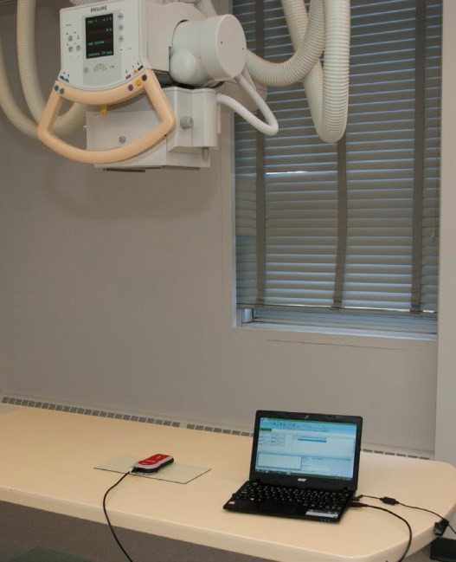
Procedure
    - Place the dosimeter on the x-ray table with the lead sheet beneath it to reduce the effects of backscatter. Using a 110 cm SID, center to the dosimeter and collimate to include the entire chamber. (Refer to image for example of setup)

    - Use the chart below to set the exposure factors and record the results.

    - Complete calculations and compare the results to acceptance criteria.
*Note: There are two sets of calculations and acceptance criterion for this test.

Reproducibility
 | Set kVp: 80 |  | SID (cm): 110
 | Set Time (ms): 100 |  | Focus: Large
 | Set mA: 100
 | Exposure | mR | Time (ms) | kVp
 | 1
 | 2
 | 3
 | 4
 | 5
 | 6
 | 7
 | 8
 | 9
 | 10

Evaluation – Part 1
- Calculate the mean value of the ten measurements for mR, ms and kVp, record below. MEAN VALUE: mR ms kVp

- Calculate the percent difference between the mean value and the maximum value of the ten measurements as follows:
(MAXIMUM VALUE – MEAN VALUE) x 100 =
MEAN VALUE

mR: % ms: % kVp: %

- Calculate the percent difference between the mean value and the minimum value of the ten measurements as follows:
(MINIMUM VALUE – MEAN VALUE) x 100 =
MEAN VALUE
mR: % ms: % kVp: %

Acceptance Criterion – Part 1
Compare the results in Step 2 and 3 to the standard in SC 35 p. 24
As per the SC 35 - Each of the 10 radiation exposures measured must be within 15% of the mean value of the 10 measurements.

Evaluation – Part 2
- Calculate the coefficient of variation of the ten measurements of mR, ms and kVp using
the “Reproducibility” worksheets on the following pages.

Acceptance Criterion – Part 2
Compare the results of the coefficient of variation to the standard in the SC 35 p. 24.

The coefficient of variation must be less than +/- 0.05.

PASS FAIL

 | mR | ms | kVp
PASS
FAIL

Testing Frequency
This test should be done annually when there is an indication that exposures are not consistent or when the generator has been calibrated.

Reproducibility Worksheet (mR)

STEP 1 Subtract each reading from the mean value.

( - | ) + ( | - ) + ( | - ) + ( | - ) + ( - ) + ( | - ) + | ( - | )
+ ( | - ) + ( | - ) + ( | - )

STEP 2 Square each result, and add them up.

( )2 + ( )2 + ( )2 + ( )2 + ( )2 + ( )2 + ( )2 + ( )2 +
( )2 + ( )2

+ + + + + + + +

+ =

STEP 3 Divide the result from Step 2 by 9.

/ 9 =

STEP 4 Take the square root of the result in Step 3.

√ =

STEP 5 Divide the result from Step 4 by the mean value.

/ = (Mean)

STEP 6 Record the result onto the data table, and repeat for time and kVp.

Note: this worksheet is based on the formula shown on pg. 24 of the SC 35.
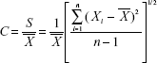

Reproducibility Worksheet (time)
STEP 1 Subtract each reading from the mean value.
( - ) + ( | - ) + ( | - ) + ( | - ) + ( | - ) + ( - | ) + ( | - ) +
( - ) + ( | - ) + ( | - )

STEP 2 Square each result, and add them up.

( )2 + ( )2 + ( )2 + ( )2 + ( )2 + ( )2 + ( )2 + ( )2 +
( )2 + ( )2
+ + + + + + + +
+ =

STEP 3 Divide the result from Step 2 by 9.
/ 9 =

STEP 4 Take the square root of the result in Step 3.
√ =

STEP 5 Divide the result from Step 4 by the mean value.
/ = (Mean)

Reproducibility Worksheet (kVp)
STEP 1 Subtract each reading from the mean value.
( - ) + ( | - ) + ( | - ) + ( | - ) + ( | - ) + ( | - ) + ( | - ) +
( - ) + ( | - ) + ( | - )

STEP 2 Square each result, and add them up.

( )2 + ( )2 + ( )2 + ( )2 + ( )2 + ( )2 + ( )2 + ( )2 +
( )2 + ( )2
+ + + + + + + +
+ =

STEP 3 Divide the result from Step 2 by 9.
/ 9 =

STEP 4 Take the square root of the result in Step 3.
√ =

STEP 5 Divide the result from Step 4 by the mean value.
/ = (Mean)

Test: kVp Accuracy

Reference
Papp, 6th ed. pp. 106-107 SC35, p. 25

Purpose
To confirm that the x-ray generator is producing the same kVp as indicated on the control panel. (Some sources feel that this test should be done first because it may affect other results.)

Equipment/Materials
Digital kVp Meter (if dosimeter does not include kVp function) Dosimeter
Calculator Lead sheet

Procedure
  - Place the dosimeter on the x-ray table with the lead sheet beneath it to reduce the effects of backscatter. Using a 110 cm SID, center to the dosimeter and collimate appropriately to include the entire chamber.

  - Refer to the chart below to set the exposure factors and record the results.

  - Complete calculations and compare the results to acceptance criteria.

Note: Typically, the full kVp range of the unit is tested, starting at 50 kVp and increasing in intervals of 5 kVp. Above 80 kVp, testing occurs in 10 kVp intervals. For the purposes of this lab procedure, the kVp range being tested has been reduced.

kVp Accuracy
 | Set mA: 100 |  | Set Time (ms): 100 |  | SID (cm): 110
 | Set kVp | Focal Spot | Actual kVp | % diff | PASS | FAIL
 | 50 | Large
 | 60 | Large
 | 70 | Large
 | 80 | Large
 | 90 | Large
 | 100 | Large

Evaluation
Fred Kasza, MRT(R) Sr. QA Technologist. Used with Permission. 2013

Determine the percentage difference between set and measured kVp values.
% Difference = (Actual kVp) – (Set kVp) x 100
(Set kVp)

Acceptance Criterion
Compare the results to the standard in SC 35 p. 25.

The measured kVp shall have a value within +/- 10% of the selected kVp value.

Conclusion
PASS FAIL

Testing Frequency
This test should be done upon acceptance and the kV should be checked annually or when there is an indication that the generator is not producing the kV selected.

Test: mA Linearity

Reference
Papp, 6th ed. pp. 109-110 SC35, p. 25

Purpose
To confirm that any two consecutive tube current settings (mA) can produce average exposure ratios within the acceptable tolerance and that mA is linear with exposure.

Equipment Materials
Lead Sheet Dosimeter Calculator

Procedure
- Place the dosimeter on the x-ray table with the lead sheet beneath it to reduce the effects of backscatter. Using a 110 cm SID, center to the dosimeter and collimate appropriately to include the entire chamber.

- Refer to the chart below to set the exposure factors and record the results.

- Complete calculations and compare the results to acceptance criteria.

Note: It is recommended to test every consecutive mA station with ten (10) exposures at each mA setting to obtain accurate data. Two exposures at each station is sufficient for the purpose of this lab.

mA Linearity
 | Set kVp: 80 |  | Set Time (ms): 100 |  |  | SID (cm): 110
 | Set mA | Set mAs | Focal Spot | Exposure | mR | Avg. mR | mR/mAs
 | 50 |  | Large | 1
 |  |  |  | 2
 | 100 |  | Large | 1
 |  |  |  | 2
 | 125 |  | Large | 1
 |  |  |  | 2
 | 160 |  | Large | 1
 |  |  |  | 2

Evaluation
Fred Kasza, MRT(R) Sr. QA Technologist. Used with Permission. 2013

Using the “mA Linearity” worksheet below, calculate the ratio of mR/mAs for each set of consecutive mA settings. (i.e. between 50 and 100, 100 and 125, etc.) where x1 and x2 are the average mR/mAs values obtained at any two consecutive mA settings of similar focal spot size.

mA Linearity Worksheet

x₁ @ 50 mA |x₁ – x₂| ≤ 0.10(x₁ + x₂)
x₂ @ 100 mA ( - ) ≤ 0.10( + )
≤

PASS FAIL

x₁ @ 100 mA |x₁ – x₂| ≤ 0.10(x₁ + x₂)
x₂ @ 125 mA ( - ) ≤ 0.10( + )
≤

PASS FAIL

x₁ @ 125 mA |x₁ – x₂| ≤ 0.10(x₁ + x₂)
x₂ @ 160 mA ( - ) ≤ 0.10( + )
≤

PASS FAIL

Acceptance Criteria
According to the SC 35, p. 25, the average mR/mAs values obtained at any two consecutive mA settings shall not differ more than +/- 0.1 times their sum.

Testing Frequency
This test should be performed annually or when service has been performed on the generator.

Test: Timer Accuracy

Reference
Papp, 6th ed. pp. 108-109 SC35, p. 25

Purpose
To confirm that the x-ray generator is producing an exposure for the amount of time set on the control panel.

Equipment/Materials
Lead sheet
Digital X-Ray Exposure Timer Test Tool/ Dosimeter Calculator

Procedure

- Place the digital timer test tool/dosimeter on the x- ray table with the lead sheet beneath it to reduce the effects of backscatter. Using a 110 cm SID, center to the digital timer test tool/dosimeter and collimate appropriately to include the entire chamber.

- Refer to the chart below to set the exposure factors and record the results.

- Complete calculations and compare the results to acceptance criteria.

Timer Accuracy
 | Set mA: 100 |  | kVp: 60 |  | SID (cm): 110
 | Set Time (ms) | Focal Spot | Result (ms) | Acceptable  Range | PASS | FAIL
 | 40 | Large
 | 50 | Large
 | 60 | Large
 | 80 | Large
 | 100 | Large

Evaluation
Determine the acceptable range for each time setting.

(0.1 x Set Time) + 1 = ms Set Time + = maximum limit
Set Time - = minimum limit

Acceptance Criterion

All exposure times must be accurate to +/- 10% + 1ms of that set on the x-ray generator control panel.
Example: If the set time is 40 ms, the acceptance criteria is +/- 5 ms. Any value between 35-45 ms would pass.
10% x 40 ms = 4 ms 4 ms + 1 ms = 5 ms

Testing Frequency
Exposure time should be checked annually, when a generator has been worked on, or when the EI numbers are not consistent for similar exposures.

Test: Leakage Radiation

Reference
SC35, p. 24

Purpose

To determine the amount of leakage radiation emitted in any direction from the focal spot of the x-ray tube.

Anderson does not have the required tools to perform this test. The following is a sample procedure of how this test can be performed.

Equipment/Materials
Lead sheets Tape measure
Dosimeter and wand Calculator

Procedure
- Move the detector away from the tube.

- Place a lead apron on the table. Close the collimator shutters and bring tube down right onto the lead apron.

- Secure the dosimeter wand/paddle on a stand at the anode end of the tube at a distance of 1 meter.

- Set 100 kVp, 200 mA and 1 second, and expose. Record the mR reading.

- Repeat step #4 each time while moving the probe to the areas specified in the diagram. Total of 5 exposures, with the probe on every side of the tube, also including an exposure 1 meter above the tube head.






- Raise the tube just high enough to fit the dosimeter wand underneath. Take an exposure and record the result as the primary mR.
1 meter
1 meter
Setup view from above table
Dosimeter and wand
1 meter above
1 meter
1 meter
© 2014, Southern Alberta Institute of Technology

Primary mR | 344.5 mR
Probe Location | Leakage mR
Anode Side | 0.0 mR
Cathode Side | 0.0 mR
Front | 0.0 mR
Back | 0.0 mR
Above | 0.0 mR

Evaluation
Leakage Radiation
Leakage mR x 100 % =
Primary mR

Acceptance Criterion
The x-ray source assembly shall not exceed an air kerma rate of 1.0 mGy/h or 115 mR at a distance of 1 meter away from the focal spot.

Conclusion

PASS X _ FAIL

Testing Frequency
Leakage is tested on completion of the room before equipment is put into service and should be checked when the tube is replaced or housing is opened.

Test: Lead Apparel

Reference
Papp, 6th ed. p. 102 SC35, p. 35

Purpose
To determine if any cracks or holes are present, and if the lead apparel is safe for usage.

Equipment/Materials
Lead markers

Procedure
  - Confirm that all the aprons have an ID number and a permanent label stating the lead equivalency. If information is missing, note it in the comments column.

  - Center the tube over the table, using a 110 cm SID. Use the largest field size appropriate to cover as much of the lead apparel as possible. Start in one corner and position subsequent exposures to ensure overlap.

  - Label the images using the lead markers (i.e. A, B, C or 1, 2, 3), ensuring that the area underneath the marker has been imaged and the marker is not obscuring a possible crack/hole.

  - Expose using the technical factors on the data table appropriate for the apparel.

  - Take exposures until the entire article of lead apparel has been imaged with overlap.

Lead | ID# | Lead  equivalence | kVp | mAs | Pass/  Fail | Comments
Full Apron |  |  | 80 | 5
Full Apron |  |  | 80 | 5
1/2 Apron |  |  | 80 | 5
Hanging  Apron |  |  | 80 | 5
Glove |  |  | 80 | 5
Glove |  |  | 80 | 5
Lead Sheet |  |  | 76 | 5
Lead Sheet |  |  | 76 | 5
Lead Sheet |  |  | 76 | 5
Lead Sheet |  |  | 76 | 5

Evaluation
Lead Apparel
- On each image, check for areas of increased radiographic density which may indicate holes, cracks or wearing. A description and the location of damaged areas need to be documented in the comments column.

- When determining pass/fail, take into consideration the size and location of the defects. A defect on the very edge of a lead apron may not require the apron to be replaced, where a crack through the middle (gonadal coverage) would require the apron to be removed from usage.

- Record the results on the data table.

Testing Frequency
This test is done with new lead apparel before it is put into service. All lead apparel must be tested annually, although every 6 months would be ideal.

Test: Automatic Exposure Control (AEC) Reproducibility

Reference
Papp, 6th ed. p. 120 SC35, p. 25

Purpose
To confirm that the exposure is being terminated at the proper time after a predetermined quantity of radiation has been detected, thereby producing the same output from exposure to exposure when the same kVp and mA are used.

Equipment/Materials
Dosimeter
Two plexiglass blocks Calculator

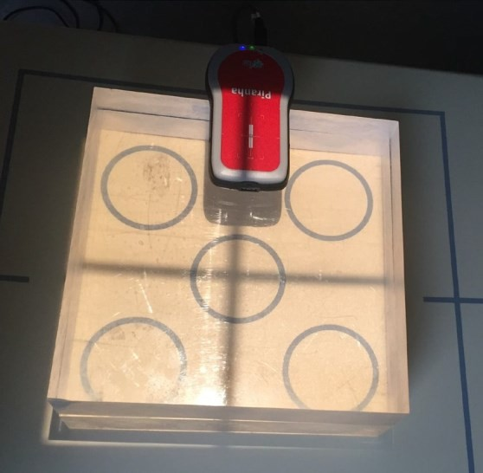
Procedure
- Place the plexiglass blocks (stacked) over the AEC cells of the detector ensuring the AEC cells are completely covered. Using a 110 cm SID, center to the detector and collimate appropriately to include the entire plexiglass blocks.

- Place the dosimeter probe on top of the blocks, to one side of the center cell ensuring the AEC cells are not obstructed. Check the shadow.

- Select AEC on the control panel with the center cell only.

- Refer to the chart below to set the exposure factors and record the results.

Note: Typically, this test must be performed on all detectors and cells in the room. For the purposes of this lab, only the table detector center cell will be tested.

AEC Reproducibility
 | AEC Cell: Center |  | kVp: 80 | SID (cm): 110
 | Exposure | mA | Time (ms) | Exposure (mR)
 | 1 | 100
 | 2 | 100
 | 3 | 100
 | 4 | 100
 | 5 | 100
 | 6 | 100

Evaluation
Determine the percent of variation using the following formula:
% Variation = (mRmax – mRmin) x 100
(mRmax + mRmin)

= ( – ) x 100
( + )

Acceptance Criterion
The acceptance criterion is user defined and site specific. The SC 35 states that manufacturer’s specifications should be used. The mR can be used to determine the reproducibility. According to Papp, the exposure reproducibility variance for an AEC device must be within 5%. The SC 35 recommends that the variance does not exceed 20%.

Conclusion

PASS FAIL

Testing Frequency

This test is performed annually, when the AEC device is malfunctioning, or when the AEC has been serviced.

Test: AEC Field Balance/Uniformity

Reference
Papp, 6th ed. p. 120 SC 35, p. 25

Purpose
To confirm that the exposure is being terminated at the proper time after a predetermined quantity of radiation has been detected, thereby producing the same output from exposure to exposure when the same kVp and mA are used, regardless of the combination of AEC cell(s) selected.

Equipment/Materials
Dosimeter
Two plexiglass blocks Calculator

Procedure
- Place the plexiglass blocks (stacked) over the AEC cells of the detector ensuring the AEC cells are completely covered. Using a 110 cm SID, center to the detector and collimate appropriately to include the plexiglass blocks entirely.

- Place the dosimeter probe on top of the blocks, to one side of the center cell ensuring it is not obstructing any of the AEC cells.

- Refer to the chart below to set the exposure factors and record the results.

Note: Typically, this test must be performed on all detectors in the room. For the purposes of this lab, only the table detector will be tested.

AEC Field Balance
 | mA: 100 |  | kVp: 70 |  |  | SID (cm): 110
 | Cell | Time (ms) |  | Exposure  (mR) | % Diff  (ms) | % Diff  (mR) | Pass | Fail
 | Center
 | Left
 | Right
 | Center + Left
 | Center + Right
 | Left + Right
 | All
 | Mean

Evaluation
% Difference = (Measured) – (Mean) x 100

(Mean)

Acceptance Criterion
The acceptance criterion are user defined and site specific, the SC35 states that manufacturer’s
specifications should be used. The AHS standard for acceptance is < 20%.

Conclusion

PASS FAIL

Testing Frequency
This test is performed annually, when the AEC device is malfunctioning, or when the AEC has been serviced.

Test: AEC Density Control Test

Reference
Papp, 6th ed. pp. 120-121 SC35, p. 25

Purpose
To confirm that the exposure is being terminated at the proper time when using density control settings and the same kVp and mA are used.

Equipment/Materials
Dosimeter
Two plexiglass blocks Calculator

Procedure
- Place the plexiglass blocks (stacked) over the AEC cells of the detector ensuring the AEC cells are completely covered. Using a 110 cm SID, center to the detector and collimate appropriately to include the plexiglass blocks entirely.

- Place the dosimeter probe on top of the blocks, to one side of the center cell ensuring it is not obstructing any of the AEC cells.

- Refer to the chart below to set the exposure factors and record the results.
Note: Typically, this test must be performed on all detectors in the room. For the purposes of this lab, only the table detector will be tested.

AEC Density Control
 | AEC Cell: Center | kVp: 70 | SID (cm): 110
 | Density Setting | mAs |  | mR
 | -2
 | -1
 | 0
 | +1
 | +2

Evaluation
Determine the % difference in mR and mAs between adjacent density control settings.
e.g. Between -2 and -1 density setting.
% Difference = ( -2 Setting) – (-1 Setting) x 100
(-1 Setting)

mR
% = ( ) – ( ) x 100 [Density Setting -2 and -1]

( )
% = ( ) – ( ) x 100 [Density Setting -1 and 0]

( )
% = ( ) – ( ) x 100 [Density Setting 0 and +1]

( )
% = ( ) – ( ) x 100 [Density Setting +1 and +2]

( )

mAs
% = ( ) – ( ) x 100 [Density Setting -2 and -1]

( )
% = ( ) – ( ) x 100 [Density Setting -1 and 0]

( )
% = ( ) – ( ) x 100 [Density Setting 0 and +1]

( )
% = ( ) – ( ) x 100 [Density Setting +1 and +2]
( )

Acceptance Criterion
The acceptance criterion is user defined and site specific, the SC35 states that Manufacturer’s specifications should be used. The AHS standard states there should be a difference of 15 - 25% between adjacent density settings.

Conclusion
PASS FAIL

Testing Frequency
This test is performed annually, when the AEC device is malfunctioning, or when the AEC has been serviced.

Test: Automatic Exposure Control (AEC) Sensitivity

Reference
SC35, p. 25

Purpose
To ensure the speed settings in the AEC program are functioning within parameters.

Equipment/Materials
Dosimeter
Two plexiglass blocks Calculator

Procedure
- Place the plexiglass blocks (stacked) over the AEC cells of the detector ensuring the AEC cells are completely covered.

- Using a 110 cm SID, center to the detector and collimate appropriately to include the plexiglass blocks entirely.

- Place the dosimeter probe on top of the blocks, to one side of the center cell ensuring it is not obstructing any of the AEC cells.

- Refer to the chart below to set the exposure factors and record the results.
Note: Typically, this test must be performed on all detectors in the room. For the purposes of this lab, only the table detector will be tested.

AEC Sensitivity
 | AEC Cell: | Center | kVp: | 70 | SID (cm): | 110
 | Sensitivity/Speed |  | mAs |  | mR
 | S200
 | S400
 | S800

Evaluation
The units in the lab are calibrated to S400 as standard practice. Using the S400 results as the comparison point, determine the percentage of variation between the speed settings.

S200 and S400
% = ( S200) – (S400) x 100
(S400)

mAs % = ( ) – ( ) x 100
( )
mR % = ( ) – ( ) x 100
( )

S800 and S400
% = ( S800) – (S400) x 100
(S400)

mAs % = ( ) – ( ) x 100
( )
mR % = ( ) – ( ) x 100
( )

Acceptance Criterion
The acceptance Criterion are user defined and site specific, the SC35 states that Manufacturer’s specifications should be used. As the speed of the system is doubled, the resultant exposure should be halved. When the speed of the system is halved, the resultant exposure should be doubled.

Conclusion
PASS FAIL

Testing Frequency
This test is performed annually, when the AEC device is malfunctioning, or when the AEC has been serviced.

Test: Positive Beam Limitation/Automatic Collimation (PBL)

Reference
Papp, 6th ed. p. 113
SC35, p.53: Y9(b), pg. 75: 12(1)

Purpose
To confirm that the automatic collimation system (PBL) quickly and accurately adjusts to the appropriate field size required for the selected APR.

**This test is for equipment that utilizes a Bucky. SAIT does not have any units with a Bucky, therefore these procedures and acceptance criterion are taught as theory only and are testable content. The following is a sample procedure of how this test would be performed.

Equipment/Materials
Ruler Calculator Timer

Procedure - Part A

- Using a 110cm SID, center the tube and cassette holder in the table. Open the light field as large as possible.

- Use the timer to determine how long it takes for the light field to adjust when a cassette is inserted. Visually confirm that the light field changes to the corresponding size of the field for the APR.

- Repeat step 2 for the different sizes of cassettes available. Record the results.

Acceptance Criterion
According to the SC 25 on p. 75, the PBL will automatically adjust the dimensions of the radiation field within 5 seconds of the image receptor being inserted into the cassette holder.

Conclusion
The PBL adjusts the radiation field size within seconds of image receptor insertion.

PASS FAIL

Procedure - Part B
- Using a 110 cm SID, center the tube with the cassette holder in the table.
- Place an 18x24 cm cassette into the cassette holder. Visually confirm the PBL.
- On the table top, center a 24x30 cm cassette in the light field.
- Take an exposure using 70 kVp and 2 mAs.
- Process the 24x30 cm (tabletop) cassette and evaluate the image. Erase the 18x24 cm cassette.

Evaluation
- Measure the length and width of the image.
PBL – measured

IR Size (cm) | 18 x 24 | 24 x 30 | 35 x 43
Meas. Width (cm)
Meas. Length (cm)

- Measure the distance between the table top and the cassette holder to determine the magnification factor using the following formulas.

SID = MF SOD = SID - OID SOD
MF =

- Multiply the width and length by the magnification factor to determine the actual size of the radiation field at the level of the cassette holder.
PBL - actual

IR Size (cm) | 18 x 24 | 24 x 30 | 35 x 43
Actual Width (cm)
Actual Length (cm)

- Calculate 3% and 4% of the SID.
  - X cm = cm
  - X cm = cm
- Calculate the difference between the cassette size (inside cassette holder), and the actual beam (calculated).

34 QUAL 370: Quality Control

IR Size (cm) | 18 x 24 | 24 x 30 | 35 x 43
Difference - Width (cm)
Difference -Length (cm)

- Compare the length and width differences to the acceptance Criterion of 3% of the SID.
PBL - Differences

- Compare the difference between the sum of the width and length of the image receptor (cassette) to the sum of the width and length of the actual field size to the acceptance Criterion of 4% of the SID.

Image Receptor = 18 + 24 = 42 cm
Actual Field Size = + = cm

Difference = cm

- Repeat for all cassette sizes, ensuring that the cassette on the table top is larger than the cassette inside the cassette holder.

Conclusion
PBL

IR Size (cm) | 18 x 24 | 24 x 30 | 35 x 43
PASS
FAIL

Acceptance Criterion
The SC 35 states that the dimensions of the radiation field should not exceed the image receptor size by more than 3% of the SID and the sum of the differences in the dimensions of the radiation field and image receptor should not exceed 4% of the SID.

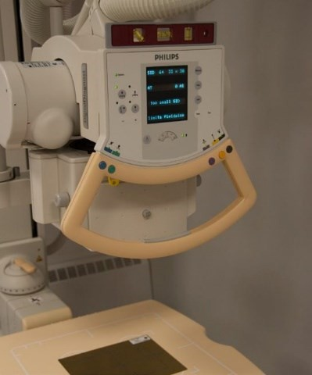
3. Use the carpenter level to ensure that there is no angle on the tube and the template; this is critical to the accuracy of the results. Both the tube and template need to be checked with the level.
35 QUAL 370: Quality Control

Test: Collimator Light/X-Ray Field Congruence and Perpendicularity

Reference
Papp, 6th ed. pp. 113-116
SC35, p. 25, p. 53: Y8, p. 75: 12(2)

Purpose
To confirm congruency of the light and x-ray field and to ensure that the central ray is perpendicular to the detector.

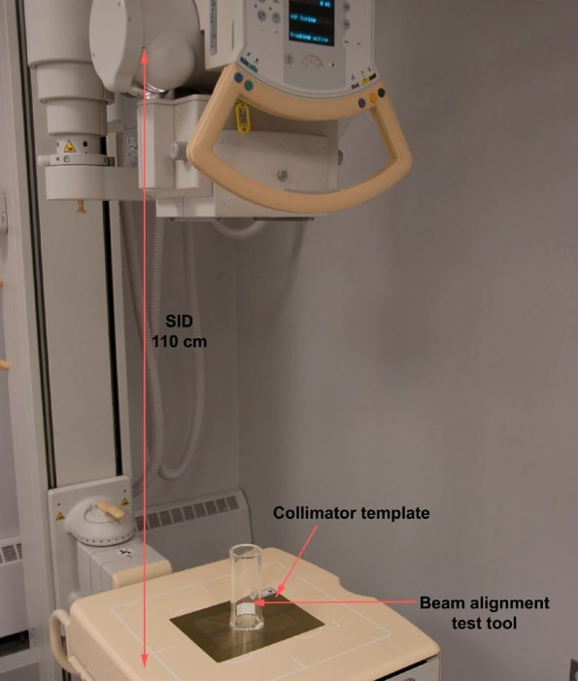
Equipment/Materials
Collimator Alignment Template Beam Alignment Test Tool Calculator
Carpenter Level

Procedure
- Using a 110 cm SID, center the tube to the detector.

- Place the collimator alignment template on top of the detector. The dot in the corner of the template should correspond to a patient’s right shoulder. The dot is used as a point of reference to determine the direction of collimator error.

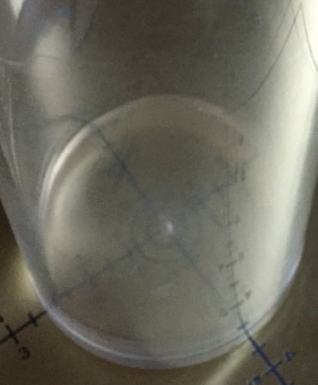
- Place the beam alignment test tool in the center of the collimator alignment template. Ensure the metal bead in the bottom of the cylinder is directly over the crosshairs on the template.
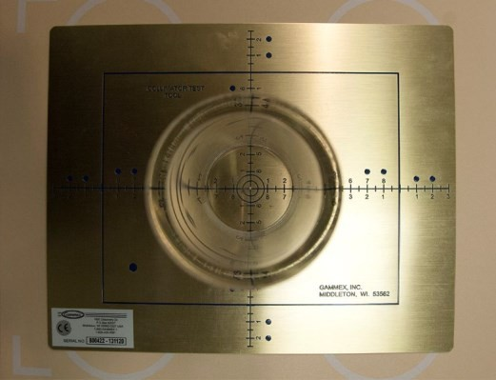

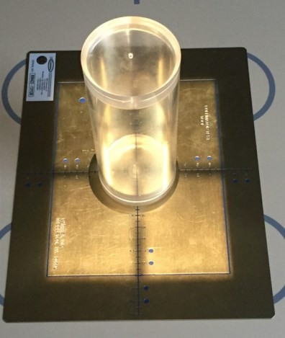
- Collimate carefully to the blue marker lines nearest to the center of the template (blue square).

- Expose using 60 kVp @ 4 mAs.

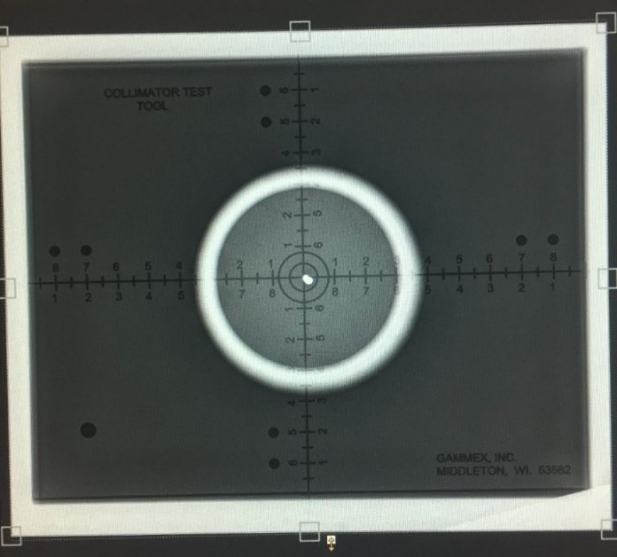
- Using the post processing tools on the console, open up the mask to visualize the edges of the collimation.
On the image, measure the distance between the actual collimation and the solid lines of the template on all four sides. Record the results on the following page.

Evaluation A – Collimator Light/X-ray Field Congruence

- Calculate 2% of SID.

0.02 X cm = cm x 10 = mm

- On each side, measure and record the distance between the light field and the x-ray field image.

X
A
B
Y

A = mm X = mm

B = mm Y = mm

- Take the sum of the distances of opposite sides found in Step 2 and compare the results to 2% of SID found in Step 1.

A + B = mm X + Y = mm

A + B + X + Y = mm

Conclusion

PASS FAIL

Acceptance Criterion
According to the SC35, the measured misalignment of the visually defined field and the x-ray field along the length or width of the x-ray field shall not exceed 2% of the SID.

Evaluation B - Perpendicularity

Refer to the chart below, compare and record which alignment appears most similar to the image taken earlier. This template is provided by the test tool manufacturer.

~0.5° | ~1.5° |  | ~3°
Result:

Acceptance Criterion
According to the SC 35 p. 75, the x-ray beam axis should be within 3° of the perpendicular to the image receptor plane. Using this test tool, the upper bead should be within the outer circle to pass.

Conclusion

PASS FAIL

Testing Frequency
The light field/x-ray congruency and beam perpendicularity should be checked semiannually or when the collimator head, collimator light or x-ray tube, has been replaced or any corrective action has been taken. Images should be taken, then stored or printed out for future reference.

Test: Half Value Layer (HVL) Measurement

Reference
Papp, 6th ed. pp. 105-106 SC35, p. 24

Purpose
To confirm that the permanently installed filtration in the x-ray tube meets the minimum standard to minimize patient radiation dose.

Equipment/Materials
Set of Al filters Dosimeter Lead sheets Tape
Ruler

Procedure
- Place the dosimeter on the x-ray table with the lead sheet beneath it to reduce the effects of backscatter. Using a 110 cm SID, center to the dosimeter and collimate appropriately to include the entire chamber.

- Refer to the chart below to set the exposure factors and record the results.

- Select the appropriate thickness of aluminum specified in the data table, and tape it onto the collimator. Complete all the exposures.

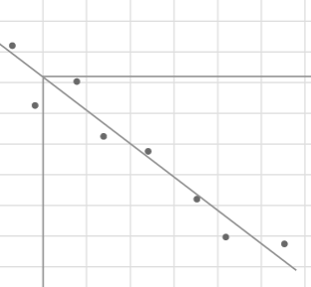
- Plot the results onto the graph, and draw a ‘best fit’ line for the data points. (Best fit line: best represents the data points, may pass through some, none or all of the points) Example:

Half Value Layer
 | kVp: 80 | mAs: 50
 | mm Al | mR
 | 0
 | 0.5
 | 1
 | 2
 | 3
 | 4

HVL Graph
Exposure (mR)

0 | 0.5 | 1 | 1.5 | 2 | 2.5 | 3 | 3.5 | 4
Filtration (mm Al)

Calculations

  - Calculate 50% of the exposure at 0 mm Al.

mR @ 0 mm Al x 0.5 = mR (a)

  - Draw a line across the graph at the level of the result (a) above.

  - Determine the point where that line intersects with the best fit line, and draw a line directly down from it.

From graph: HVL = mm Al

Acceptance Criterion
Compare the actual HVL to the SC35 acceptance criterion on p.24.

According to Table 8, the SC35 states there must be a minimum HVL of 2.9 mm @ 80 kVp.

**Table 8 needs to be memorized**

Conclusion

PASS FAIL

Testing Frequency
The HVL test should be performed annually, when the x-ray tube has been replaced, the collimator has been removed, repaired, replaced and re-installed or when added filtration has been modified.

Test: Fluoroscopic kVp Accuracy

Reference
Papp, 6th ed. p. 106-107, 154
SC35, p. 25

Purpose
To confirm that the fluoroscopic x-ray generator is producing the same kVp as that which is indicated on the control panel.

Equipment/Materials
Dosimeter
Digital kVp meter (if dosimeter does not include kVp function) Lead apron

*(Note: When performing tests on fluoroscopic equipment, a consideration to keep in mind is the configuration of the unit, as the x-ray tube can be over or under the table.)

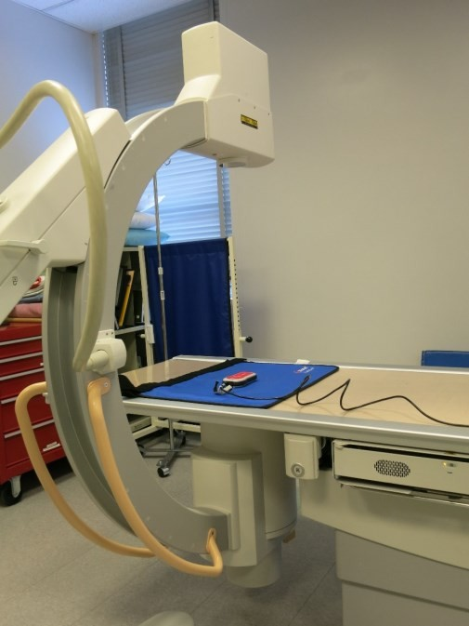
Procedure
- Position the image intensifier of the c-arm beneath the table.

- Place the lead apron on the table to absorb any backscatter. Position the dosimeter on top of the lead and center to the x-ray tube, collimate appropriately to include entire chamber.

- Set the kVp as indicated on the data table.

- Expose for 2 seconds and record the reading. Repeat the exposure once more.

- Repeat step 4 for all kVp stations in the table.

Fluoroscopic kVp Accuracy
 | Set kVp | Exposure | kVp | Avg kVp | % Diff
 | 60 | 1
 | 60 | 2
 | 70 | 1
 | 70 | 2
 | 80 | 1
 | 80 | 2
 | 100 | 1
 | 100 | 2

Evaluation
Determine the percentage difference between set and measured kVp values.

% Difference = (Actual kVp) – (Set kVp) x 100
(Set kVp)

Acceptance Criterion
Compare the results to the standard in SC 35 p. 25

The measured kVp shall have a value within +/- 10% of the selected kVp value.

Conclusion

PASS FAIL

Testing Frequency
This test should be done upon acceptance and the kV should be checked annually or when there is an indication that the generator is not producing the kV selected.

Test: Maximum Fluoroscopic Exposure Rate

Reference
Papp, 6th ed. pp.155-156 SC35, pp. 26, 54

Purpose
To confirm that the maximum exposure rate that can be delivered does not surpass the regulation as determined by the SC35 for any combination of mA and kVp.

Equipment/Material
Dosimeter Calculator Lead sheets

Procedure
- Position the image intensifier of the c-arm beneath the table.

- Center the x-ray tube over the dosimeter and collimate appropriately. The dosimeter needs to be set for measuring exposure rate (R/min).

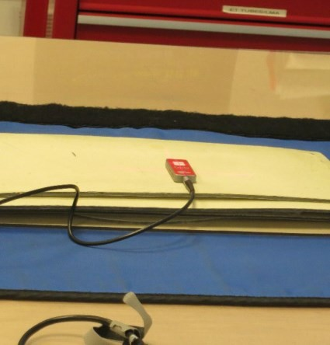
- Use the crosshairs to align the dosimeter, ensure it is in the center of the image. Set the fluoroscopic controls as indicated on the data table below.

- Place a lead sheet underneath the dosimeter.

- Fluoro until the ABC/AIC stabilizes.

- Continue adding lead sheets until the exposure rate no longer changes. (Minimum is 6 mm of lead equivalent thickness)

NOTE: Ensure the beam is completely attenuated by the lead.

- Record the results, and complete the data table.

Maximum Entrance Exposure
 | Mode | kVp | mA | R/min | mGy/min
 | Continuous
 | Pulse

Evaluation and Acceptance Criterion
Compare the dose rates obtained with the requirement stated in SC35 p. 26:

50 mGy/min or 5.75 R/min: for equipment not equipped with automatic intensity control. 100 mGy/min or 11.45 R/min: for equipment equipped with automatic intensity control.
150 mGy/min or 17.18 R/min: for equipment equipped with an automatic intensity control, a high radiation control and the high radiation control is activated.

Conclusion

PASS FAIL

Testing Frequency
This test should be done upon acceptance and checked annually.

Test: Fluoroscopic Resolution (Line Pair)

Reference
SC35, p. 54

Purpose
To determine if the resolution is within acceptable limits.

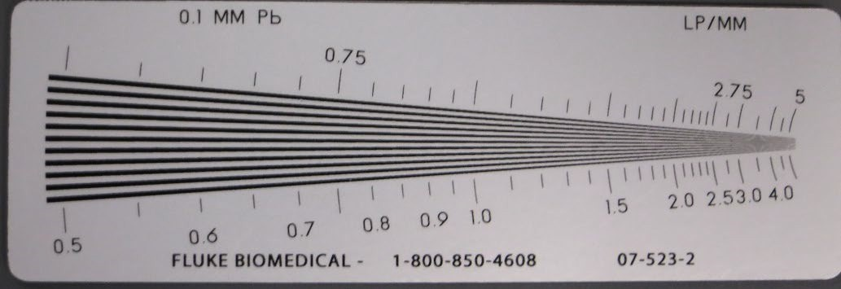
*This test is subjective and results may vary, but should be very similar if performed by more than one individual.

Equipment/Materials
Line Pair Test Tool

Procedure
- Position the c-arm with the image intensifier on the bottom.

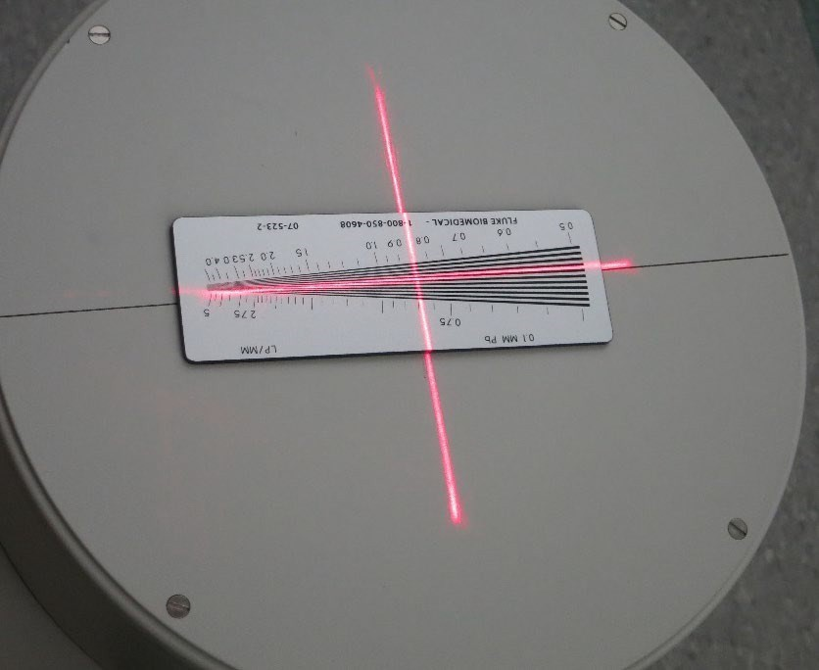
- Center the test tool on the image intensifier and collimate appropriately to include the entire tool.

- Using 90 kVp, expose for 2 seconds and determine how far down the test tool the lines and spaces can be clearly visualized. Record the results.

- Repeat the exposure for the settings specified in the data table.

 |  | Fluoroscopy Setting
 | Dose | Regular | Mag 1 | Mag 2
Lp/mm | Regular
Lp/mm | Low Dose

Evaluation and Acceptance Criterion
Fluoroscopic Resolution (Line Pair)
The SC 35 states to follow the manufacturer’s recommended test procedures for resolution. For each mode of operation, resolution must be within established limits. As per the manufacturer, the acceptance criterion for this test is to clearly visualize a minimum of 1.2 lp/mm with a 23 cm field and 1.6 lp/mm with a 15 cm field.

Conclusion

PASS FAIL

Testing Frequency
This is tested annually or when any modifications have been made according to the SC35.

Test: Fluoroscopic Low Contrast Resolution

Reference
Papp, 6th ed. pp. 157-158

Purpose
To determine that the low contrast resolution is within acceptable limits.

Low contrast resolution is the ability to resolve relatively large structures with a small difference in radiolucency.

*This test is subjective and results may vary, but should be very similar if performed by more than one individual.

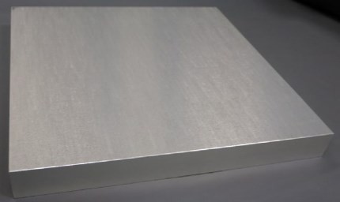
Equipment/Materials
Low Contrast Resolution Tool Aluminum blocks (2)

Procedure
- Position the c-arm with the image intensifier on the bottom.

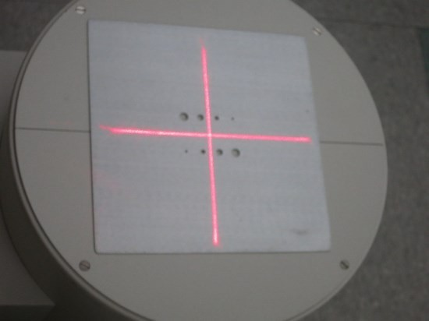
- Center the test tool on the image intensifier and collimate appropriately to include the entire tool.

- Using 100 kVp, expose for 2 seconds and determine the number of holes that can be clearly visualized. Record the results.

- Add one block onto the tool, and repeat the exposure. Record the results.

- Add the second block on top of the first, and expose. Record the results.

- Repeat steps 3-5 for all settings indicated in the data table.

 | # Al Blocks | Magnification Setting
 | # Al Blocks | Regular | Mag 1 | Mag 2
# of holes visualized | 0
# of holes visualized | 1
# of holes visualized | 2




Example:
Low Contrast Resolution

0 Al Blocks 1 Al Block 2 Al Blocks

Evaluation and Acceptance Criterion
The SC 35 states to follow the manufacturer’s recommended test procedures for resolution. For each mode of operation, resolution must be within established limits. As per the manufacturer, the acceptance criterion for this test is to clearly visualize a minimum of the two largest holes (7mm and 5mm) with 2 Al blocks.

Conclusion

PASS

Testing Frequency

FAIL

This is tested annually or when any modifications have been made according to the SC35.

Test: Fluoroscopic High Contrast (Spatial) Resolution

Reference
Papp, 6th ed. p. 157

Purpose
To determine that the high contrast resolution is within acceptable limits as visualized on the monitor.

High contrast resolution, also known as spatial resolution, is the ability to resolve small, thin areas with a large difference in radiolucency.

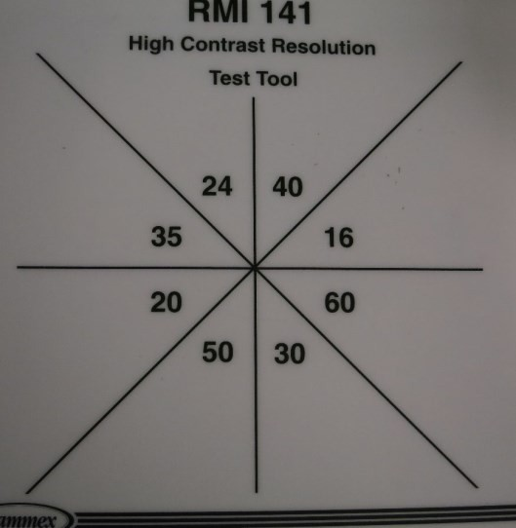
*This test is subjective and results may vary, but should be very similar if performed by more than one individual.

Equipment/Materials
High Resolution Contrast Tool

Procedure
- Position the c-arm with the image intensifier on the bottom.

- Center the test tool on the image intensifier and collimate appropriately to include the entire tool.

- Using 100 kVp, expose for 2 seconds and determine the highest numbered section that the lines can be visualized. Record the results.

- Add one block onto the tool, and repeat the exposure. Record the results.

- Add the second block on top of the first, and expose. Record the results.

- Repeat steps 3-5 for all settings indicated in the data table.

 |  | Magnification Setting
 |  | Regular |  |  | Mag 1 |  |  | Mag 2
 | # of Al blocks | 0 | 1 | 2 | 0 | 1 | 2 | 0 | 1 | 2
Holes/inch Visualized | Regular
Holes/inch Visualized | Low Dose

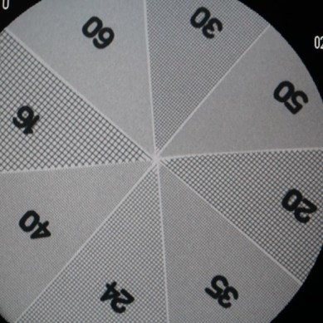
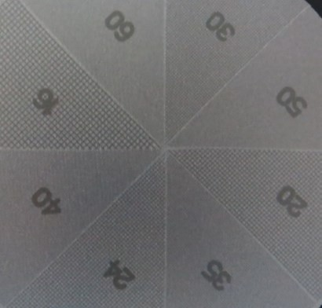
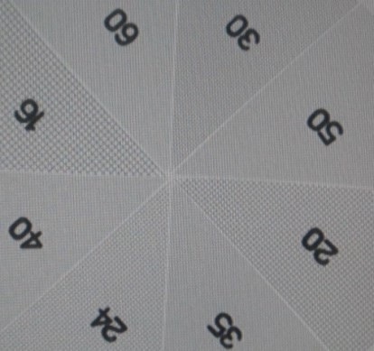
Example
High Contrast Resolution

0 Al Block 1 Al Block 2 Al Blocks Evaluation and Acceptance Criterion
The SC 35 states that the manufacturer’s recommended specifications must be followed. For each mode of operation, spatial resolution must be within established limits. For our purposes, the acceptable limits for an input screen of 23cm, the minimum mesh visualization is 20 at the edge and 20-24 in the center with 2 Al blocks. Visualization should increase as the magnification increases.

Conclusion

PASS

Testing Frequency
FAIL

This is tested annually or when any modifications have been made according to the SC35.

Test: Fluoroscopic Image Noise/Lag

Reference
Papp, 6th ed. pp. 158-159 SC35, p. 54 (Y22)

Purpose

To determine if the image lag and noise displayed on the monitor is within acceptable limits.

*This test is subjective and results may vary, but should be very similar if performed by more than one individual.

Equipment/Materials
Coin or Metal Washer

Procedure
- Position the c-arm over the table with the x-ray tube underneath.

- Place the coin/washer on the table, and center to the tube.

- Fluoro to locate the coin/washer on the monitor.

- While fluoro is activated, move the c-arm around and observe the ‘comet-like’ tail behind the coin/washer.

Evaluation
It is important to note that there is always some inherent lag in a system, but with vidicon cameras there may be slightly more lag as compared with CCD or plumbicon systems. Determine the system type before making any decisions regarding the image lag.

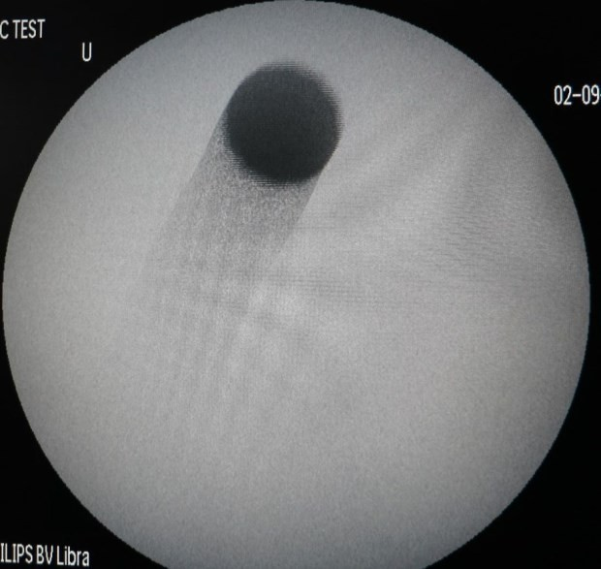
There is no hard data that can be collected for this test, acceptance is determined through the experience and impression of the observer.

Example

Acceptance Criterion
An accurate evaluation of lag is done by observing a rotating test tool as per SC35 p. 54. (Papp 5th ed. pp. 132-133)

Conclusion

PASS FAIL

Testing Frequency

This is tested annually or when any modifications have been made according to the SC3.

