Specialized Imaging 2 Final Exam Comprehensive Review
- Aortic arch labelling A, B, C, D, E, F and G. Check exam for answers.

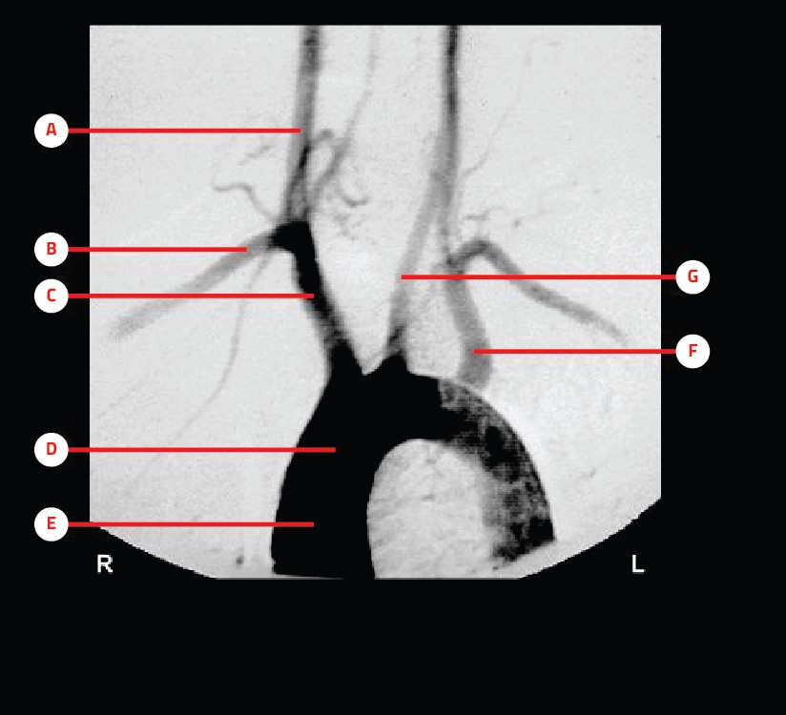

- The amount of contrast media typically administered for a thoracic angiogram is: 30mL – 50 mL
- Which position best demonstrates the aortic arch and its branches free of superimposition from other structures during thoracic angiography? 45-degree LAO
- Road mapping is: An image overlaid on a live fluoroscopic image
- Which vessel is preferred during a TIPS procedure to access the hepatic portal system? Right jugular vein
- The x-ray tube used for interventional radiologic procedures has a . Small tube target
- Which of the following projections demonstrates the axillary tissue of the breast and a portion of the pectoral muscle? Mediolateral oblique (MLO)
- Which of the following imaging modalities can best distinguish between a solid mass and a cyst in the breast? Sonography (ultrasound)
- Which of the following breast tissues is least dense? Adipose (fat)
- What is the primary objective of compressing the breast for mammography? To produce uniform breast thickness
- What projections are included in a screening mammographic examination? Bilateral CC and MLO
- The junction between the inferior aspect of the breast and the anterior chest wall is termed the: inframammary fold
- For the craniocaudal projection of the breast, the IR holder should be raised to the upper limits of the : inframammary fold
- What are the preferred DXA sites for evaluating bone density? The proximal femur and lumbar spine
- A patient's T-score given in a bone density report: compares the patient's BMD with that of a young, healthy person of the same gender
- A patient's Z-score given in the bone density report: compares the patient's BMD with that as an average individual of the same gender and age
- L-Spine DXA scan should include the region of: T12 to iliac crest
- DXA of the hip should include the following: a true AP hip projection
- Estrogen replacement therapy is given primarily to: reduce bone loss
- Which of the following is NOT a possible risk factor for osteoporosis? Excessive body weight
- Newer dual energy x-ray absorptiometry (DXA) use: Fan beam x-ray source
- Which vertebral region(s) is analyzed during a DXA scan? L1 – L4
- Which member of the nuclear medicine team is responsible for calibration and maintenance of imaging equipment? Health physicist
- With modern MRI, the reemitted radio wave signals from the patient are captured by: Receiver or antenna
- Which of the following nuclei found in the body is most often used in MRI? Hydrogen
- Which type of ultrasound unit is used to examine the structure and behavior of flowing blood? Doppler
- Ultrasound images that demonstrate dynamic motion or changes within a structure are termed: Real-time imaging
- Sonography uses high frequency sound waves in the range of MHz Answer is 2-20 MHz
- Matching the frequency of a precessing nucleus with a radio wave frequency is termed Resonance
- PET uses radioactive compounds, which include oxygen and nitrogen, as well as: Carbon and fluorine
- Most PET tracers have a half life of: 120 seconds to 110 minutes
- In mammography units our target is made of? Molybdenum
- The kVp range used in digital mammography is: 25–35
- The standard (s) being used with dual energy x-ray absorptiometry to compare the patient's bone density measurements are: Z Score and T Score
- Patient positioning has the greatest impact on precision during a DXA scan.
- Technetium 99m has a physical half life of approximately: 6 hours
- PET brain mapping techniques are intended to: Identify key motor or sensory regions of the brain
- Which vessel is formed when the vertebral arteries join together at the base of the skull? Basilar artery
- Select the most likely angiographic procedure performed for each pathologic condition.(Use each choice only once). Check exam for answers
- Match each description with the correct interventional term. (Use each only once). Check exam for answers.
- Why is it not recommended to use AEC for mammography of a breast implant? The image will be overexposed.

