.3 Explain alternate identification systems.

The two main labelling systems in Workplace Hazardous Materials Information System (WHMIS) are the supplier and the workplace labels. However, there are circumstances where exceptions or alternate identification systems may replace a WHMIS label. In all cases, the worker must be trained to be able to identify the hazardous products and their alternate labelling used at the workplace.
Alternative identification may be a mark, warning sign, stamp, sticker, seal, ticket, tag, wrapper, symbol, placards or coding systems. It may be attached, imprinted, stencilled or embossed on the container or the hazardous product.
Other exceptions for supplier labels:

Bulk shipments
  - There is a labelling exemption for products sold without packaging (e.g. bulk oil) - exemption in section 5.5 of Hazard Products Regulations (HPR)

100 ml or less
  - Exempt only from having a precautionary or hazard statement on the label- exemption in section 5.4.(1) of HPR

3 ml or less
  - If the label interferes with normal use, then a label for transport and storage is required but may be removable during use. - exemption in section 5.4.(2) of HPR

Outer label
  - For hazardous products that are packaged in multi-containers, the outer container does not require a WHMIS label if:
    - The inner container is visible and legible through the outer container under normal conditions
    - If the outer container has a label in accordance to the Transportation of Dangerous Goods Regulations (TDG). - exemption in section 5.2 of HPR

In Transit Products
  - Hazardous products which are being transported through Canada, where the place of initial loading and the final destination are outside of Canada, are exempt from WHMIS labelling requirements. - exemption in section 5.14.(2) of HPR

In many situations, it is impractical to produce a complete WHMIS label and attached it to the container due to container size or lack of access. Instead of a workplace label, specific colour coding or marking may be used at the workplace. An example would be a process system containing piping, vessels, pumps, reactors or tanks as it would be very difficult to put labels on such equipment. An alternative system could be to identify the different hazardous materials with different colours or bands of colours. An example of pipeline marking is shown in Figure 4. Pipelines could be marked by painting them a solid colour or by putting different coloured tape on them at specific intervals.

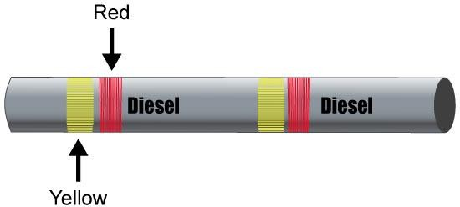

Figure 4: Example of Pipeline Marking

Process equipment could be identified with appropriate signs to warn workers that the equipment contains hazardous products.

Figure 5 is an example of identifying parts of a process system containing hazardous products. The raw materials on the left come with supplier labels on them if they are hazardous products.
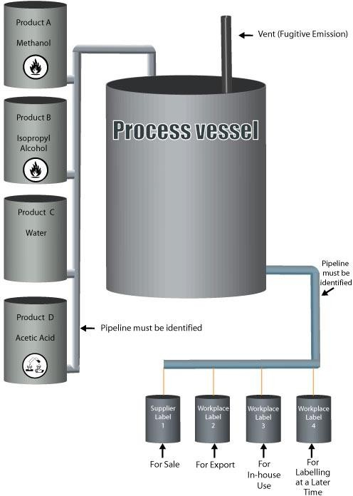
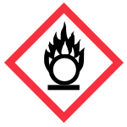


Figure 5: Example of Process System Marking

Identification of the process piping is normally achieved by using colour coding. The finished product containers above are labelled depending on their final destination.

Any marking system that has clear hazard communication to inform workers that hazardous products are present is acceptable for workplace identification. As long as the workers understand the code or signs, all requirements of WHMIS for worksite labels have been met.

