Match the Fracture Image with it’s Name

C | Boxer’s
W | Avulsion
K | Bennett’s
Y | Colles
X | Salter-Harris
V | Smith’s
L | Blowout
F | Greenstick
H | Galeazzi
D | Jones
J | LeFort
U | Monteggia
E | Spiral
M | Bimalleolar
N | Pathological
O | Supracondylar
T | Compression
P | Comminuted
S | Intertrochanteric
Q | Undisplaced
B | Clay shoveler’s
I | Depressed
R | Jefferson’s
G | Marcher’s
A | Impacted
A B
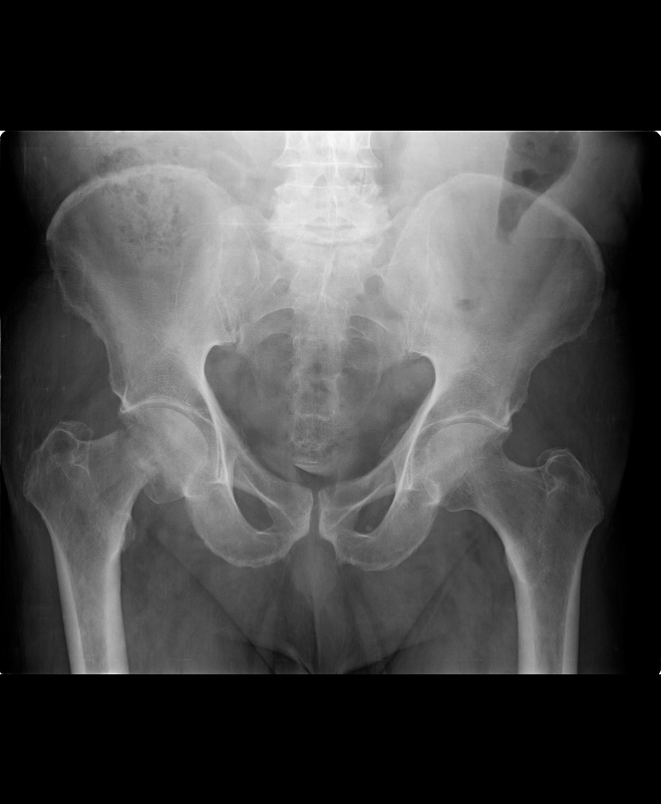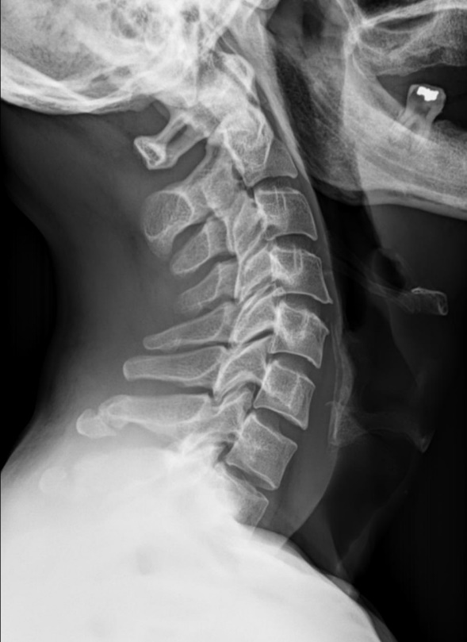

Case courtesy of Dr Ahmed Abdrabou, Radiopaedia.org, rID: 35629 Case courtesy of Dr Mohammad Taghi Niknejad, Radiopaedia.org, rID: 87218

C D
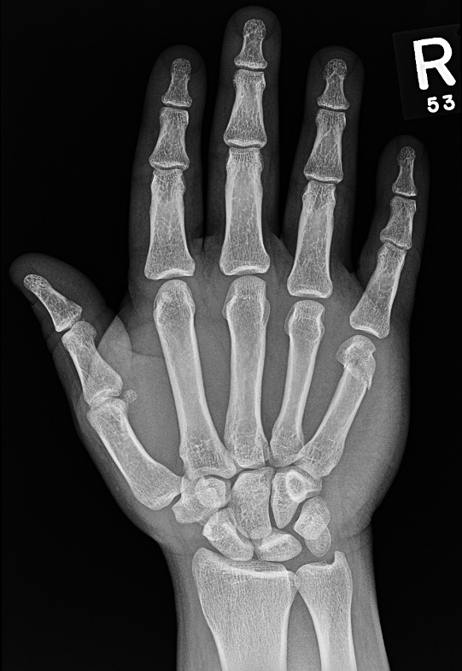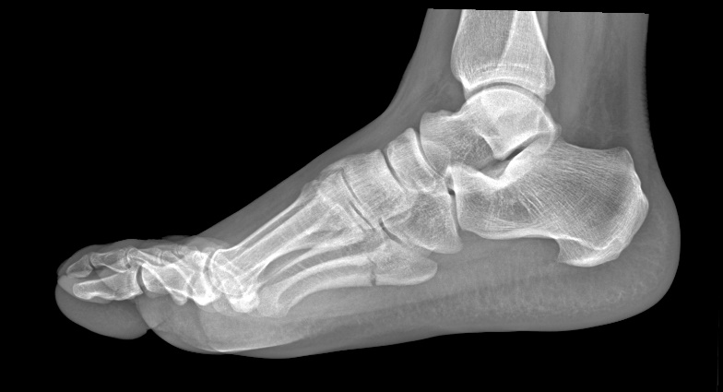
Case courtesy of Dr Hani Makky Al Salam, Radiopaedia.org, rID: 10390 Case courtesy of Dr Matt Skalski, Radiopaedia.org, rID: 35716

E F
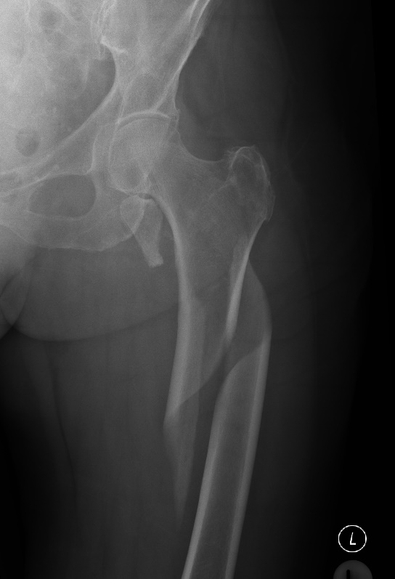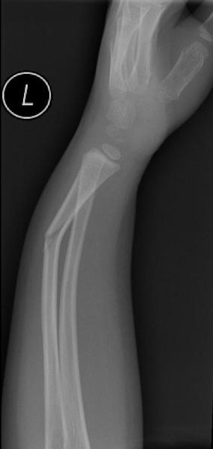
Case courtesy of Dr Andrew Dixon, Radiopaedia.org, rID: 25704 Case courtesy of Dr Sharifah Intan, Radiopaedia.org, rID: 31084

G H
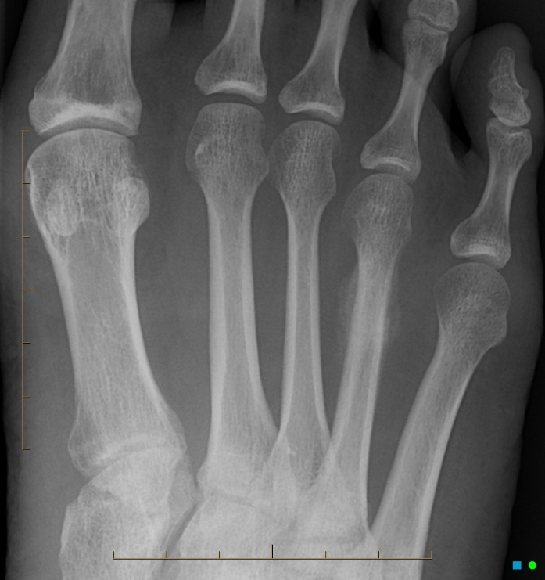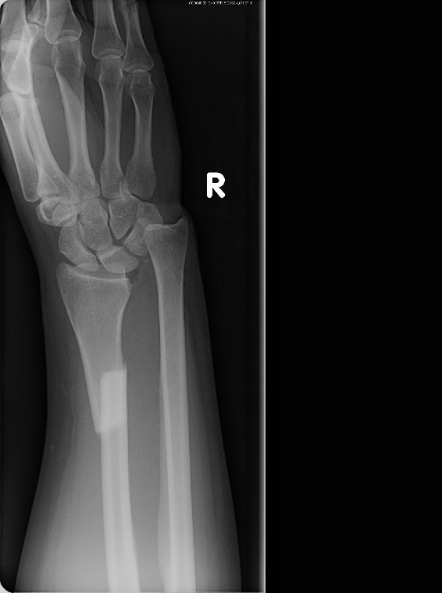
Case courtesy of Assoc Prof Frank Gaillard, Radiopaedia.org, rID: 2683 Case courtesy of Dr Alexandra Stanislavsky, Radiopaedia.org, rID: 10961

I J
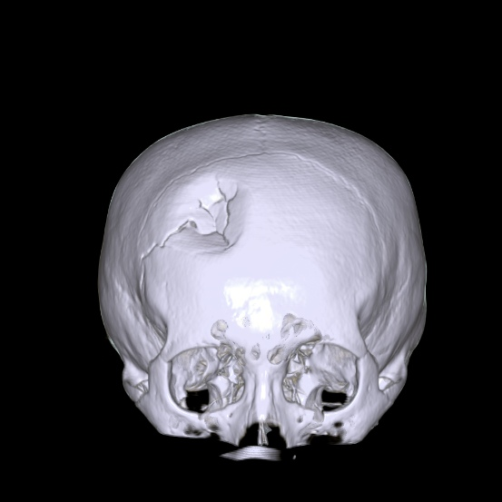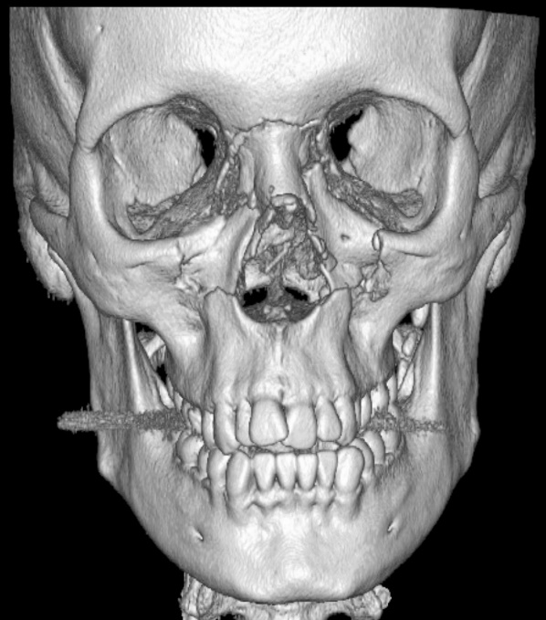
Case courtesy of Dr Ian Bickle, Radiopaedia.org, rID: 53944 Case courtesy of Assoc Prof Frank Gaillard, Radiopaedia.org, rID: 36011

K L
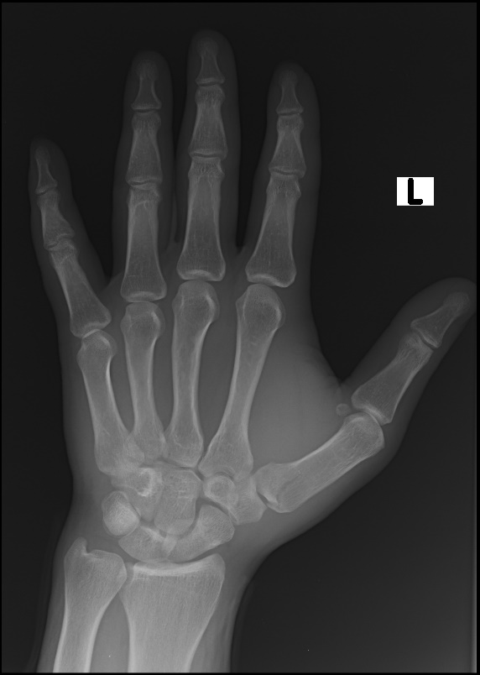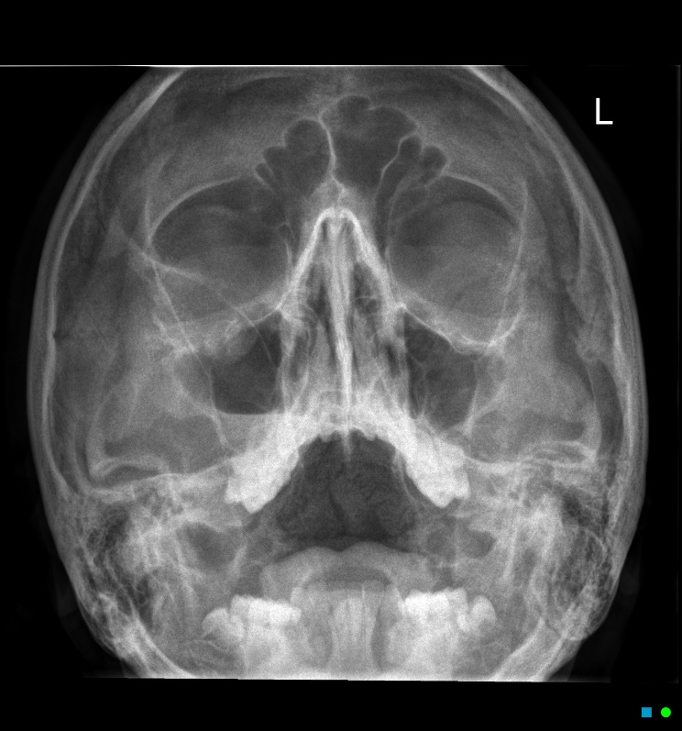
Case courtesy of Dr Abdulmajid Bawazeer, Radiopaedia.org, rID: 59116 Case courtesy of Dr Chris O'Donnell, Radiopaedia.org, rID: 19329

M N
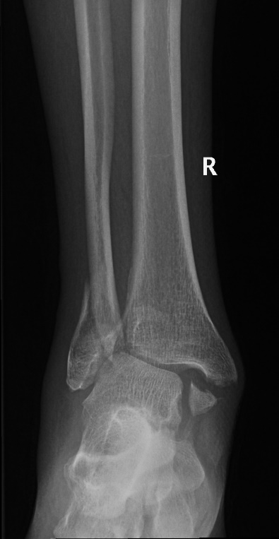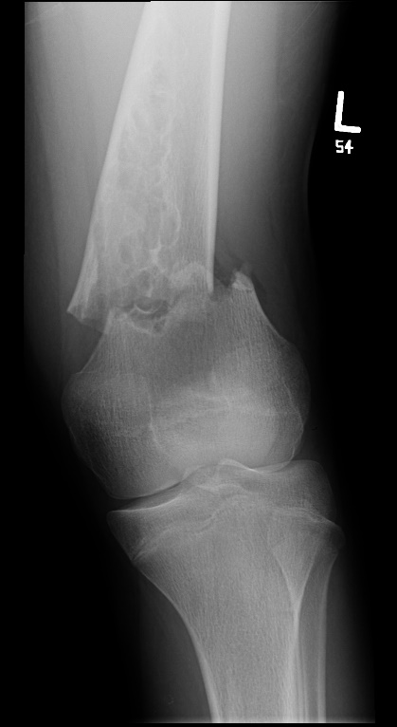
Case courtesy of Dr Hani Makky Al Salam, Radiopaedia.org, rID: 9135 Case courtesy of Dr Hani Makky Al Salam, Radiopaedia.org, rID: 8716

O P
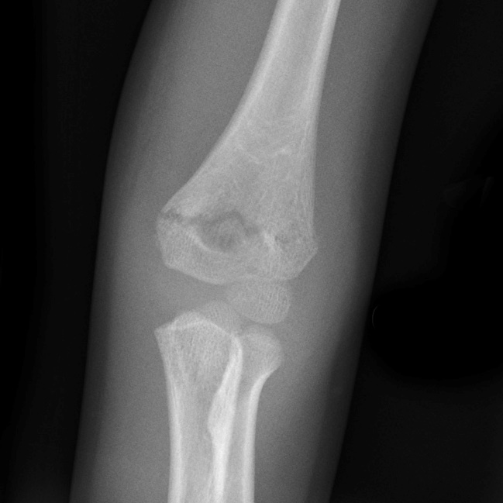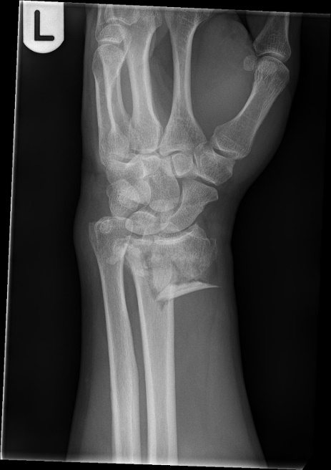
Case courtesy of Assoc Prof Frank Gaillard, Radiopaedia.org, rID: 10342 Case courtesy of Mr Dom LeGros, Radiopaedia.org, rID: 40171

Q R
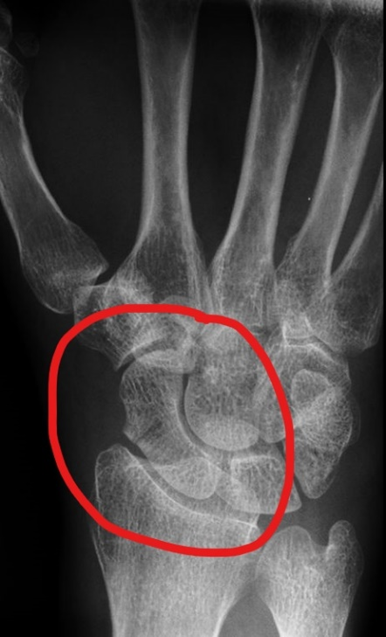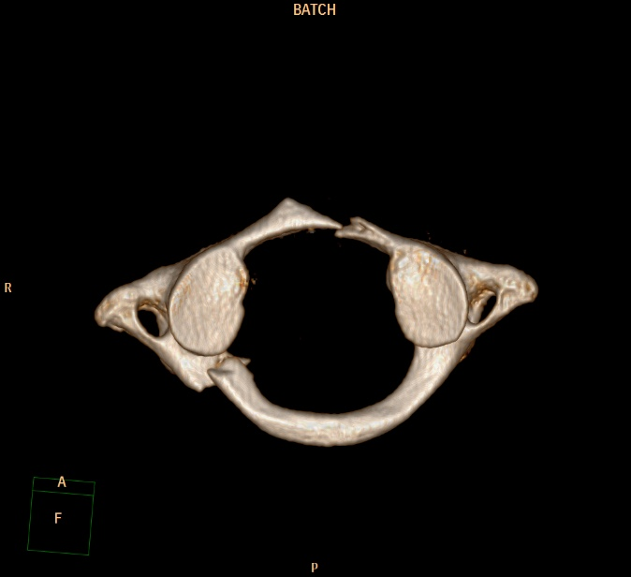
Case courtesy of Assoc Prof Frank Gaillard, Radiopaedia.org, rID: 7669 Case courtesy of David Puyó, Radiopaedia.org, rID: 59622

S T
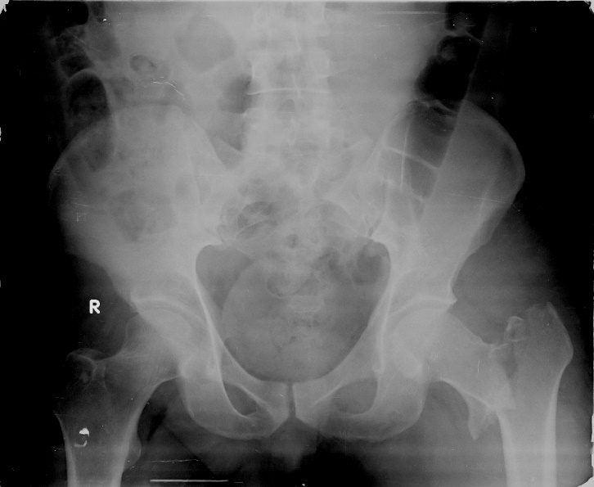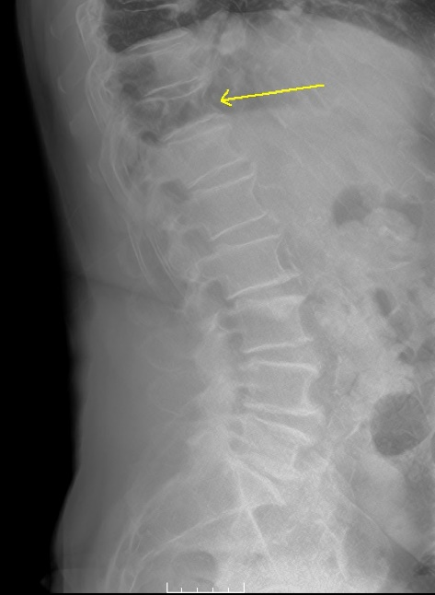
Case courtesy of Dr Pir Abdul Ahad Aziz Qureshi, Radiopaedia.org, rID: 47715 Case courtesy of Dr Adam Eid Ramsey, Radiopaedia.org, rID: 71323

U V
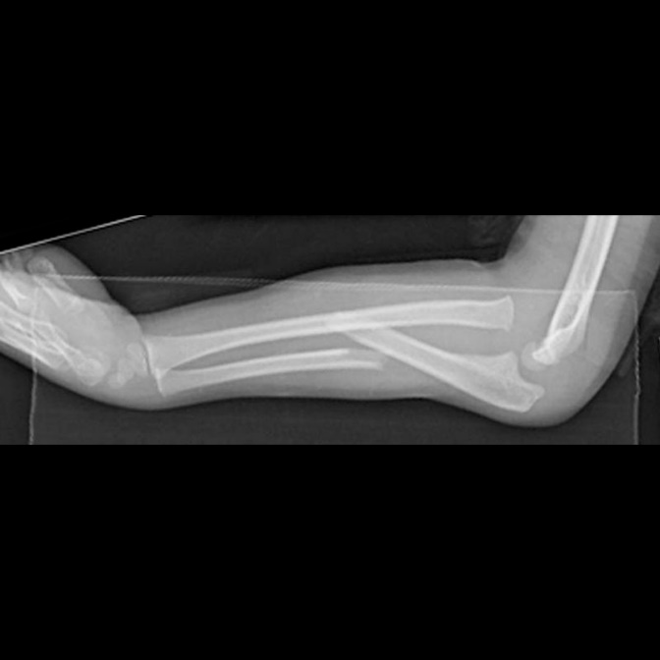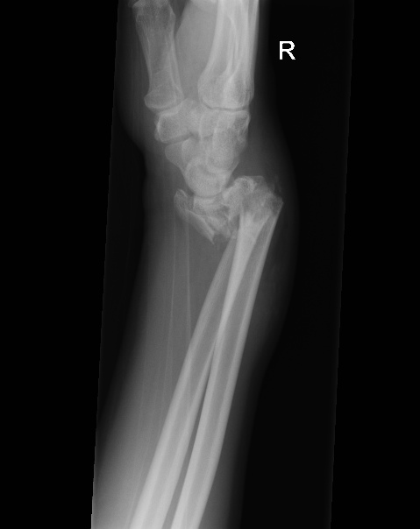
Case courtesy of Radswiki, Radiopaedia.org, rID: 12222 Case courtesy of Dr Jan Frank Gerstenmaier, Radiopaedia.org, rID: 25199

W X
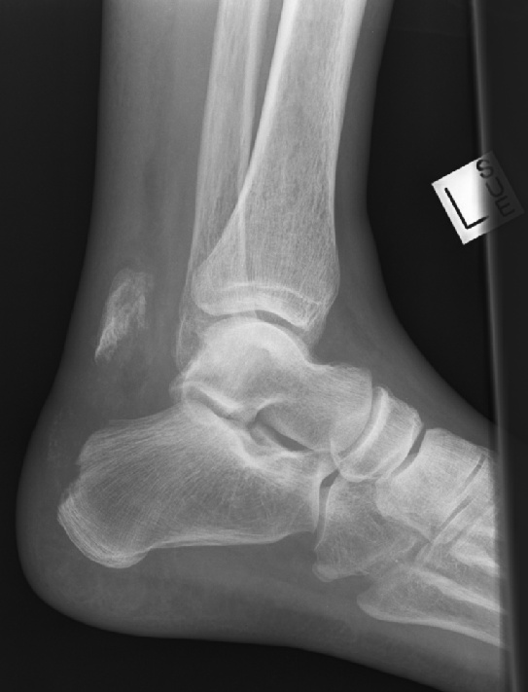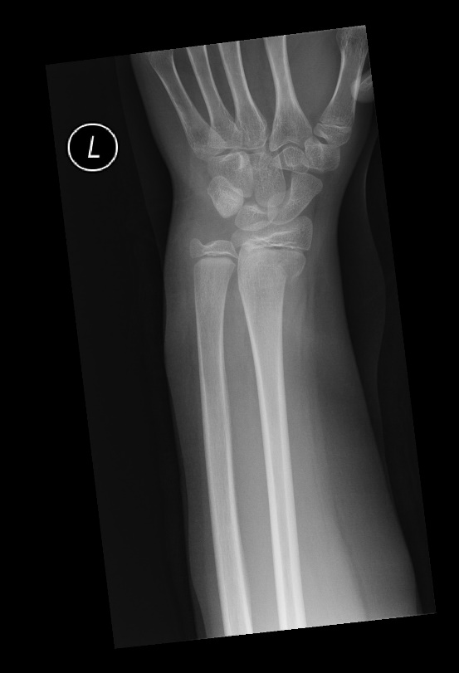
Case courtesy of Assoc Prof Frank Gaillard, Radiopaedia.org, rID: 35974 Case courtesy of Dr Lawrence Oh, Radiopaedia.org, rID: 24098

Y Z
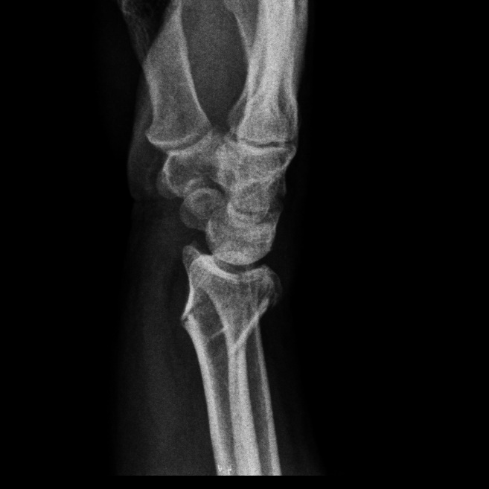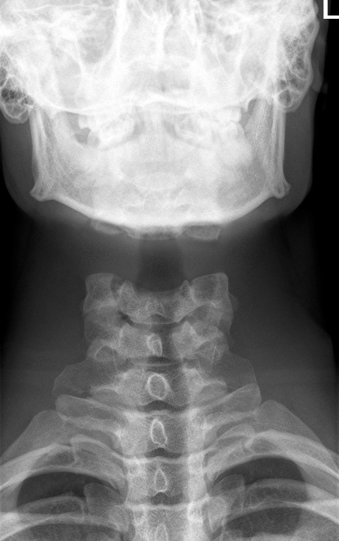
Case courtesy of Dr Benoudina Samir, Radiopaedia.org, rID: 22354 Case courtesy of Dr Matt Skalski, Radiopaedia.org, rID: 22417

