Label the blood supply to the brain (Bontrager CH 17):

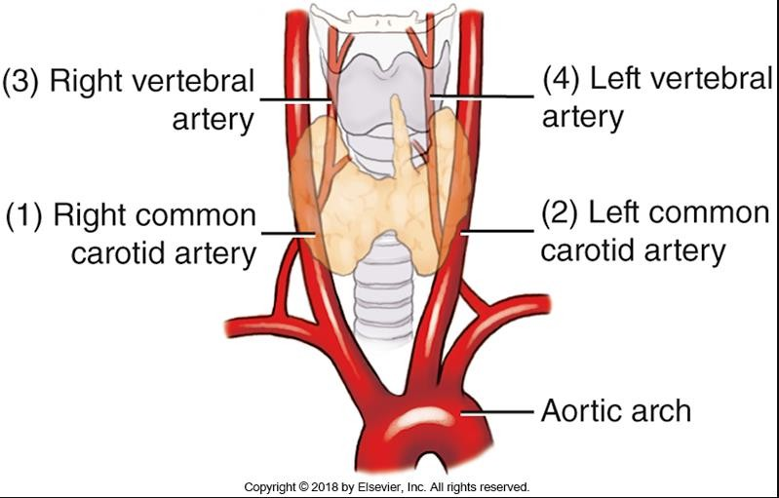

Label the arteries of the head and neck indicated
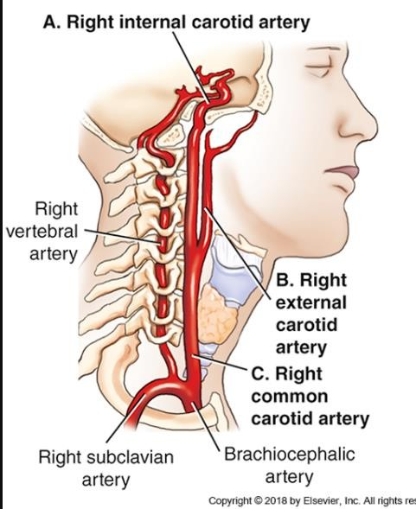

What is this an illustration of? Label the various arteries.
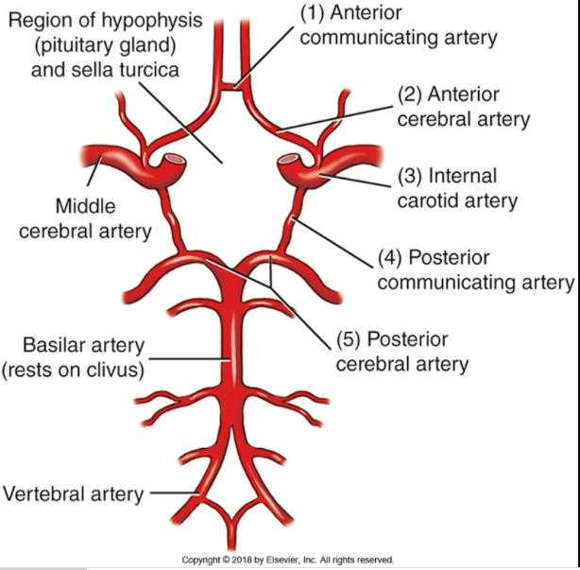

What type of angiogram is this? Abdominal Angiogram Label the correctly.

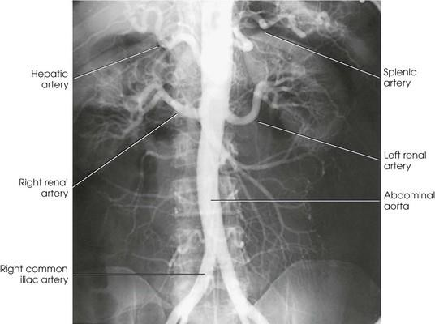

Label the arteries indicated by solid lines and identify the landmark at the level of the dotted line.
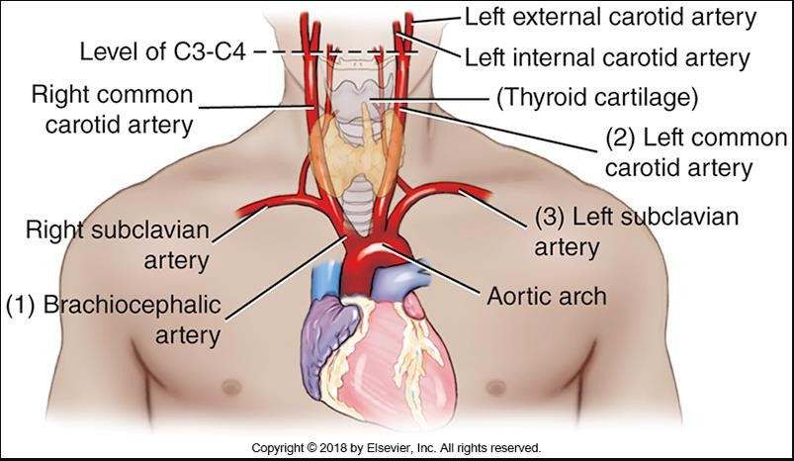

Identify the veins of the neck.
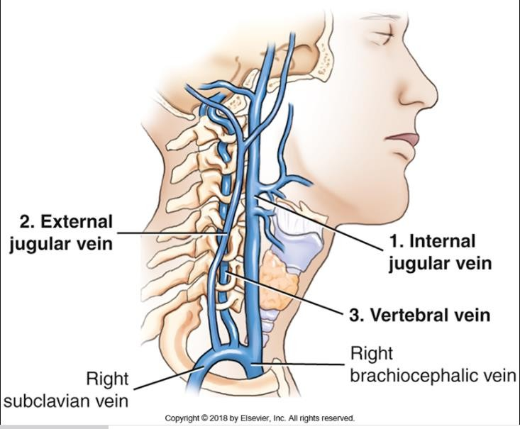

Label these parts of the thoracic aorta
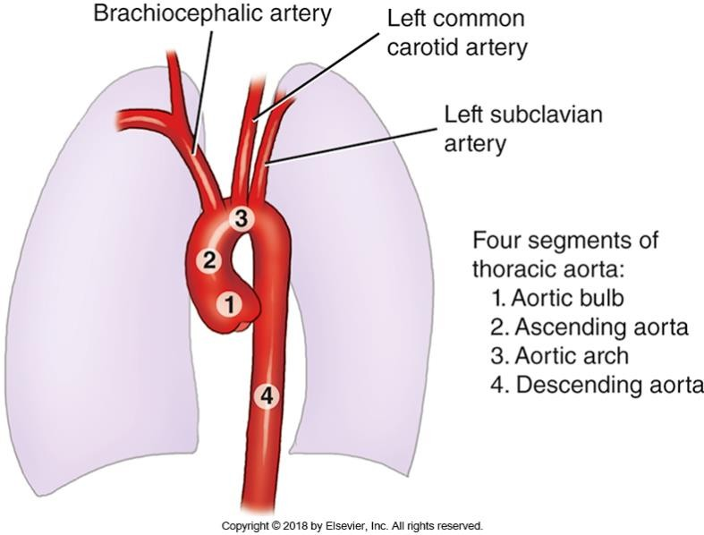

Label the following indicating correct side:
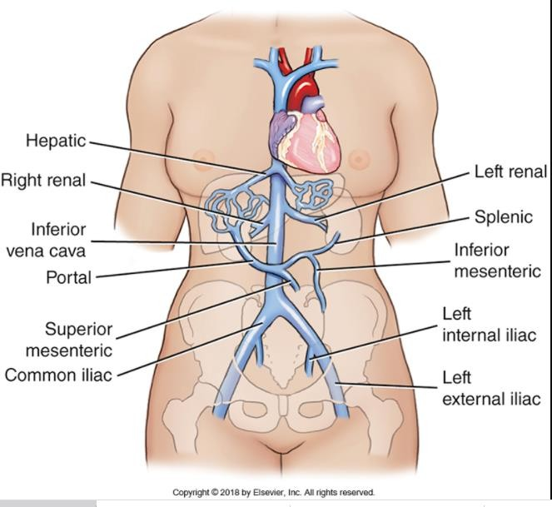

- What are the three main branches of the aorta?
ANSWER: Left subclavian, left common carotid, & brachiocephalic
- Which two vessels deliver blood to the heart muscle? ANSWER: Right and left coronary arteries

- The right common carotid artery bifurcates into internal and external arteries at what level? ANSWER: C4

- Which vessel is formed when the vertebral arteries join at the base of the skull? ANSWER: Basilar arteries

- Eventually the external jugular connects with the to form the brachiocephalic vein? ANSWER: Subclavian vein
- Where do the openings for the coronary arteries originate? ANSWER: Aortic bulb (root)

- What vein drains and receives blood form the intercostal, bronchial, esophageal and phrenic veins?
ANSWER: Azygos vein

- Which of the branches of the abdominal aorta is considered the most superior? ANSWER: Celiac artery

- Which two vessels unite to form the hepatic portal vein? ANSWER: Superior mesenteric and splenic veins

- On the right side of the body, the subclavian artery is a branch of which artery? ANSWER: Right brachiocephalic

- On the left side of the body the subclavian is a branch of which anatomical structure? ANSWER: Directly off the arch of the aorta
- Venous blood below the diaphragm is returned to the heart by the : ANSWER: Inferior Vena Cava

- The distal portion of the abdominal aorta will bifurcate into the: ANSWER: Common iliac arteries

- How long should food be withheld prior to angiography? ANSWER: 8 hours
- What vessels are typical puncture site for catheterization during angiography? ANSWER: Brachial artery, femoral artery, axillary artery

- Which is the preferred site for arterial puncture for most angiography? ANSWER: Femoral artery

- What are three contraindications for angiography?
ANSWER: Impaired renal function, taking anti coagulant medication, unstable cardiopulmonary status
- When imaging the aortic arch and thoracic aortography what is the most useful position to prevent superimposition?
ANSWER: Left Anterior Oblique

- Generally, where is the femoral artery punctured during an arterial catheterization procedure? ANSWER: Just inferior to the inguinal ligament
- If an interventionalist is performing a left common carotid angiogram and using the femoral artery as the access point, identify the arterial path that the catheter would travel to reach its destination?
Answer:Left common femoral artery, Left external iliac artery, left common iliac artery, abdominal aorta, thoracic aorta, left common carotid artery

21 Match each description with the correct interventional term

Dilation of stenosed vessel | Percutaneous intrahepatic angioplasty
Placement of cagelike metal device in the lumen of the  vessel | Stent placement
A procedure wherein a clot is disintegrated | Thrombolysis
A procedure to treat variceal bleeding cause by portal  hypertension- | TIPS
A procedure to restore and stabilize a compression fracture  within a vertebral fracture | Kyphoplasty
Cease blood flow to a site of pathology | Embolization
A procedure for patients at high risk of developing  pulmonary embolism | Inferior Vena Cava Filter

22. Select the most likely angiographic procedure performed for each pathologic condition.

Coronary artery disease | Angiocardiography
Evaluation of aorta pseudocoarctation | Thoracic angiography
Arteriovenous malformations | Cerebral angiography
Atherosclerosis disease lower limbs | Peripheral angiography
Pulmonary emboli | Pulmonary angiography
Stenosis/occlusion celiac or mesenteric arteries | Abdominal angiography

23.
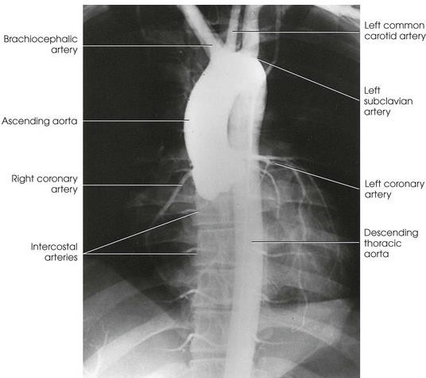

ANSWER: The patient is in a LPO position to best demonstrate the aortic arch

