Activity: Test 22 Fluoroscopic Image Lag Procedure

Purpose
This activity will help you identify the procedure steps for this test.

Instructions
- Review the images below of the equipment and materials used at Edenbrook for this test.
- Review the procedure steps from the Edenbrook MRT lab.
- Compare this procedure, the textbook reading and your practicum site QA manual for similarities and differences between a C-arm and dedicated fluoro unit.

Equipment
- Coin or metal washer

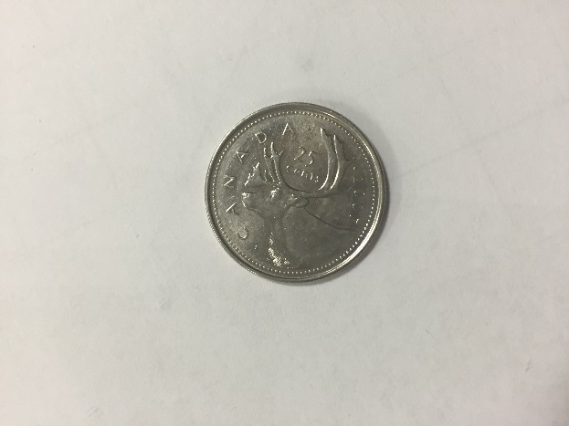

Edenbrook MRT Procedure Steps (Note: using C-arm at Edenbrook is limited by equipment)
- Position the C-arm with the X-ray tube on the bottom.

- Place a coin or washer on the table and centre it to the tube.

- Fluoro to locate the object on the monitor.

- While using continuous fluoro, move the C-arm around and observe the lag behind the coin or washer. It should have a comet tail-like appearance.

- This method is subjective and acceptance is determined through the experience and impression of the observer.

