ANPH 252 – Anatomy and Pathology 2
Activity - From Ingestion to Elimination
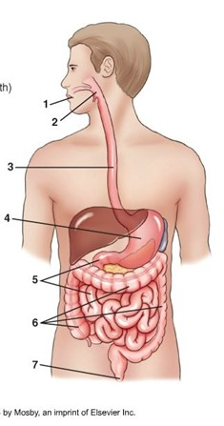
1.

2.

3.

4.

5.

6.

7.

