Accessory Equipment

Learning Outcome: Evaluate the performance of the accessory equipment according to Safety Code 3J requirements.
Objectives 4.1 -4.7

Testing Lead Apparel (Test 7’) — Papp 6" Edition pg 102, SC 3J pg 3J: Section 4.1
- Inspection of lead apparel is usua lly performed at the same time as the visual inspection
- This includes all types of equipment used: aprons, gloves, shielding, lead sheets
- This is important because this equipment protects patients and staff
  - If there is a large crack right through the middle of a lead apron, how will thatapron offer sufficient protection?
    - What if the lead equivalent in the apron is insufficient, will that affect anyone?
- There are two main methods of testing aprons, fluoroscopically and radiographically.
  - Cracks will appear:

Method:
- Black — radiographically
- White — fluoroscopically

  - First, confirm the presence of a permanent label (must include ID, lead
equivalency)
  - Lay the apron on the table
    - Collimate to the size of the IR
    - Label each image taken, using leaâ ma rkers
    - Ensure overlap for each image, including areas where the marker was
    - Expose until the entire apron has been imaged
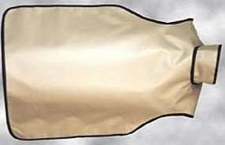

5 images would be required for this apron to be assessed properly (as shown above with colors)

1

This test is typically performed annually, but every 6 months is preferable
- Results must be included in QC test records

Typically results are recorded in a chart, with on area to note any comments
  - i.e. location/size of a defect, areas to be aware of, date of inspection, any corrective action/recommendations
  - If there is a defect, it is site specific protocol for what action to take
    - Commonly, if the defect is small and not located over a radiation sensitivearea when worn (i.e. bottom edge), it will stay in circulation with a note to check it more frequently
    - If the defect is large and located over radiation sensitive areas (pelvis), itis typically removed from use.
- Defective equipment must be removed from clinical use

Must be disposed of appropriately
  - Recycling is common, lead can be reused
- Common issues that may be encountered are:

Labels missing
  - Improper storage and care
    - Lead must be properly hung in order to prevent crocks

Need to confirm that the lead equivalency meets the criteria in the SC 35
    - Pg 3J Section 4.1 Protective Equipment

IP cleaning
- Screens that are dirly or dusty can result in creating image artifacts
- In cases where an artifact is suspected to be caused by a dirty cassette, the technologistshould open it and clean it
  - Screens are delicate and must be handled gently to avoid damage
  - This is why they are not cleaned and handled regularly — handle the IP asminimally as possible
  - Otherwise, only the exterior of cassettes is cleaned and disinfected on a regularbosis
- Procedure:
  - Use the tip of a pen to open the CR cassette lock release
  - Keep the block side of the cassette facing up, and carefully pull the IP oursidewoys
  - Do not touch the white surface with fingers, and keep it facing up
  - Using a manufacturer approved cleaning wipe or cleaner, gently wipe the plate inone direction only. Avoid excessive rubbing and pressure. Do not use a back and forth motion as debris can be dragged back onto the surface.
  - Allow it to air dry completely before use
  - Place IP back inside of the cassette, and reset the lock.

2

Automatic Exposure Control — Density Control, Uniformity/Field Balance, Reproducibility,Sensitivity
Popp 6*‘ Edition pg 118-121, SC 35 pg 53 (Y7), pg 78 (24.1-3) Automatic Exposure Control - review

When on appropriate quantity of radiation is received, the exposure will be terminated
  - AEC controls the exposure time

Main advantage: helps to ensure that the appropriate amount of radiation is used toachieve acceptable image quality
  - Especially useful for varying thickness of anatomy, pathology, patient conditions

When should AEC be avoided?
  - Anatomy that is smaller than the cell, difficult patients, prosthetics
- Testing is done on acceptance, annually, whenever service to the AEC is performed andwhenever there is an indication that the AEC is malfunctioning.

AEC Reproducibilify (Test 8)
- Purpose of this test: to ensure that the exposure is being terminated at the appropriatetime after a predetermined quantity of radiation has been detected, thereby producing the same output from exposure to exposure when the same kVp and mA are used.
  - If it is not, images will be consistently over/under exposed
  - Ensures the same radiation output is being produced when exposures with thesame kVp, mAs and part thickness ore taken
    - Remember: AEC controls time
- Refer to the QUAL 370 Procedures manual for the equipment and sample procedure toperform this test and analyse results.
- Use the following sample data results to perform the calculations. Formulas andcalculation
sheets ore provided in the QUAL 370 Procedures manual.

AEC Reproducibility
 | AEC Cell: Center | kVp: 80 | SID (cm): 110

Exposure | mA | Time (ms) | Exposure (mRj
1 | 100 | 12.54 | 12.39
2 | 100 | 12.55 | 12.42
3 | 100 | 12.56 | 12.4Z
4 | 100 | 12.54 | 12.41
5 | 100 | 1 2.J4 | 12.42
6 | 100 | 1 2.JJ | 12.39

3

" "this gaidedco/cu/ation is for the exposure time. P/eose comp/ete co/cu/otions for the tu// dota set.
% Variation = (mRmax – mRmin) x 100
(mRmax + mRmin)

% Variation = ( 1 2.56 ms — 1 2.54 ms) x 100
(12.56 ms + 12.id ms)

= 0.0797'% variance in exposure time

Compare the results to the standard in SC 3J pg 53
- The SC 3J recommends that the variance does not exceed 20%

Acceptance criterion ore user defined and site specific, the SC 3J recommends manufacturerspecifications should be used.

Based on resu/ts, exposure time for center ce// -‘ PASS

Please ensure all calculations ore completed in full for the remaining mA settings. Check youronswers for accuracy.

% v'orionce for mP ——0. 3££fifi

AEC Uniformity/Field Balance (Test 9)
- Purpose of this test: To confirm that the exposure is being terminated at the proper timeafter a predetermined quantity of radiation has been detected, thereby producing the some output from exposure to exposure when the same kVp and mA are used, regardless of the combination of AEC cell(s) selected.
- The ideal result is minimal variance between exposure times when using different combinations of AEC cells and all other factors staying constant
- Acceptance criteria is manufacturer specific.
- Refer to the QUAL 3Z0 Procedures manual for the equipment and sample procedure toperform this test and analyse results.
- Use the following sample data results to perform the calculations. Formulas andcalculation sheets are provided in the QUAL 370 Procedures manual.

AEC Field Balance
 | mA: 100 | kVp: Z0 | SID (cm): 110

Cell | Time (ms) | Exposure  (mR) | % Diff  (w ) | % Diff  (mR) |       Poss | Foil
Center | 23.10 1Z.1J
Left | 26.04 | 19.26
Right | 25.6 1 | 18.84
Center + Left | 24.J6 | 18.07
Center + Right | 24.09 1Z.87
Left + Right | 25.58 | 19.10
All | 24.J8 | 18.24
Mean

*This guíded ca/rt//al/es is /or the exposure time. P/eose ensure a// ca/cu/otíons /or the /u// data set arecomp/eted.

Mean time: Add oli the time values, then divide by Z. Mean = 2d.Z9 ms

% Difference = (Meosured) — (Meon) x 100
(Meon)

% Difference = (23.10 ms — 2d.Z9 ms) x 100
24.Z9 ms
% Difference = -6.8 17’% for the center cell exposure time
Acceptance criterion ore user defined and site specific, the SC 3J recommends manufacturerspecifications

should be used. The AHS standard for acceptance is < 20% variance.

Please ensure all calculations ore completed in full for the remaining mA settings. Check youronswers for accuracy.

Mean mR = 18.3ó mR
Cell |  | % Diff (ms) |  | % Diff (mR)
Center |  | -d.d/Z |  | -d.úí90
Left | | | z.o 2 |  | x.eo2
Right |  | 3.308 |  | 2.6 II
Center + Left |  | -o.eza | | | - Lzao
Center + Right |  | -J.6J4 |  | -£.669
Left + Right |  | 3. I8X |  | 4.03 I
Ali |  | -0.84X |  | -0.óúí4

% Difference = ( -2 Setting) – (-1 Setting) x 100
(-1 Setting)

% = ( S800) – (S400) x 100
(S400)
% = ( S200) – (S400) x 100
(S400)

mR
5200 and 5400 ——120. U3A
5800 and 5400 ——-43.098%

Positive Beam Limitation (Test 12) Popp 6'^{h} Ed. Pg 113, SC 35 pg. 53: Y9(b), pg. 75: 12. (1)
- A system in the x-ray unit that detects IR size and adjusts collimation to match
- There are sensors inside the cassette holder (Bucky) to detect the IR size
- So why is this important?
  - Helps to prevent the radiation field from being larger than the IR
  - Decreases unnecessary dose — what is the purpose of having a large field size ifthe IR cannot capture the entire radiation field?
- Two tests performed
  - Test the amount of time for the field size ad|Ustmentto be made
  - Test the accuracy of the field size and the corresponding IR that was inserted
- Use a timer to determine how long it takes for the field size to adiustafter IR insertion
  - SC 35 states that adjustment should occur within 5 seconds
- To test the accuracy of the size detection
  - Place an 18 x 2d cm cassette into the Bucky and visually confirm that the lightfield has been ad|usted by the PBL.
  - Center a 2d x 30 cm cassette in the light field on the table top, do not adiust collimation.
  - Expose and evaluate the image on the 24 x 30 cm IR — remember to account for magnification from the OID
  - Repeat with all common IR sizes
- Purpose of this test: to confirm thot the PBL quickly and accurately od|usts to theappropriote field size required
- Testing is done on acceptance, semi-annually, before/after any work is done on x-roytube,

collimator or bulb
- Troubleshooting Considerations
- Mechanism that detects the IR size can malfunction with age and wear
- Shutters may malfunction
  - Should have an override switch

- Refer to the QUAL 3Z0 Procedures manual for a more detailed sample procedure ondadditional
information.
- * * Note: Acceptance criteria is different from the collimation light field test in the SC 3J:
  - The dimensions of the x-ray field do not exceed those of the IR by more than 3%of the SID
  - The sum of the width and length of the radiation field shall not exceed the sum ofthe length and width of the IR by more than 4%.
  - The PBL will automatically ad|Ust the dimensions of the radiation field within Sseconds of the IR being inserted into the cassette holder.

Collimator light field congruence and Perpendiculorify (Test 13) Popp 6'^{h} Ed. pg 113-116, SC 35 pg 25, pg 53 Y8, pg 75: 12(2)
- Collimation plays a significant role in patient dose and image qualify
  - M•i r factor in decreasing scoher and skin exposure
- If the light field is inaccurate, it is impossible to tell where the radiation field is
  - This con result in unnecessary anatomy being exposed, or repeat exposures dueto clipped anatomy
  - In short, it is important that the light field accurately represents the area that willbe exposed
to radiation
- What if the beam is not perpendicular?
  - Con result in shape distortion of image, or masking of potential pathologies
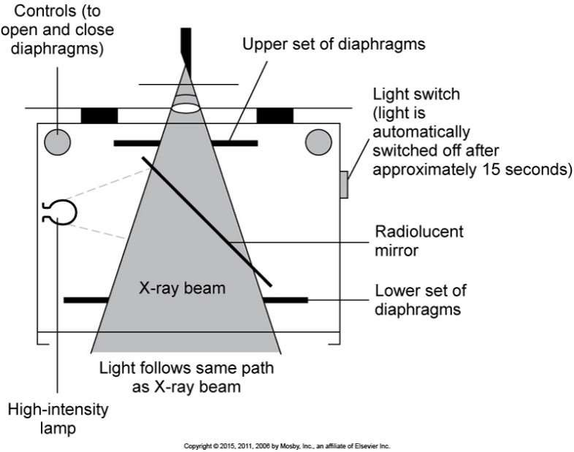
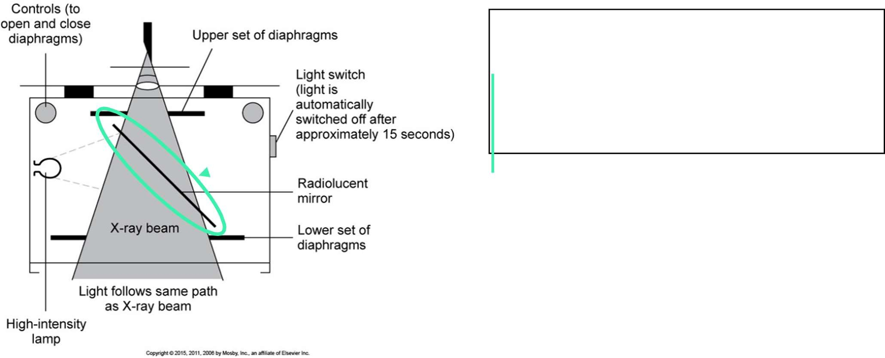
If the x-ray tube is bumped or handled roughly, the mirror thot directs the light downward can become misaligned. Thiscan cause the light field to misrepresent the
radiation field

- Purpose of this test: To confirm congruency of the light and x-ray field and to ensure thatthe central ray is perpendicular to the IR.
- Possible reasons that the collimotion test may foil ore: if the mirror has shifted or amalfunction with the collimator shutters
- Perpendicularify may fail if the tube has had a ma|or collision or impact, disruption to thestability of the tube inside the housing caused by rough handling.
- Testing is done on acceptance, annually, after any service. Test can also be done if thereis any reason to suspect misalignment.
- Two pieces of equipment are used: the collimator alignment template (metal plate), andthe beam alignment test tool (plexigloss cylinder)
- One image is taken with both test tools
- Refer to the QUAL 3 7'0 Procedures manual for the equipment and sample procedure toperform this test and analyse results.
- Use the following sample data results to perform the calculations. Formulas andcalculation

sheets are provided in the QUAL 370 Procedures manual.

Sample Image
X


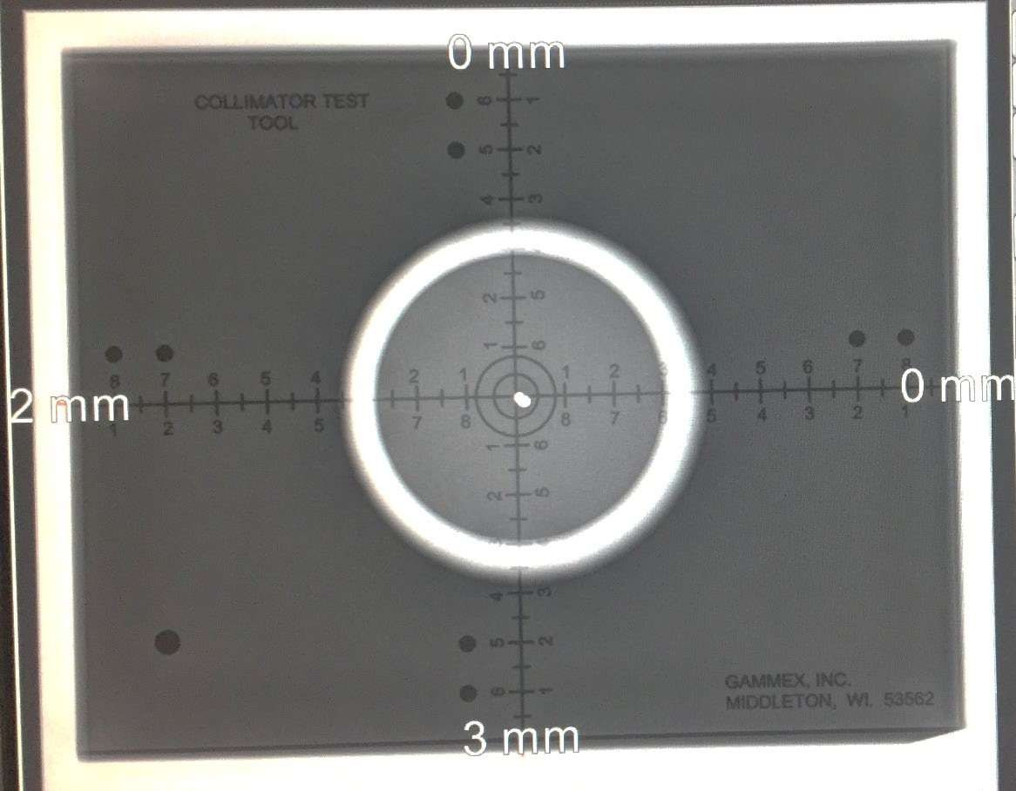
A
Y
B

*Meosurements are taken between the actuo/ exposure ñ‘e/d/ro//imn/ion fe/dJ and the solidtemp/ote line,measure a// Your sides, use positive zoiaes.

Please ensure /amiliarity with all ca/cu/ations ondmethodo/ogy /orthis test.

Evaluation A

Calculate 2% of SID

(To convert into mm, multiply by 10). 2.2cm x 10 ——22mm
This means S2mm is the maximum omount olmisalignment ollow'ed.

A + B =
2 + 0 = 2 mm

X + Y =
0 + 3 = 3 mm

Total = 5 mm

Compare the results to the standard in the SC 3J p.2J
- The measured misalignment of the visually defined field and the x-ray field alongthe length
or width of the x-ray field shall not exceed 2% of the SID.

Based on results, hmm is within 2% offhe SID ——PASS

Evaluation B
Compare the sample image to the chart below and record which alignment appears most similorto the results.
|
-0.5° | -1.5° |  | -3°
Result: |  | -0.5°

Compare the results to the standard in the SC 35 p.75
- The x-roy beam axis should be within 3° of the perpendicular to the imagereceptor

plane.
- Using this test tool, the upper bead must be within the outer circle to pass.

Based on resu/fs, < -- PASS

Half Value Layer (Test 14) Popp 6'^{h} Ed. Pg 105-106, SC 35 pg 24:

- Filtration review:
  - Filtration eliminates low energy x-rays from the x-ray beam
    - Results in ’hardening’ the beam, as the average energy of the beam isincreased after removal of the low energy x-rays
  - Decreases the patient's skin dose significantly — by 80-90% with proper filtration
  - Total filtration is the combination of inherent and added filtration
  - HVL is the best method to determine if filtration of the beam is sufficient
  - HVL
    - The amount of filtration required thot will reduce the intensity of theprimary beam to half of its original value
    - Does NOT measure the amount of filtration in the tube, it is only used todetermine that the beam has sufficient filtration
  - As HVL increases, so does the energy of the primary beam — higher energyphotons = less pt dose
  - * * * HVL is NOT the amount of aluminum filtration in the tube, it is the amount ofaluminum that decreases the intensity of the beam by half* * *
  - So why is this test important?
    - If the beam does not love sufficient filtration, low energy photons willincrease the patient's dose

  - Purpose of this test: to confirm that the permanent filtration is maintained at anappropriate
level to minimize the exposure to the patient.
- Testing is done on acceptance, annually, when tube is replaced, collimator removed, orany

changes to added filtration.

- Refer to the QUAL 370 Procedures manual for the equipment and sample procedure toperform this test and analyse results.
- Use the following sample data results to perform the calculations. Formulas andcalculation sheets are provided in the QUAL 370 Procedures manual.
mAs: JO
kVp: 80
Holt Volue foyer

mm AI | mR
0 298.1
0.5 2J8.4
1 | 23J.3
2 190
3 157.1
4 | 134.3

This graph is a sample illustration to demonstrate how to use the graph. Use the data table results to plot your graph to
determine HVL with the data set.

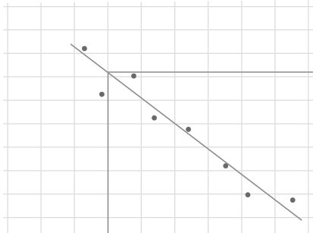
Step 1: Plot the results on the graph. Label y axiswith
Exposure (mR)
30 60 90 120 150 180 210 240 270 300
appropriate increments.
Step 2: Draw a best fit line. Doesn't have to intersect all the points, make a straight line following trend of data points
Step 3: Calculate 50% of the exposure withno filtration, draw a horizontal line at that exposure value.
Step 4: At the point that the line intersectswith the best fit line, draw a vertical line downwards to determine the amount of filtration used to Valve the radiation.
In this example, HVL = 1.J mm AI

Compare the results to the standard in the SC 3J p.24 Table 8

0 0.5 1.5 2 2.5 3 3.5 4
Filtration (mm Al)

” ”this table needs to be memorized for each of the kV settings””
- At 80 kVp, the minimum HVL must be 2.9 mm AI

Based on results from c/o/o Table (nof fhe samp/e proph)HV'l ——
3.25 mm AT -- PASS

Note.- tithe «ofue you home gotten from your praph is drostica//y diFerent, re-assess how you’«e draw'n thebest ñ‘t line.

Example Question:
Which beam is more penetrating?
Beam A: HVL= 3.5 mm AI Beam B: HVL = 2.5 mm AI
Answer: Beam A - stronger beams mi//require more o/aminam in order to ha/ftheir intensity Physicists determi“ne the amount oLHV’l required to indiCote suNci“ent hordeningofthe beom to prove there is adequate tota/ ñ“/tration present

