Name:

CT Imaging of the Head Review Activity

Activity - Part 1 – ANATOMY

- Match the definition or description with the correct term or structure.

Cerebral Aqueduct

Corpus Callosum

Dura Mater

Falx Cerebri
Middle Cerebral Artery

Perpendicular plate of ethmoid

Pons

Posterior Cerebral Artery

Sigmoid Sinus
Thalamus

Vertebral artery

- Ascends in transverse foramen
- Part of the nasal septum
- Drains into the internal jugular vein
- Branch of the basilar artery
- Branch of the internal carotid artery
- Passes through the midbrain
- Part of the white matter of the brain
- Outermost layer of the meninges
- Middle region of the brainstem
- Part of the diencephalon
- Located between the cerebral hemispheres

- Label the image below:
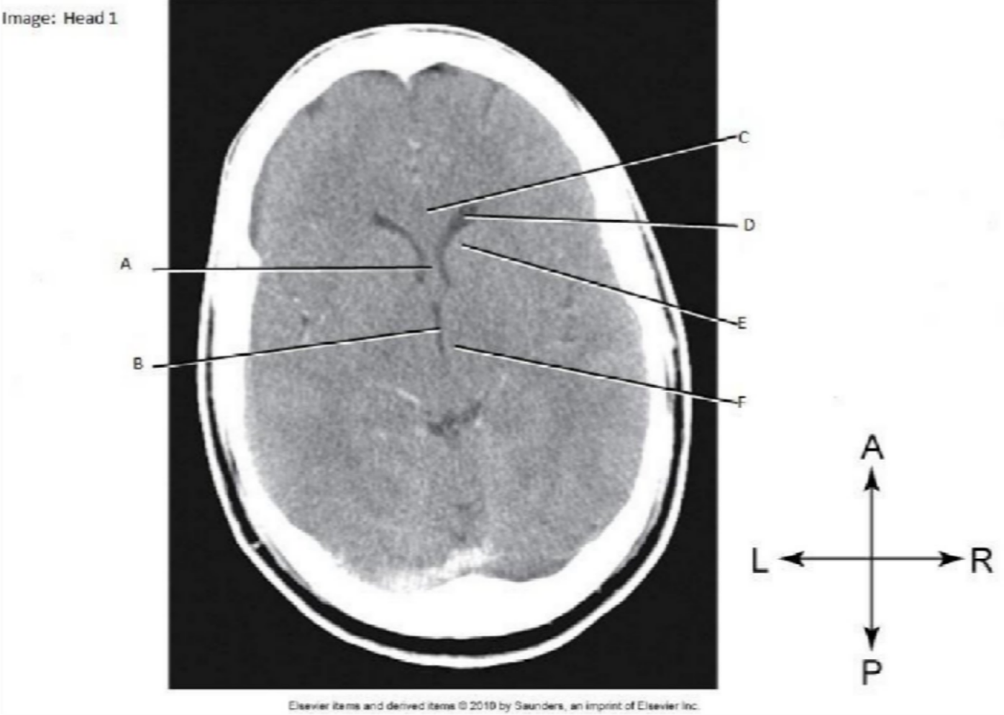

  - Septum pellucidum B.
C.
D.
E. Head of caudate nucleus F.

CTTheory
©EdenbrookColleg

- Label the image below:
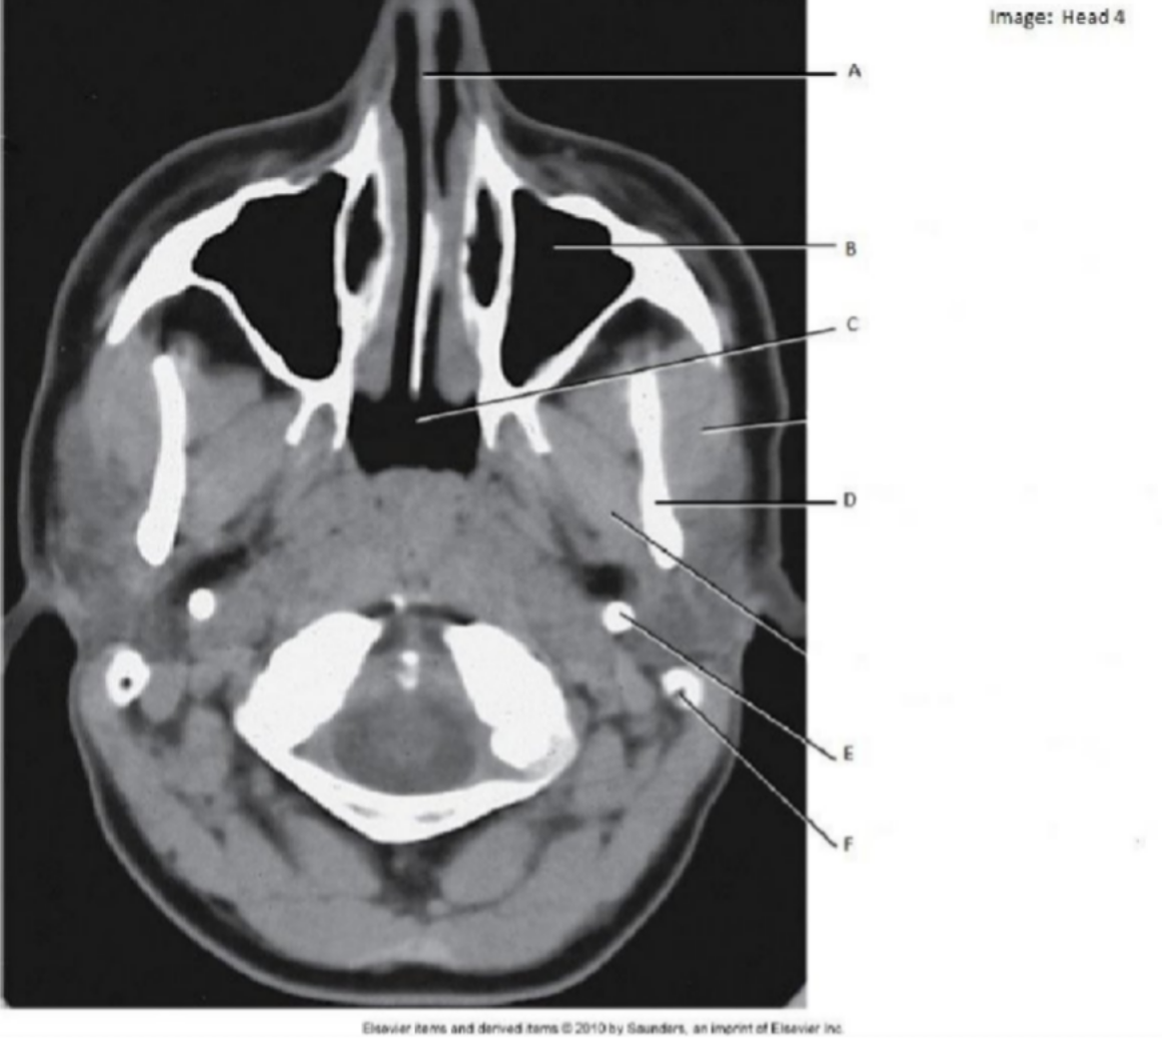

A.
B.
C.
D.
E.
F.

- Label the image below:
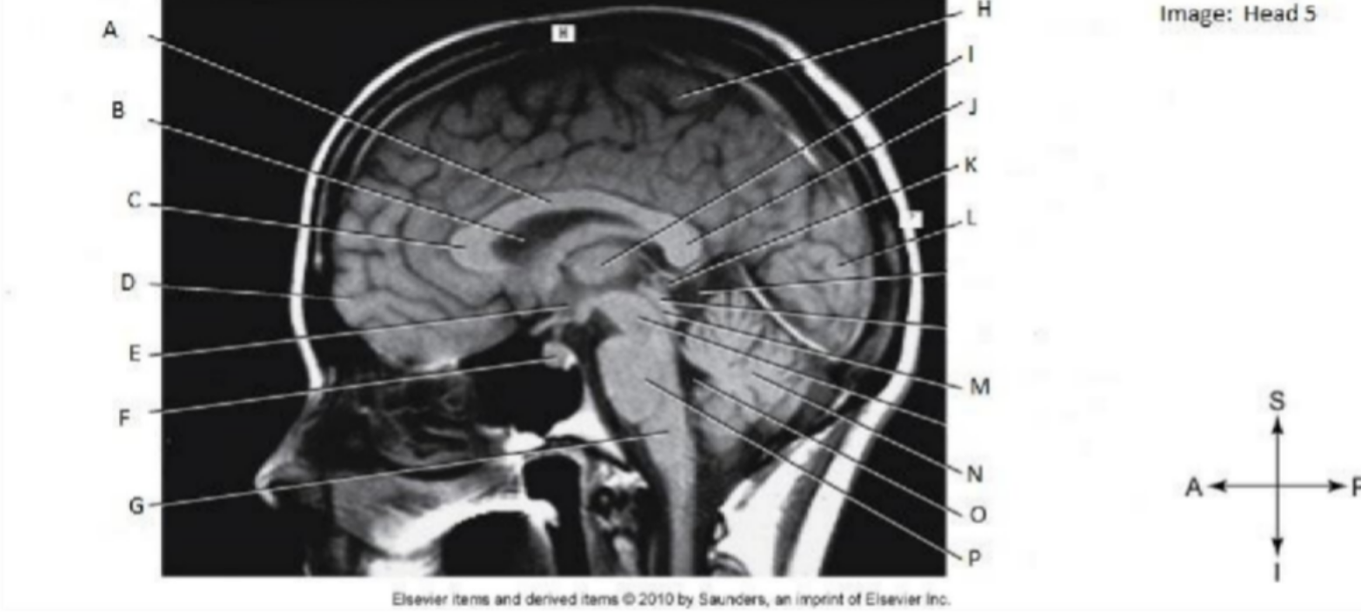

A.
B.
C.
D.
E.
F.
G.
H.
CTTheory
©EdenbrookColleg

I.
CTTheory
©EdenbrookColleg
J.
K.
L. M N.
O.
P.

- Label the image below:

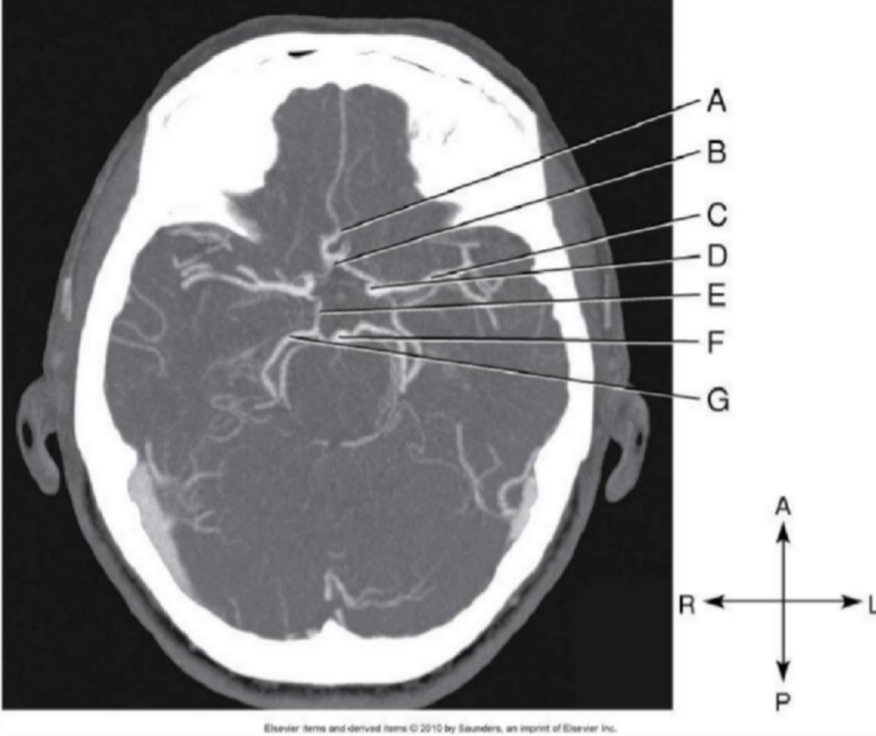

A.
B.
C.
D.
E.
F.
G.

- Label the image below:
CTTheory
©EdenbrookColleg

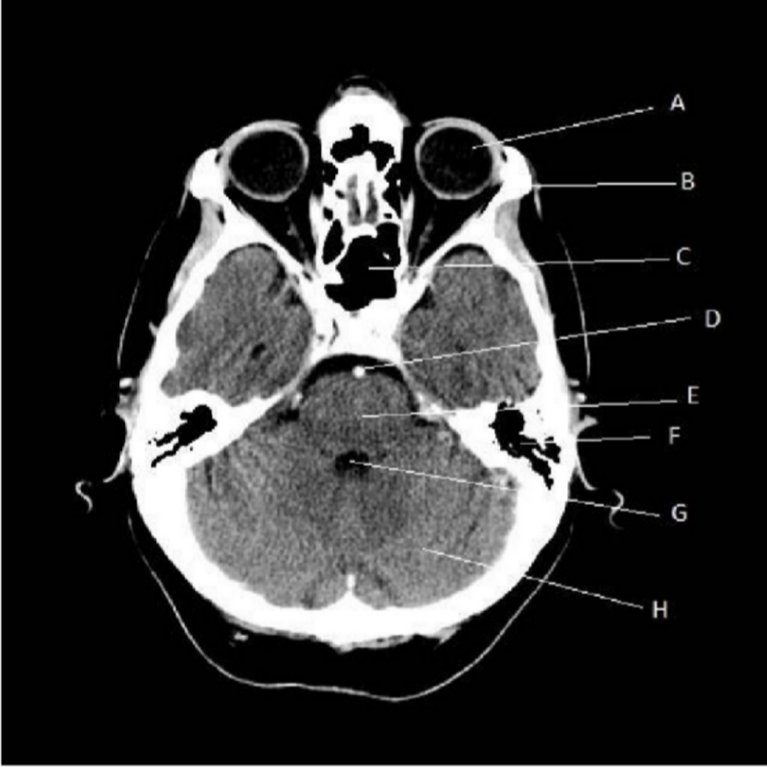
A.
B.
C.
D.
E.
F.
G.
H.
CTTheory
©EdenbrookColleg

- Label the image below:
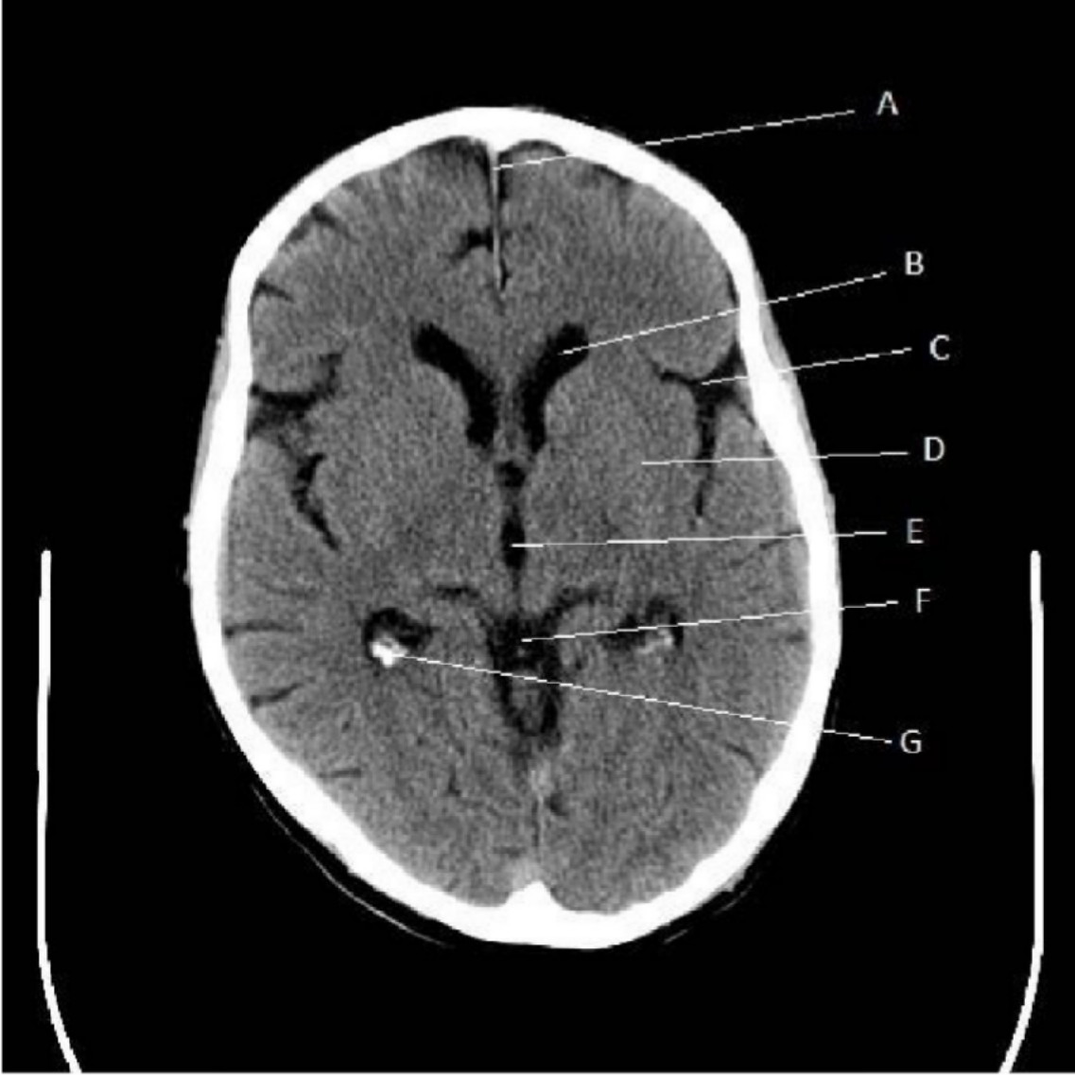
A.
B.
C.
D.
E.
CTTheory
©EdenbrookColleg

F.

- List the ventricles of the brain.

- Which ventricle sits the most inferiorly?

- What are the choroid plexus and how does it appear on CT images?

- List the meninges and their relationships? (ie – which layer is the outermost layer -> innermost layer)

- List the lobes of the cerebrum

- What is the corpus callosum?

- What are the superficial shallow grooves on the surface of the brain called?

- List the fissures of the brain and the sections each separates.

- What is the falx cerebri?
CTTheory
©EdenbrookColleg

- The temporal lobes are seen on axial CT images at the level of what?

- List the 3 sections of the brainstem and their relationship (Superior -> Inferior)

- What is the vermis?

- What venous sinus is shaped like an S and is continuous with the internal jugular vein?

- What venous sinus occupies the entire space (anterior – posterior) along the superior aspect of the brain and moves ?

- At the junction of the falx cerebri and the tentorium cerebelli, what two venous sinuses
/ veins join to become the straight sinus?

- What artery ascends into the brain through the transverse foramen?

- What structure allows passage of CSF between the 3rd and 4th ventricles?

Part 2 – Imaging Procedures

- Describe the patient & anatomy position for a CT Head

- How can the technologist position the patient to reduce radiation dose?

- Determine which of the following statements describe helical scanning (H), conventional (C) scanning, or both (H, C)
CTTheory
©EdenbrookColleg

  - Short acquisition time
  - Improved detail
  - Improved spatial resolution
  - Allows gantry tilt
  - Reduced radiation dose
  - Capable of MPR
  - Capable of 3D reconstructions
- How can you reduce beam-hardening artifact in the posterior cranial fossa?

- What is a reasonable Soft-Tissue window for viewing images of the head?

- What is a reasonable bone window for viewing images of the head?

- Define, and describe the radiographic appearance of:
  - Epidural hematoma
  - Subdural hematoma
  - Subarachnoid hemorrhage
  - Intracerebral hemorrhage

- List 3 common indications for NECT head.

- List 3 common indications for CECT head.

- Why should a non-enhanced study be performed before injection of contrast?

- What is the contrast protocol for CECT head?

- What are some advantages of using CT Angiography over conventional catheter angiography?

- What is the contrast protocol for CTA head?
CTTheory
©EdenbrookColleg

- List 3 indications for CT sinuses.

- List 3 indications for CT facial bones.

- List 2 indications for NECT orbits.

- List 3 indications for CECT orbits.

- What is the contrast protocol for CECT orbits?

