ANPH 252 – Anatomy and Pathology 2
Respiratory Pathology EXAM Review
Emphysema 1
Carcinoma of lungs (primary) 2
Carcinoma of lungs (metastases) 3
Atelectasis 4
Pleural effusion 5
Pneumonia 6
Respiratory distress syndrome (infant) 7
Acute respiratory distress syndrome (adult) 8
Cystic fibrosis 9
Bronchiectasis 10
Chronic bronchitis 11
Pulmonary edema 12
Tuberculosis 13
Subcutaneous emphysema 14
Pulmonary emboli 15
Lung abscess 16
Pulmonary infarct 17
Empyema 18

Using the chart above match the letter to the pathology
- Infected purulent, loculated pleural effusion
- Enlargement of airspaces caused by destruction of alveolar walls
- Loss of lung volume secondary to collapse
- Infection within the lung due to material filling the alveoli
- Circumscribed collection of pus within the lungs
- Disease common in developing countries, caused by bacteria
- Irreversible abnormal dilation of the bronchial tree
- Presents on imaging as diffuse ground glass lungs with low volumes and a bell-shaped thorax
- Presence of a productive cough for 3 months in 2 successive years
- A broad term for an abnormal accumulation of fluid in the extravascular components of the lung
- A complication of a pulmonary embolism
- Lung injury occurring as a result of severe pulmonary injury causing alveolar damage throughout the lung
- Occlusion of the pulmonary arteries or its branches
- Linked to inhaled carcinogens
- Affects exocrine function of lungs liver, pancreas, small bowel and sweat glands
- Collection of serous fluid in the pleural space
- Can be caused by penetrating trauma
- Appears as rounded nodules of various size scattered throughout the lungs
Using the chart above match the number of the pathology to the image
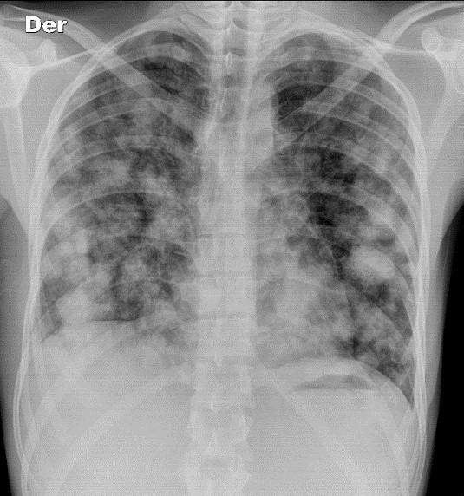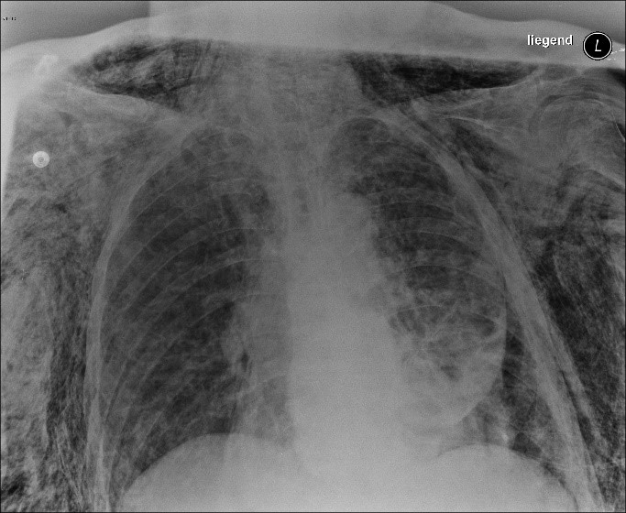
Pathology: Pathology:
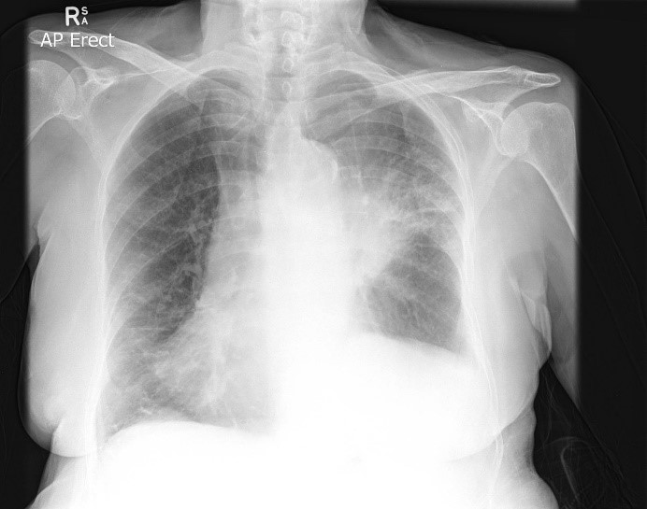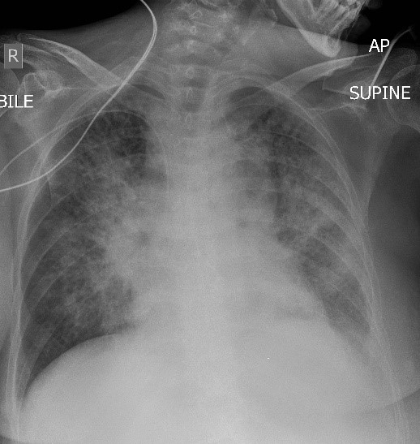
Pathology: Pathology:

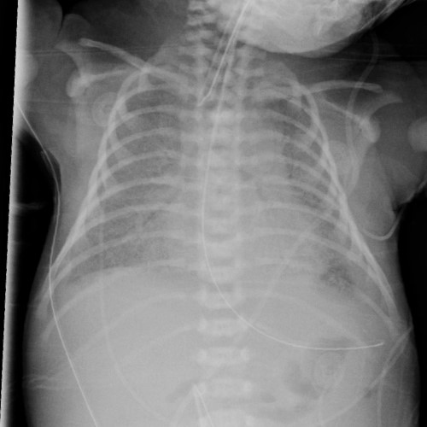  Pathology:  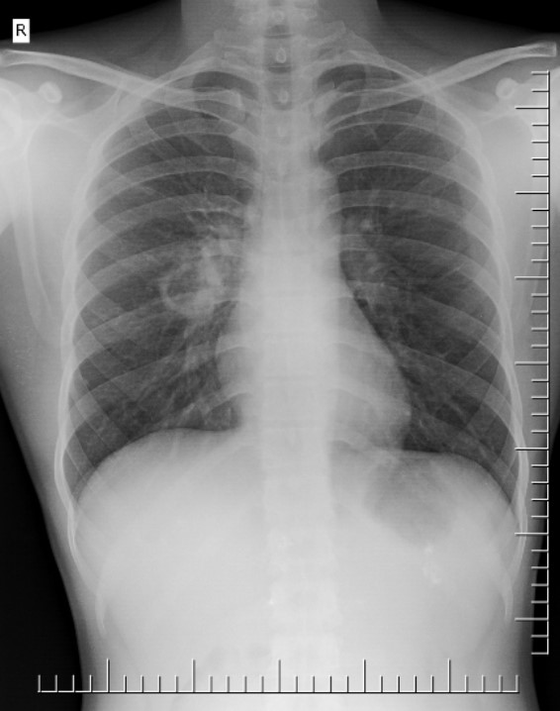  Pathology: | 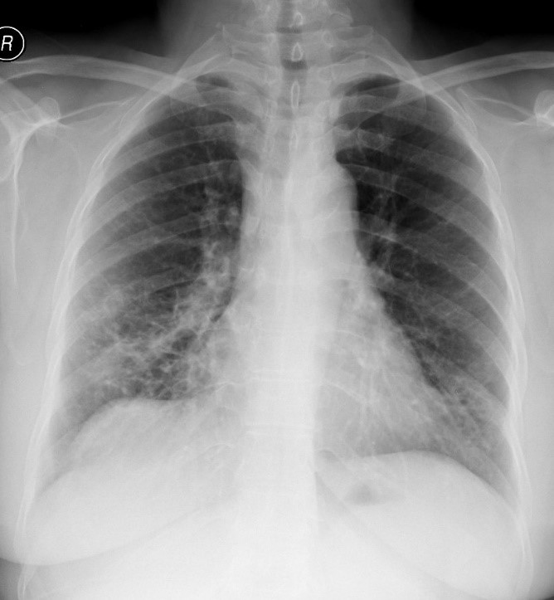  Pathology:  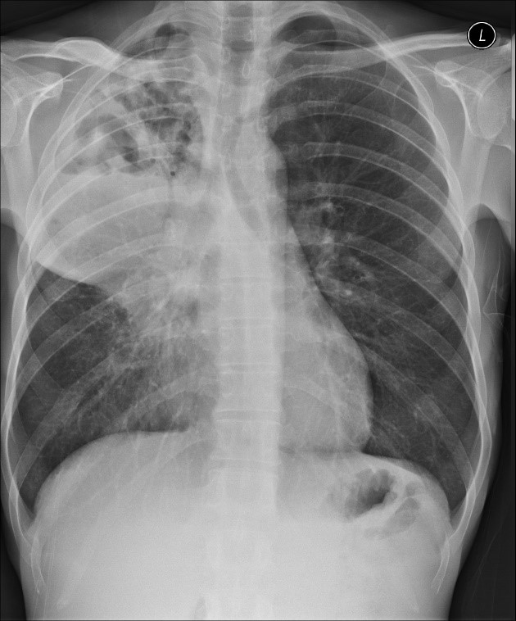  Pathology:

