Labelling Questions – ANSWER KEY (this item is a drag and drop activity)

Module 3

- Match the anatomy listed to the anatomy seen in the radiograph:

a. Anatomical neck
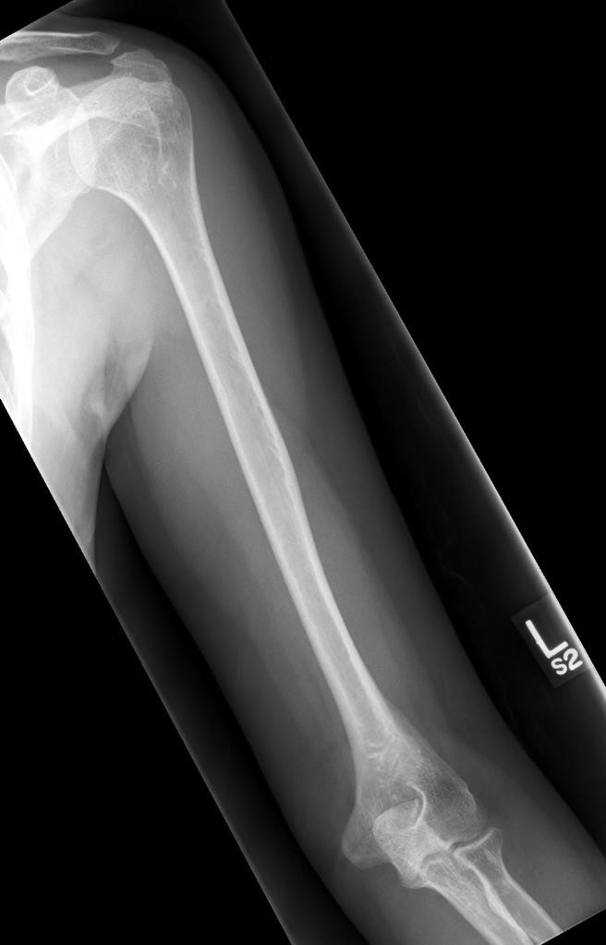
h.

Greater

tubercle

k. Humeral

head

d.

Intertubecular

sulcus

b. Lesser

tubercle

j.

Surgical

neck

l. Deltoid

tuberosity

f. Olecranon

fossa

c. Medial

epicondyle

e.

Capitulum

i.

Radial

head

m. Coronoid

tubercle

g. Radial

tuberosity

- Match the anatomy listed to the anatomy seen in the radiograph:

a. Surgical neck
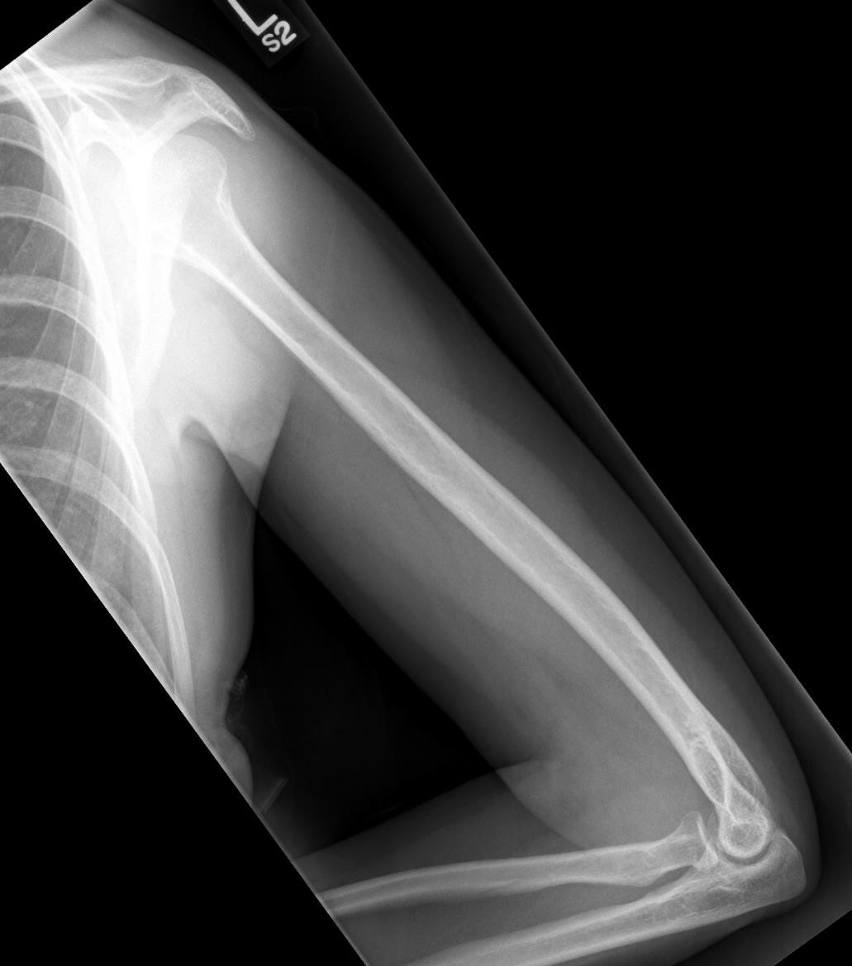

e.

Epicondyles

d. Coronoid

process

g.

Condyles

b.

Olecranon

process

c.

Radial

tuberosity

f. Trochlear

sulcus

- Label the anatomy seen in the radiograph:
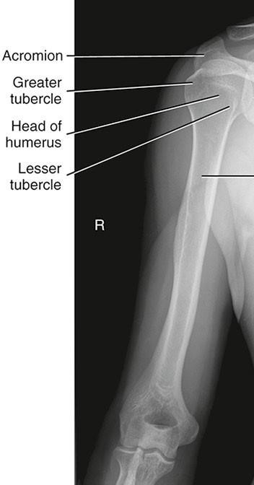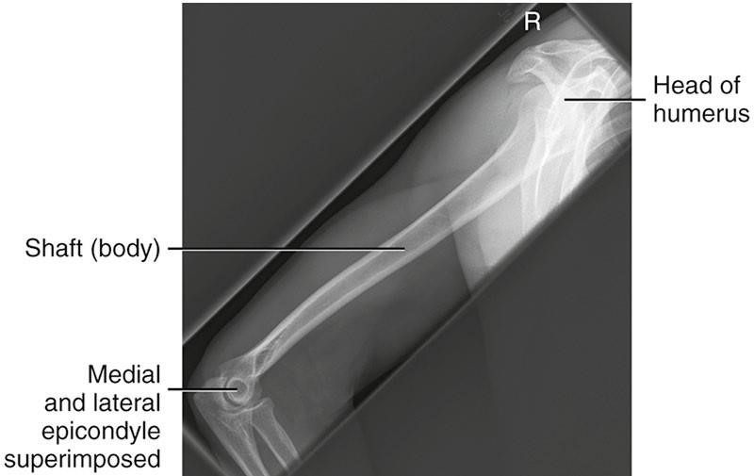

Body of

proximal

humerus

Deltoid

tubercle

Bontrager

9
th

Ed.

pg.

&
187

188

Fig.

5.28

&

5.33

- Label the anatomy seen in the radiographs:
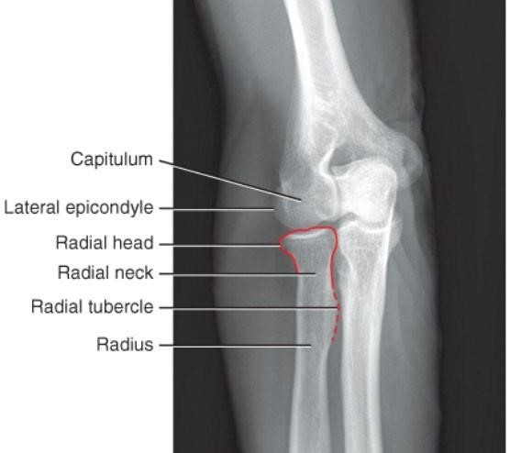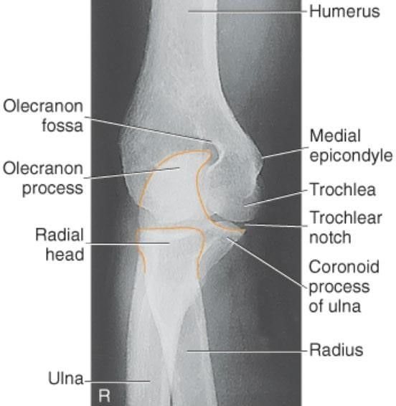
Bontrager

9
th

Ed.

pg.

170
&

171

Fig.

4.136

&

4.140

- Match the anatomy listed to the anatomy seen in the radiograph:
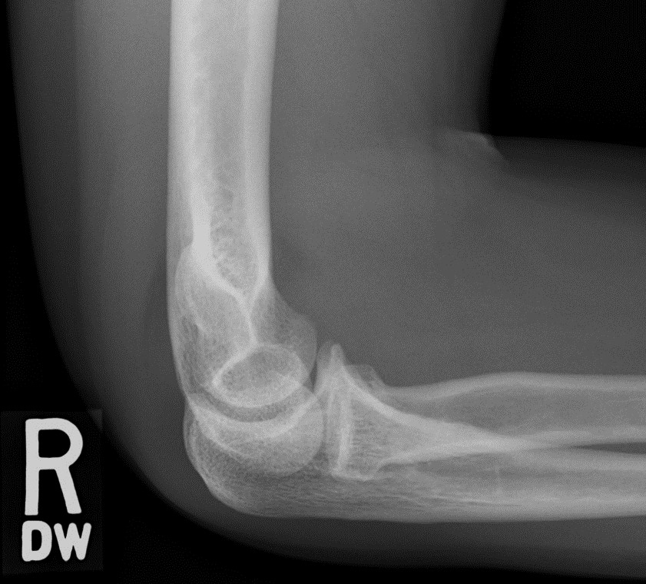

f.

Trochlea

d. Coronoid

process

h. Posterior

fat

pad

c. Radial

tuberosity

a.

Olecranon

process

Edenbrook

imaging

library

a.

Radial

neck

e.

Capitulum

g.

Trochlear notch

- In the radiograph, outline the listed anatomy:

a. Capitulum | c. Olecranon process | e. Radial head
b. Trochlea | d. Coronoid process | f. Trochlear sulcus

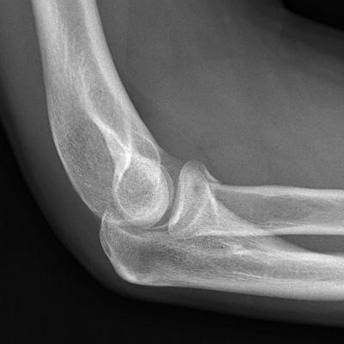
http://www.wikiradiography.net/page/The+Lateral+Elbow

