RADP 215 – Radiation Protection
ESE/ESD Calculations Worksheet – ANSWER KEY

Complete the following chart:

SID (cm) | IR to TT (cm) | Body part (cm) | SSD (cm)
100 | 5 | 5 | 90
130 | 7 | 20 | 103
150 | 6 | 14 | 130
180 | 8 | 23 | 149
100 | 0 | 10 | 90

Nomogram
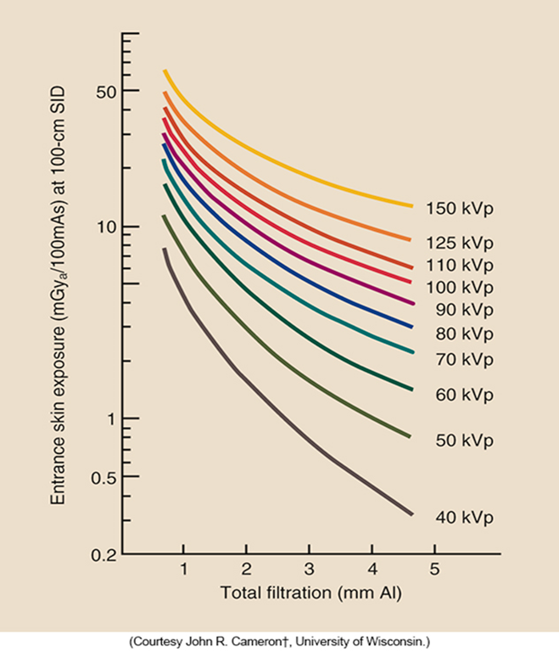
Intensity Chart
mGy/mAs chart at 110 cm
kVp | mGy/mAs
50 | 0.009
60 | 0.017
70 | 0.025
80 | 0.035
90 | 0.045
100 | 0.056
110 | 0.069
120 | 0.079

Complete the chart using the provided nomogram:
 | kVp | mAs | Al (mm) | SSD (cm) | Estimated ESE | Nomogram read out used
1. | 50 | 10 | 2 | 84 | 0.43 mGy | 3 mGy/100mAs
2. | 70 | 50 | 3 | 112 | 1.59 mGy | 4 mGy/100mAs
3. | 80 | 125 | 3.5 | 132 | 3.23 mGy | 4.5mGy/100mAs
4. | 125 | 2 | 4 | 162 | 0.08 mGy | 10mGy/100mAs

Complete the following 2 questions using the provided intensity chart:

5. Calculate the approximate ESE for an AP hip exam.

Body part thickness: 20 cm.
Distance from the patient to the IR: 7 cm.
70 kVp @ 20 mAs
SID: 150cm

ESE = 0.4 mGy

6. Calculate the approximate ESE for a PA chest image 40 cm thorax.

Body part thickness: 40 cm.
Distance from the patient to the IR: 5 cm.
120 kVp @ 5 mAs
SID: 180cm

ESE = 0.26 mGy

Space provided for calculations:

