ANPH 252 – Anatomy and Pathology 2
Worksheet - GI Pathology
Questions 1-26
1. Match the following terms with their definitions:
A) hypertrophy |  | A condition that is caused by medical intervention
B) resection |  | Against the flow of nature
C) fistula |  | A mass of tissue that branches into a lumen
D) achalasia |  | An increase in the number of cells unrelated to a tumor
E ) nosocomial |  | Surgical repair of an organ
F) retrograde |  | Deficient blood supply
G) abscess |  | Abnormal passageway between two organs
H) polyp |  | A sphincter’s inability to relax
I) ischemia |  | A loculated collection of pus
J) iatrogenic |  | A hospital acquired disease

2. State the disease classifications associated with each of the following pathologies:
Crohns -
Esophageal atresia -
Hypertrophic Pyloric Stenosis -
Sliding hiatal hernia -
Peptic ulcer -
Situs inversus -
Adynamic ileus -
Vovulus –

3. Define “hernia” and explain why a hernia must be treated surgically.

4. What does GERD stand for?

5. Which sphincter is compromised in patients with GERD?

6. Explain why occasional acute episodes of GERD are not usually a cause for concern

7. What complications can occur as a result of chronic GERD?

Refer to case study one to answer questions 8 thru 15
CASE STUDY ONE

Craig is forty-two years old and a self-professed workaholic. He has been experiencing chronic heartburn for the last six months. As a travelling sales rep, he is on the road constantly, and wines and dines in fancy restaurants 5 days out of 7. He drinks copious amounts of coffee to keep himself awake while driving. Recently he has been waking up with generalized abdominal pain, which is usually relieved by NSAID’s and a midmorning breakfast.
Although his physician does not think Craig has a life threatening condition, he has scheduled him for an esophagram and an endoscopy (placing a scope down his throat to view his stomach) and has recommended that he stop taking NSAID’s for the time being.
8. What is a NSAID?

9. Give an example of a common NSAID.

10. What is the most likely cause of Craig’s heartburn?
11. List some lifestyle changes that might relieve Craig’s heartburn:

12. What two digestive pathologies may be causing Craig’s symptoms?

13. Where will Craig’s GE junction most likely appear on the esophagram, when the table is tipped into a Trendelenburg position?

14. Why did the physician schedule an endoscopic exam?

15. Why did the physician ask Craig to stop taking NSAID’s?

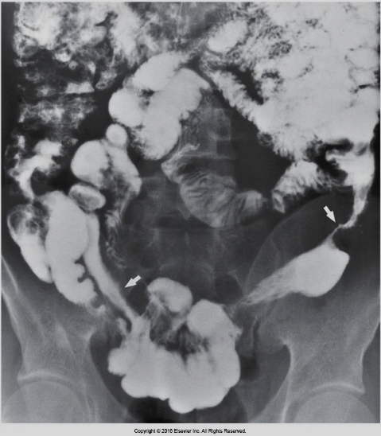
CASE STUDY TWO

An ambulatory adult comes to the x-ray department for a small-bowel follow-through. They are on contact isolation. As you are taking their history, they tell you they have LUQ pain and bloody stool. They are thin as a rake. During the exam the doctor examines the terminal ileum very closely, and you notice a generalized cobblestone appearance to the bowel. Their AP abdomen x-ray is shown in image 2 below.

2
Eisenberg 5-44
16. Which of the following is true regarding this situation?

a) The “string sign” in image 2 indicates that the patient most likely has colon cancer
b) The “string sign” in image 2 is a classic radiographic sign of regional enteritis
c) The technologist will need to wear a gown, gloves, and mask for the exam.
d) The “string sign” in image 2 indicates a type of fistula
e) The patient has bloody stool because they have peritonitis
f) This patient is suffering from a chronic disease with acute episodes
g) This patient is most likely between the ages of 50 and 70
h) If this patient has a bowel resection done, they will still be at risk for a recurrence.

17. What is the most common cause of a large bowel blockage?

A small bowel one blockage?

18. What is the most likely complication of diverticulosis?

19. Which of the following will most immediately cause a bowel blockage?
a) achalasia
b) intussusception
c) peptic ulcer
d) gastroenteritis

20. All colonic polyps should be removed regardless of size, as they have the potential to become cancerous.
a) True
b) False

21. What is the primary radiographic sign of colon cancer?

22. List two diseases that are a pre-disposition to colon cancer.

23. If colon cancer is not diagnosed early in its development, it has the potential to spread via the lymphatic system to other organs such as the liver, or lungs.
a) True
b) False
24. A volvulus most often occurs in the transverse colon
a) True
b) False

25. In the chart below, match the radiographic appearance/sign with the disease. More than one sign may apply to a given disease. Some diseases may have no radiographic signs listed.
Crohn’s |  | A) rat tail
Achalasia |  | B) step ladder
Volvulus |  | C) cobblestone
Intussusception |  | D) coiled spring
Diverticulosis |  | E ) napkin ring
Diverticulitis |  | F) collar-buttoned
Ulcerative colitis |  | G) lead pipe
Colon cancer |  | H) skip lesions
Bowel blockage |  | I) string sign
Hiatal hernia |  | J) boot sign
 |  | K) beak sign
 |  | L) apple core

26. Almost all patients who undergo bowel surgery will suffer from adynamic ileus
a) True
b) False

