
Exam 1
Quality Assurance and Control
QUAL 370
Date:
Weight: Marks:

Time Allotted:

Do not open this exam booklet until you are instructed to do so.
Student Name:
Student ID:

QUAL 370: Quality Assurance and Control Exam 1 Answers

Part A: Multiple Choice Questions
- What is the purpose of the AEC reproducibility test?
- To ensure you have consistent kVp
- To ensure you have a consistent mAs
- To ensure you have consistent radiation output* Papp p. 112
- To ensure you have consistent time

- Which of the following tools is not used during the AEC reproducibility test?
- Dosimeter
- Lead shielding* Papp p. 112
- Acrylic blocks
- None of the above

- What is the acceptable range for the AEC reproducibility test?
- All readings must be within 1% of the average
- All readings must be within 5% of the average
- All readings must be within 10% of the average
- All readings must be within 20% of the average* SC 35 p. 25

- In which of the following tests do we take exposures at all of the mA stations?
- AEC density
- AEC reproducibility
- AEC sensitivity* Papp p. 111
- AEC uniformity

- During the AEC density test, our mR reading should change ____% for each density setting we select.
- 5
- 10
- 15* (AHS specs)
- 20

- An alternate name for the reproducibility test is:
- Coefficient of mAs
- Coefficient of kVp
- Repeatability*
- kVp accuracy

- The purpose of the reproducibility test is to ensure that the unit is producing the same ______ each time.
- Exposure* Papp p. 97
- kVp
- mA
- mAs

- Which of the following equipment is NOT required for the kVp accuracy test?
- kVp meter
- Dosimeter
- Densitometer*
- Lead strips

- The purpose of the kVp accuracy test is to determine that the machine is producing:
- Consistent mR value for each exposure
- The kVp set on the control panel* Papp p. 98
- Consistent kVp values
- Consistent exposure times

- What parameter is kept constant throughout the kVp accuracy test?
- kVp
- mAs*
- mA
- time

- The relationship between mAs and dose can be described as:
- Direct*
- Indirect
- Non-threshold
- Threshold

- If we double the mAs, how will the exposure be affected?
- Halved
- Doubled*
- Unable to determine
- No effect

- The purpose of the timer accuracy test is to determine that the machine is:
- Exposing for the amount of time that has been set* Papp p. 101
- Producing the mAs that has been set
- Producing linear time settings
- Producing the mA that has been set

- For the timer accuracy test, the results that we record are:
- Dose
- mA
- Time* Papp pp. 101–102
- kVp

- As the time is halved, how is the kVp affected?
- Halved
- Doubled
- No effect*
- Quartered

- Clinically, if a tube failed the perpendicularity test, a potential consequence could be:
- Missed diagnosis of an undisplaced hairline fracture* Papp p. 107
- Magnification
- Clipped anatomy
- Increased patient dose

- If the coefficient of variation is smaller than the acceptable limit, what will the clinical outcome be?
- Consistent radiographic exposures attained when the same exposure factors are used* SC 35 p. 24
- Inconsistent radiographic exposures attained when the same exposure factors are use
- Consistent radiographic exposures attained when different exposure factors are used
- Inconsistent radiographic densities produced consistently

- The tool used in the line pair test is called:
- Line test tool
- Line resolution tool
- Line pair test tool*
- Line pair measurement template

- How does the tool used in the above mentioned test work?
- The observer counts as many lines as possible
- The observer looks for the furthest area where the lines and spaces can be differentiated*
- The observer looks for the area of fewest lines
- The observer looks for the last number seen in the space between the lines

- What is the main purpose of filtration?
- To make a more homogenous beam
- To decrease patient dose by absorbing high energy x-rays
- To increase radiographic density by absorbing low energy x-rays
- To decrease patient dose by absorbing low energy x-rays* Papp p. 98

- To determine the HVL reading, you:
- Divide the mean value by the original value
- Divide your original reading on the dosimeter by 2* Papp p. 99
- Calculate 20% of the original dose
- Multiply the number of aluminum sheets used by the original kVp

- The purpose of the mA linearity test is to determine the relationship between _________ is linear.
- mAs and dose* Papp p. 103
- mAs and kVp
- mA and time
- mAs and filtration

- If the exposure readout at 64 mAs is 400 mR, theoretically what will the exposure be at 32 mAs?
- 200 mR*
- 800 mR
- 400 mR
- 100 mR

- AEC tests need to be performed:
- Monthly
- Bimonthly
- Semiannually
- Annually* SC 35 pp. 52–53

- The below picture depicts the set up for which of the following tests:
- mA linearity  - Timer accuracy  - AEC sensitivity  - AEC field balance  - Positive beam limitation  - HVL | 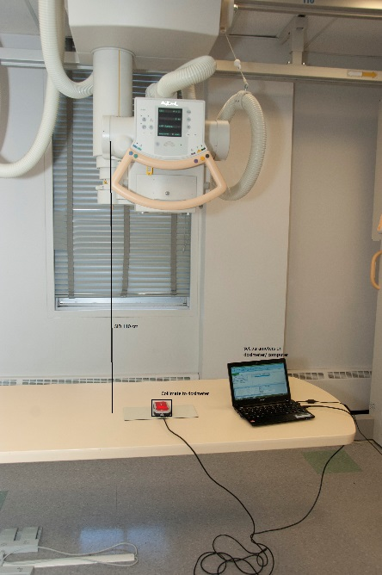

- All of the above
- 1,2,5,6
- 3,4,6
- 1,2,6*

- The below picture depicts the set up for which QC tests?
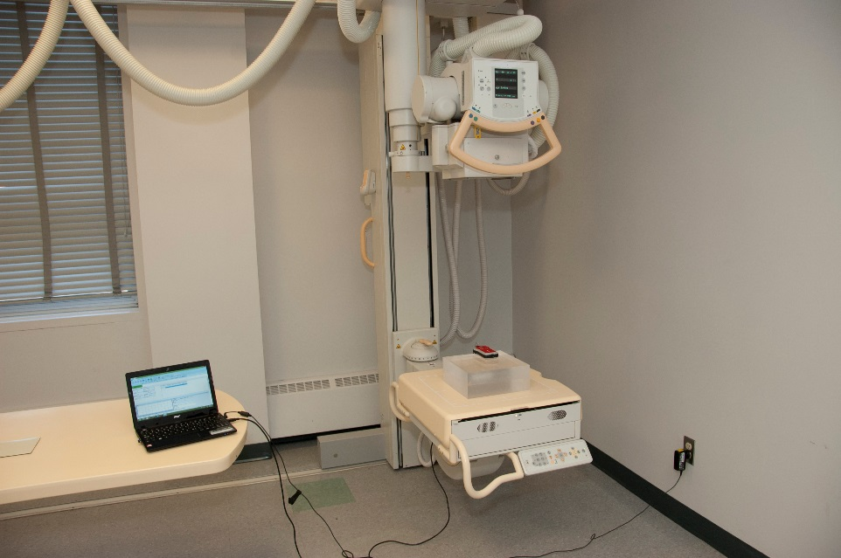
- mA linearity
- Reproducibility
- AEC field balance*
- Light field-radiation field alignment

- According to SC 35, the HVL at 80 kVp must be at least ____mm of aluminum.
- 2.5
- 2.9*
- 3.2
- 3.6

- According to SC 35, the kVp must not deviate from the selected value by more than:
- 10%*
- 20%
- 15%
- 5%

- According to SC 35, the mA must not deviate from the selected value by more than:
- 10%
- 20%*
- 15%
- 5%

- According to SC 35, the loading time must not deviate from the selected value by more than:
- 10% + 1 ms*
- 20% + 1 ms
- 10% + 0.2 ms
- 20% 0.1 ms

