Activity: Test 1 – Reproducibility/Repeatability Procedure

Purpose
This activity will help you identify the equipment, materials and steps required to complete this test.

Instructions
- Review the images below of the equipment and materials used at Edenbrook for this test.
- Review the procedure steps from the Edenbrook MRT lab.
- Compare the textbook readings and your practicum site QA manual for similarities and differences.

Equipment
- ½ apron or lead sheet
- Dosimeter

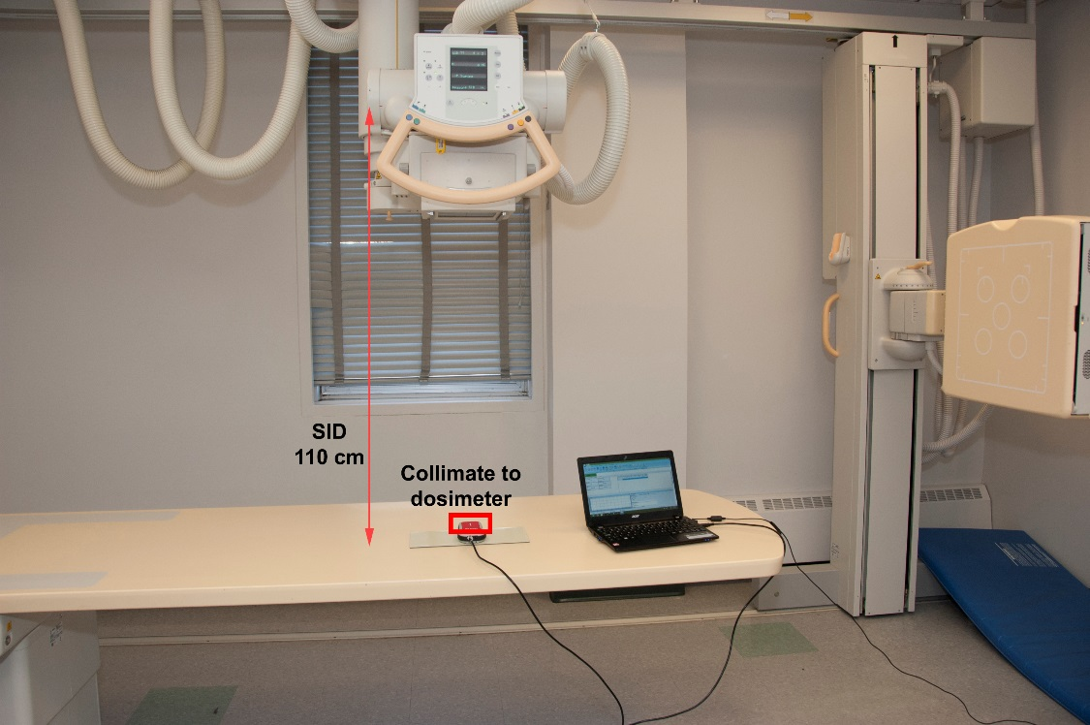

MRT Procedure Steps
- Place a lead ½ apron on the X-ray table top and move the detector out of the beam.

- Place a dosimeter on the lead.

- Make sure you are using 110 cm SID.

- Centre the X-ray tube to the dosimeter and collimate to an area slightly larger than the chamber.

- Set the exposure factors in the data table with a minimum exposure time of 100 ms.

- Continue to use the same technical factors for all ten exposures.

- Make ten exposures and record the dosimeter readout on the data table.

Questions
- What differences do you see from the textbook compared to the Edenbrook MRT procedure steps or equipment?
- Access your department’s quality control manual and compare the equipment and procedure to the Edenbrook MRT steps and equipment.
- View the City College of San Francisco (CCSF) Diagnostic Radiology Quality Control video: https://www.youtube.com/watch?v=lAKc-Tj88_k
  - Find the Exposure Reproducibility Test.
  - Compare the procedure with the Edenbrook MRT procedure steps and equipment.

