Activity: Test 5 AEC Reproducibility Procedure

Purpose
This activity will help you identify the procedure steps for this test and confirm that the exposure is being terminated at the proper time after a predetermined quantity of radiation has been detected, producing the same output when exposures use the same kVp and mA.

Instructions
- Review the images below of the equipment and materials used at Edenbrook for this test.
- Review the procedure steps from the Edenbrook MRT lab.
- Compare the textbook readings and your practicum site QA manual for similarities and differences.

Equipment
- Dosimeter
- Two Plexiglas blocks
- Calculator

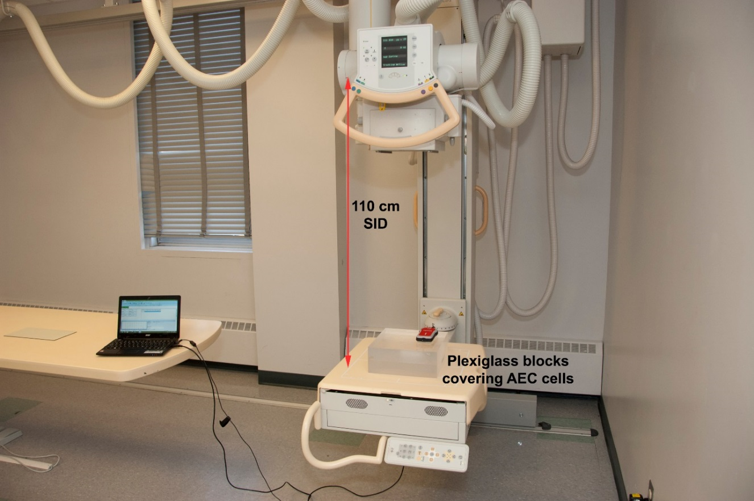

Edenbrook MRT Procedure Steps
- Place the Plexiglass blocks (stacked) over the AEC cells of the detector, ensuring the AEC cells are completely covered.

- Using a 110 cm SID, centre to the detector and collimate appropriately to include the entire dosimeter and the entire Plexiglass block.

- Place the dosimeter probe on top of the blocks to one side of the centre cell, ensuring the AEC is not obstructed.

- Select AEC on the control panel, centre cell only. Select 80 kVp and 100 mA.

- Take 6 exposures, recording mAs, time (ms) and exposure (mR).

