Activity: Basic CT Equipment

Purpose
Objective 2.1: Apply terminology specific to CT equipment.
Objective 2.2: Characterize the various acquisition components that comprise a CT scanner.

Instructions:
- Use the diagram below to draw and identify the location of seven internal components of a gantry.
- Draw the SFOV and DFOV based on the following scenario: A patient requires lumbar (aka. lower back) imaging.

D2l
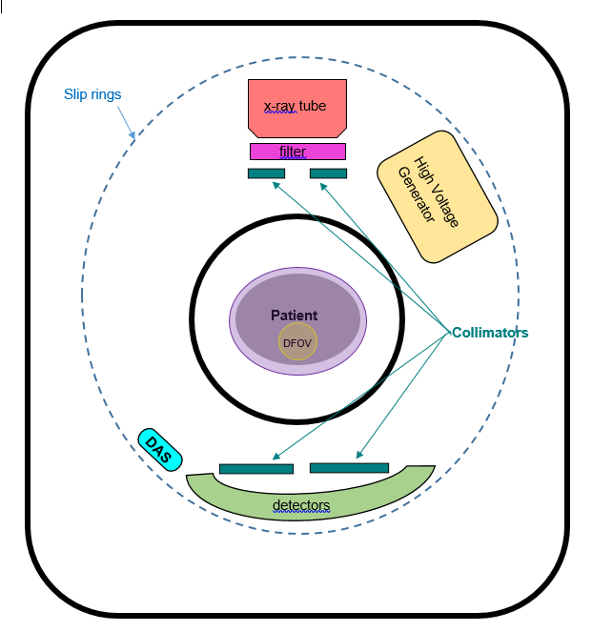

Instructions:
- Answer the following short answer questions.
- Compare your answers with the answer key.

Questions
- What are the 2 purposes of filtering the x-ray beam in a CT scanner?
- Produces a more uniform beam
- Reduces pt. dose

- Describe a special type of filter used in CT, and how it works.
Bow Tie Filters are a special kind of added filtration that help create a more uniform object thickness. *Filters help absorb lower energy photons

- Explain 2 functions of the collimators in a CT scanner.
- Can define slice thickness (in SDCT systems only)
- Restrict the x-ray beam to the cross-section of interest

- Which type of collimation Acts on the beam before it passes through the patient?
- Source (aka. Pre-patient collimators)

- What is the purpose of having a collimator positioned before the detector array?
- Prevents scatter from reaching the detector array, and maintains beam width

- What is the purpose of a detector in a CT system?
Capture transmitted radiation photons, and convert the x-ray energy into electrical signals for recording. (i.e. collect & convert x-ray energy)

- What does DAS stand for, and what is its function?
Data Acquisition System: measures radiation flux at the detectors via sampling, converts that information into a digital signal (using an ADC), and sends the digital signal to the computer for image reconstruction.

- What does ADC stand for, and what is its function?
Analog to Digital Converter: is a component of the DAS; converts the electrical (aka. analog signal) from the detectors into digital signals for the computer

- Which component enabled Helical scanning?
Slip Rings

- What helps reduce heat production within the tube in a CT imaging system? Note: Review from Week 1.
- Larger and thicker anodes
- 2 Focal Spot Sizes
- Smaller target angle
- High rotation speeds
- Define scannable range, and explain why it is important for technologists to identify.
Scannable range describes the maximum horizontal table Incrementation (aka. maximum horizontal table movement). Determines the extent a patient can be scanned without repositioning.

- Which component enables a technologist to adjust the DFOV?
Operating console
- Raw data is required to change the DFOV, therefore the technologist would need to use the operating console to retrieve the raw data to reconstruct it with a new DFOV

- What enables accurate patient positioning?
Positioning (laser) lights located on the gantry
- Help identify where the scan will begin, and if the desired anatomy is within the isocenter of the gantry aperture

- How can you ensure consistency between scans?
Using table referencing (manually setting the table position to zero to identify a scan point)
- Ensures repeat scans only irradiate the tissue of interest

- What is table Incrementation?
The specific distance the table travels.
- Example: in contiguous axial scans the distance the table moves through the gantry during each inter-scan delay is equivalent to slice thickness
- In helical scans the table moves continuously, and the specific distance traveled per tube rotation is measured in mm/sec

