Radiographic Technique 1 Written Midterm Exam Comprehensive Review
- Which structure is most proximal? Answer is Head of the Scapula. (Head of the Ulna, Head of the Radius, Head of the Humerus)
- From anatomic position, which structure is closest to the midsagittal plane of the body? Answer is Medial epicondyle. (Trochlea, Capitulum, Coronoid Fossa)
- When the arm is positioned in internal rotation, which structure is most posterior? Answer is Medial epicondyle. (Greater tubercle, lesser tubercle, olecranon fossa)
- Which structure is part of the ulna? Trochlear notch
- Which structure is most lateral when the hand is supinated? Answer is Trapezium (5th distal phalanx, ulnar styloid proceed, 2nd metacarpal)
- An AP forearm radiograph reveals slight superimposition of the proximal radius and ulna. What positioning error occurred? No positioning error occurred
- What is the purpose of performing partially flexed projections of the elbow? Provide an AP perspective if a patient cannot fully extend the elbow
- Which wrist projection demonstrates the lunate as a cup or "half-moon" shape? Lateral
- Why would a tube angle be used when positioning for a superoinferior axial projection of the shoulder? Ensure the required anatomy is visualized on the image receptor
- When positioning for a scapular Y projection, which palpable landmarks must form a line that is perpendicular to the IR? Acromion and the superior angle of the scapula
- Which position of the epicondyles would demonstrate the lesser tuberosity in full profile on an AP projection of the shoulder? Internal oblique (epicondyles perpendicular)
- What describes the patient position for a PA oblique projection of the right shoulder? RAO
- Which adjustment should be applied when performing an AP axial clavicle projection for a hypersthenic patient? Decrease tube angle
- What would cause superimposition of the proximal radius and ulna? Pronation of the hand
- The humeral head is visualized below the coracoid process on a PA oblique shoulder projection. What was demonstrated radiographically? Anterior dislocation
- Radiographically, which projection would best demonstrate evidence of rheumatoid arthritis? AP oblique hands
- In comparison to an extension lateral, what is better demonstrated in a fan-lateral hand projection? Phalanges
- Which statement regarding a properly positioned lateral humerus projection is true? Lesser tubercle will be visualized in profile medially

- Image of superoaxial shoulder for Lesser Tubercle
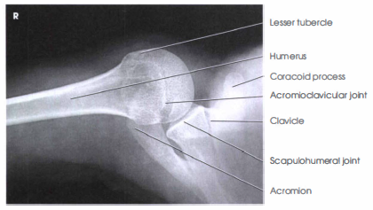

- Image of elbow for trochlea

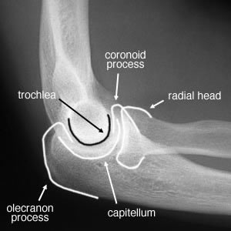

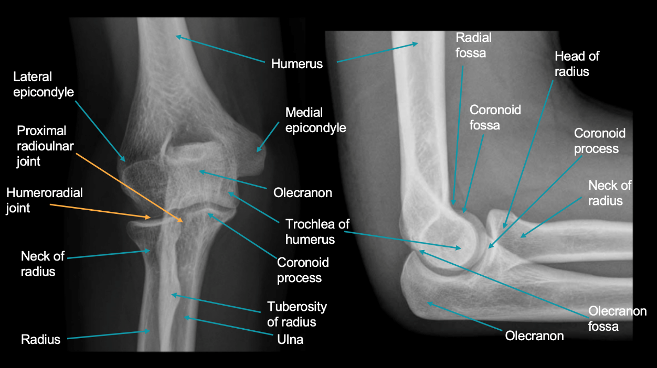

- Image for PIP joint
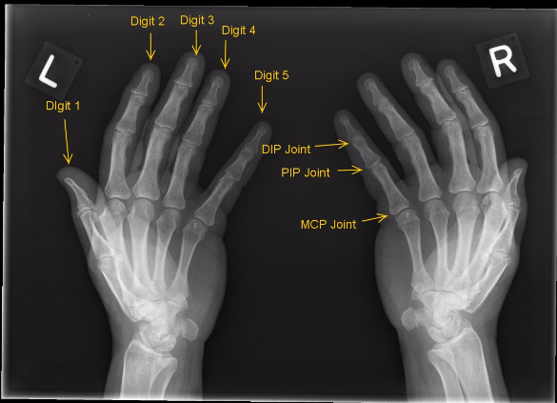
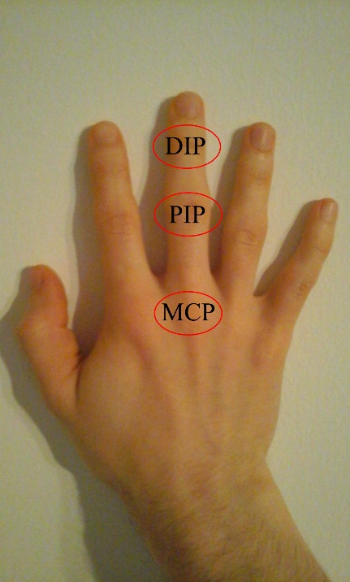

- Image of pisiform bone wrist
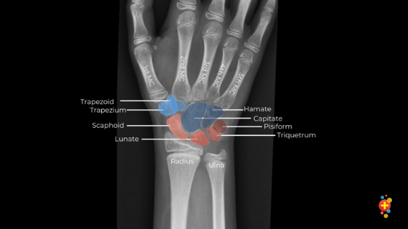

- Image of lateral elbow and position of externally rotated hand (see midterm exam for reference)

- Image of elbow with an externally rotated arm
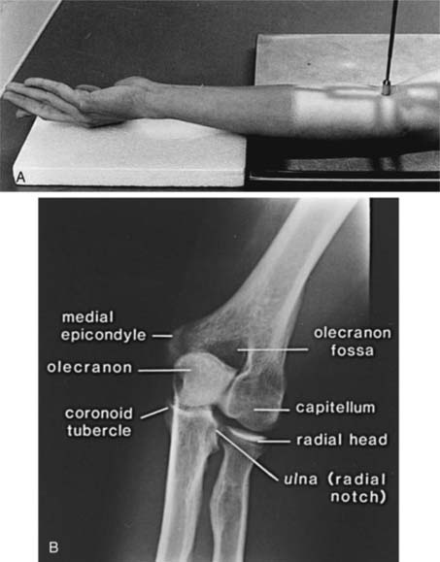

- Image of shoulder with hand in neutral (rotation) position
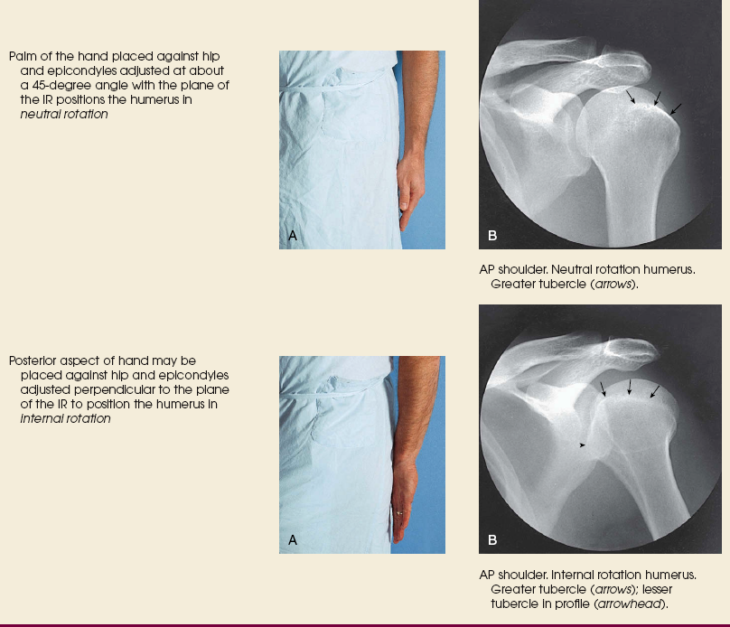

- Image of wrist with evidence of rotation (see midterm exam for reference)
- AP image of thumb (see midterm exam for reference)
- Image of a shoulder and clavicle that requires adjustments to CR centering and collimation (see midterm exam for reference)

