Lab Project (25%)

Setting Up the Room
- Review the Requisition Form:
  - Check the requisition form to determine what needs to be X-rayed and identify if the patient is ambulatory, on a wheelchair, or a stretcher.
- Console:
  - Access the console and select the correct patient from the worklist.
  - Confirm the correct accession number is selected.
- Equipment Preparation:
  - Set the system to the correct settings, ensuring the upright Bucky is selected.
  - Detente the tube to the detector and engage the locks.
  - Ensure the grid is in the upright Bucky.
  - Adjust the Source-to-Image Distance (SID):
    - 180 cm for lateral views.
    - 110 cm for other views.
  - Set the exposure parameters to 75-85 kVp and 8-12 mAs.

Work Flow
- Requisition Form:
  - Take the requisition form to the waiting area.
- Patient Interaction:
  - Call out the patient’s last name, e.g., “Santos.”
- NOD Protocol:
  - Introduce yourself to patient by using the NOD,:
    - Name: “Hi, my name is Bella.”
    - Occupation: “I am an X-ray student.”
    - Duty: “I will be taking your images today.”
- Changing Room Instructions:
  - Provide clear instructions:
    - “For the X-ray, I need you to remove clothing from the waist up. Here is a gown that opens at the back and please tie it in the back. Here is a bag for your belongings. Once you are done changing, come through this door.”

In the X-ray Room
- Belongings:
  - Tell Marie to place their belongings on the counter, table, or to the side.
- Double Identification:
  - Confirm the patient’s identity by asking for their:
    - First and last name.(Marie Santos)
    - Date of birth. (May 25, 1968)
    - Reason for the visit. (Pain on the back of the neck)
- Check the ID on the requisition form
- Pregnancy Screening:
  - For female patients, inquire about their last menstrual period (LMP). If it is within 10 days, proceed with the X-ray.
    - “When was your last period cycle?”
- Pain Assessment:
  - Ask if the patient has any pain and where it is located.
    - “Where is the pain?”
  - Inform the patient that images of their spine will be taken.

Positioning the Patient for a Lateral Cervical Spine X-ray
- Preparation:
  - The X-ray tube’s SID is 180 cm.
  - Ensure this is a horizontal beam.
- Initial Positioning:
  - Position the patient with their left side touching the upright Bucky.
  - She must stand close to the Bucky and ask the patient to face forward, looking straight at the wall.
  - Ensure the patient’s feet are shoulder-width apart and that they are standing straight with relaxed shoulders.
  - Align the shoulders to ensure no rotation.
- Spinal Alignment:
  - Inform the patient: “I need to feel your spine and back. Is that okay?”
  - Adjust the head position, ensuring the chin is slightly lifted if necessary.
- Beam and Detector Alignment:
  - Center the central ray (CR) at the laryngeal prominence (C4).
  - Align the crosshairs with the mid-coronal plane.
  - Collimation:
    - Superiorly: Include the top of the ear attachment (TEA).
    - Inferiorly: Extend past the shoulders.
    - Side-to-side: Ensure it is one finger width away from the neck to adhere to ALARA principles.
- Marker Placement:
  - Place the left marker on the detector, and make sure it’s in the light field.
- Breathing Instructions:
  - Provide instructions: “Take a deep breath in, blow all the air out, and hold your breath.”
  - Take the exposure.
  - Inform the patient: “You can breathe now and relax.”
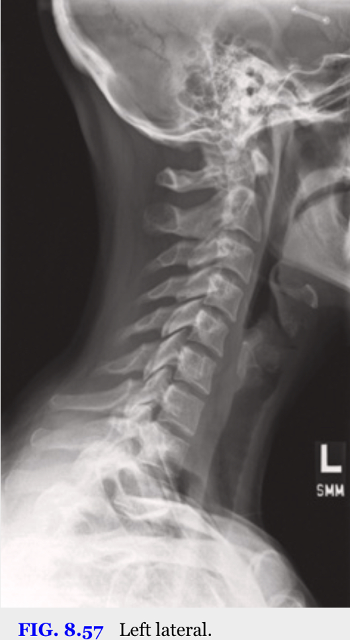
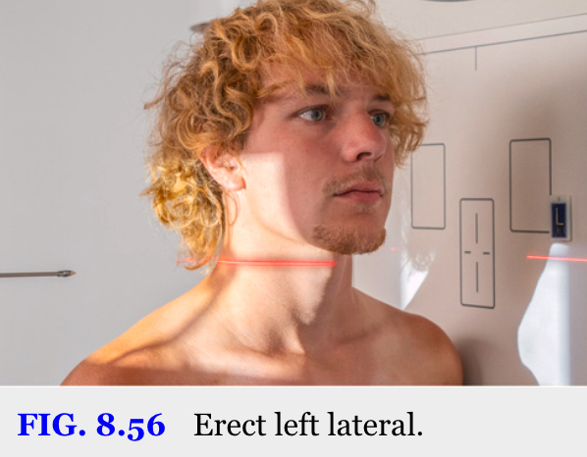
(Lampignano & Kendrick, 2024, p. 321)

Positioning the Patient for an AP Open Mouth (C1 and C2) X-ray
- Preparation:
  - Bring the tube closer to patient. The X-ray tube’s SID to 110 cm.
  - Ensure this is a direct beam setup.
- Patient Positioning:
  - Instruct the patient to stand with their back against the upright Bucky, facing the X-ray tube.
  - Ensure the patient’s feet are shoulder-width apart, with arms resting naturally at their sides.
- Alignment:
  - Ask the patient to open their mouth wide and confirm permission to touch their head for alignment.
  - Align the mastoid tip to the lower margin of the upper incisors (occlusal plane), ensuring this plane is perpendicular to the detector.
- Central Ray and Collimation:
  - CR at the occlusal plane.
  - Align the crosshairs to the midsagittal plane.
  - Collimation:
    - Superiorly: The top of the light field should be just beneath the nose.
    - Inferiorly: The bottom of the light field should be halfway through the chin.
    - Side-to-side: Limit side-to-side collimation to one finger width beyond the neck to minimize radiation exposure.
- Marker Placement:
  - Place the right marker on the detector’s left side, ensuring it is captured within the divergent beam.
- Exposure:
  - Inform the patient: “Please hold still while I take the image.”
  - Take the exposure.
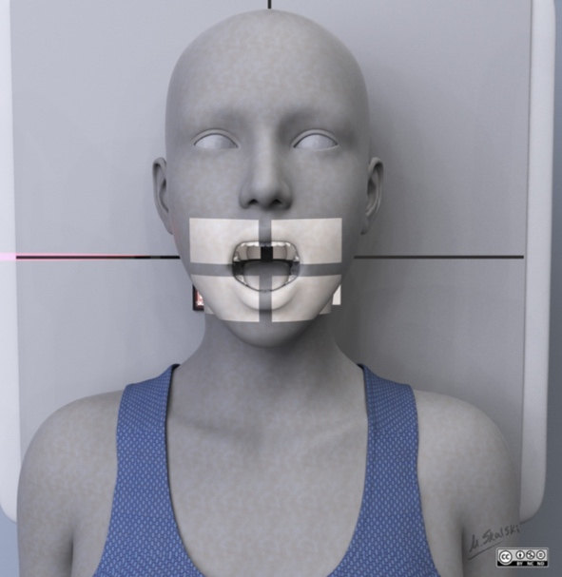
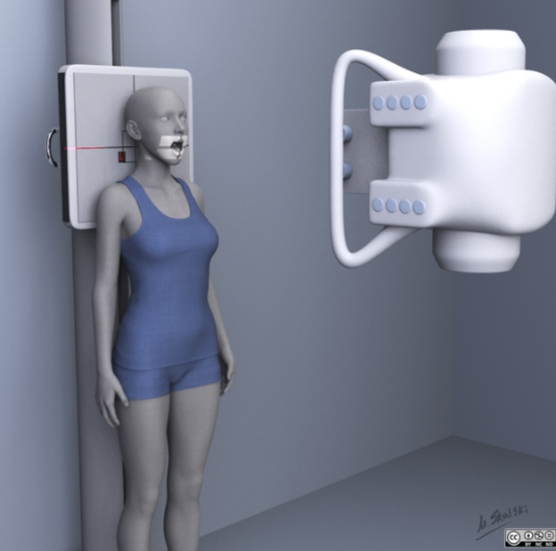
  - Afterward, reassure the patient: “You can relax now.”
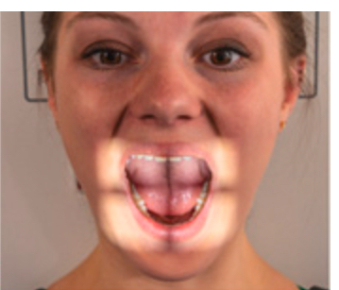
(Murphy, 2023) (Murphy, 2023)
(Lampignano & Kendrick, 2024, p. 318)

Positioning the Patient for an AP Cervical Spine X-ray (C3-C7)
- Tube Adjustment:
  - Lower the X-ray tube and angle the beam 15 degrees cephalad.
  - SID is 110cm
- Patient Positioning:
  - Instruct the patient to stand with their back against the upright Bucky, facing the X-ray tube.
  - Ensure their feet are shoulder-width apart, arms resting naturally at their sides, and eyes looking straight ahead.
- Head Alignment:
  - With the patient’s permission, adjust the head so that the angle of the mandible and the corner of the mouth are perpendicular to the image receptor (IR).
- Central Ray and Collimation:
  - Center the central ray at the laryngeal prominence (C4).
  - Adjust the light field:
    - Superiorly: Collimate to just below the mouth (bottom lip).
    - Inferiorly: Include the jugular notch to capture T2.
    - Side-to-side: Allow one finger-width of spill beyond the width of the neck.
- Marker Placement:
  - Ensure the right marker is positioned on the left side of the patient and is visible within the collimation field.
- Breathing Instructions:
  - Provide instructions: “Take a deep breath in, blow it all out, and hold your breath.”
  - Take the exposure.
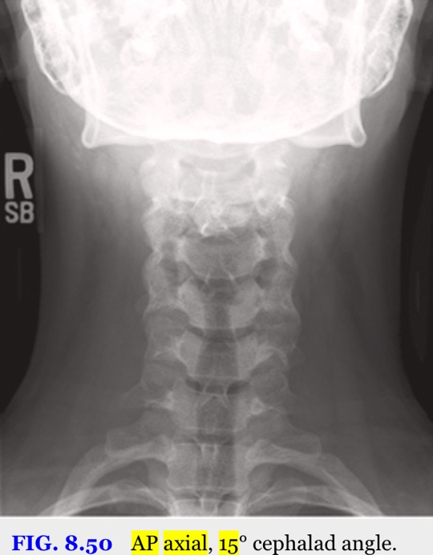
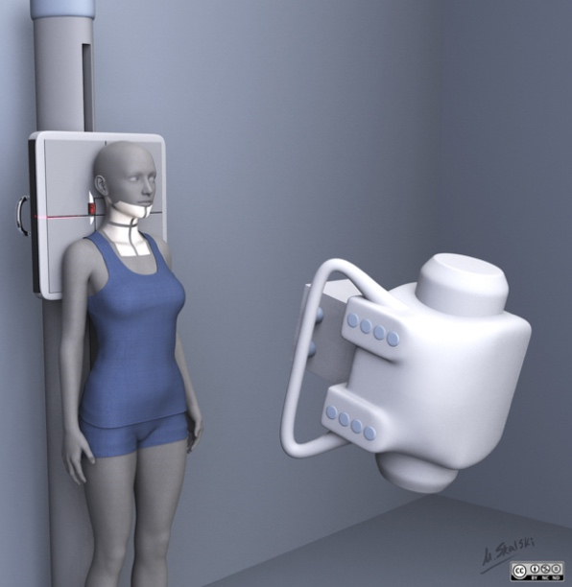
  - Afterward, inform the patient: “You can relax now.”
(Chieng, 2024) (Lampignano & Kendrick, 2024, p. 319)

Positioning the Patient for an AP 15-Degree Axial Oblique (RPO) X-ray
- Tube and SID Adjustment:
  - Ensure the X-ray tube’s SID is 110 cm.
  - Maintain the 15-degree cephalad angle from the previous exposure.
- Patient Positioning:
  - Position the patient with their right posterior side against the detector.
  - Tell Marie that I will be moving her where her right back side is touching the board and ask permission to move.
  - Rotate the patient’s body 45 degrees from lateral or until their acromioclavicular joint is align to the medial border of the scapula.
- Central Ray and Collimation:
  - CR at the laryngeal prominence (C4).
  - Adjust the light field:
    - Superiorly: Collimate to include halfway to the external auditory meatus.
    - Inferiorly: Extend to the jugular notch.
    - Side-to-side: Include soft tissue with one finger-width spill beyond the neck.
- Marker Placement:
  - Place the right marker on the lateral side within the light field, ensuring visibility in the image..
- Breathing Instructions:
  - Instruct the patient: “Take a deep breath in, blow it all out, and hold your breath.”
  - Take the exposure.
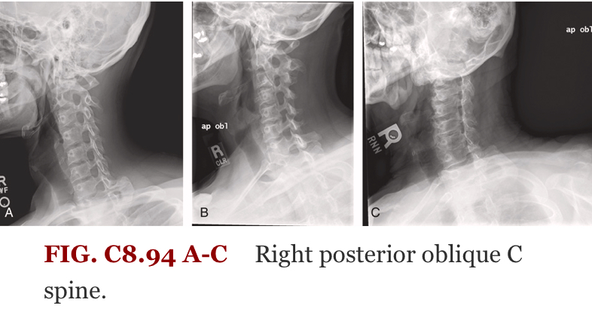
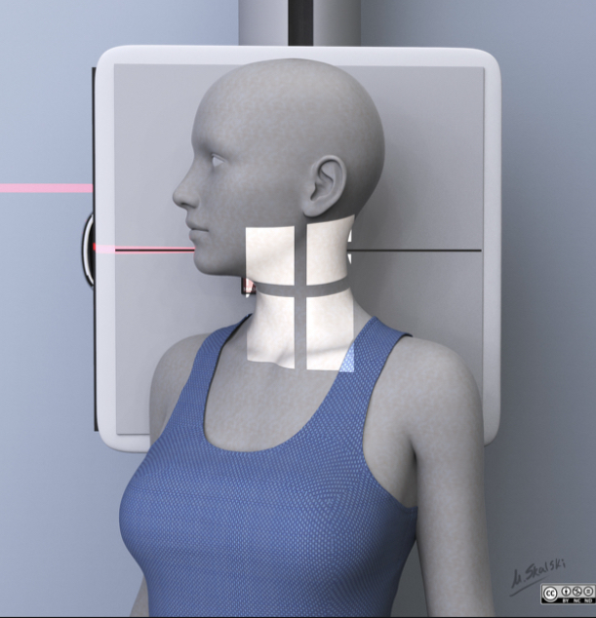
  - Afterward, reassure the patient: “You can relax now.”
(Campos, 2024) (Lampignano & Kendrick, 2024, p. 332)

Positioning the Patient for an AP 15-Degree Axial Oblique (LPO) X-ray
- Tube and SID Adjustment:
  - Ensure the X-ray tube is set to a SID of 110 cm.
  - Maintain the 15-degree cephalad angle from the previous exposure.
- Patient Positioning:
  - Position the patient with their left posterior side against the detector.
  - Tell Marie that I will be doing the same thing but in the left side.
  - Rotate the patient’s body 45 degrees from lateral or until their acromioclavicular joint is align to the medial border of the scapula.
- Central Ray and Collimation:
  - CR at the laryngeal prominence (C4).
  - Adjust the light field:
    - Superiorly: Collimate to include half way through the external auditory meatus.
    - Inferiorly: Extend to the jugular notch.
    - Side-to-side: Include soft tissue with one finger-width spill beyond the neck.
- Marker Placement:
  - Place the left marker on the lateral side within the light field.
- Breathing Instructions:
  - Instruct the patient: “Take a deep breath in, blow it all out, and hold your breath.”
  - Take the exposure.
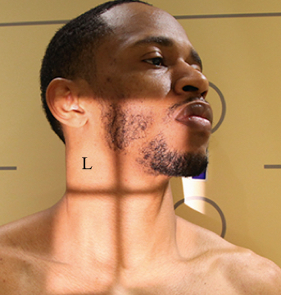
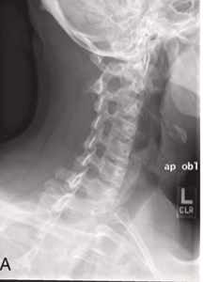
  - Afterward, reassure the patient: “You can relax now.”
(Lampignano & Kendrick, 2024, p. 332) (Anderson College, 2025, slide 40)

Dismissal
“Marie you are all done! You can change back to your regular clothes. The doctor should get the report in 2-3 business days. Do you know your way out?”
Once she leaves, clean the room by wiping the IR, x-ray tube, and console. Then, finish the paperwork.

References
Anderson College. (2025, January). MRAD 256: Radiographic Technique 2 Cervical Spine. Lecture.

Campos, A. (2024, July 26). Cervical spine (AP oblique view) | radiology reference article | radiopaedia.org. Cervical Spine (AP Oblique View). https://radiopaedia.org/articles/cervical-spine-ap-oblique-view

Chieng, R. (2024, May 13). Cervical spine (AP view) . Cervical Spine (AP View). https://radiopaedia.org/articles/cervical-spine-ap-view
Lampignano, J. P., & Kendrick, L. E. (2024). Radiographic positioning and related anatomy. Mosby.
Murphy, A. (2023, March 23). Cervical spine (odontoid view). Cervical Spine (Odontoid View). https://radiopaedia.org/articles/cervical-spine-odontoid-view

