Activity: Test 14 Lead Apparel Testing Procedure

Purpose
This activity will help you identify the procedure steps for this test.

Instructions
- Review the images below of the equipment and materials used at Edenbrook for this test.
- Review the procedure steps from the Edenbrook MRT lab.
- Compare the textbook readings and your practicum site QA manual for similarities and differences.

Equipment
- Lead apparel to be tested
- Lead markers (numbers or letters)

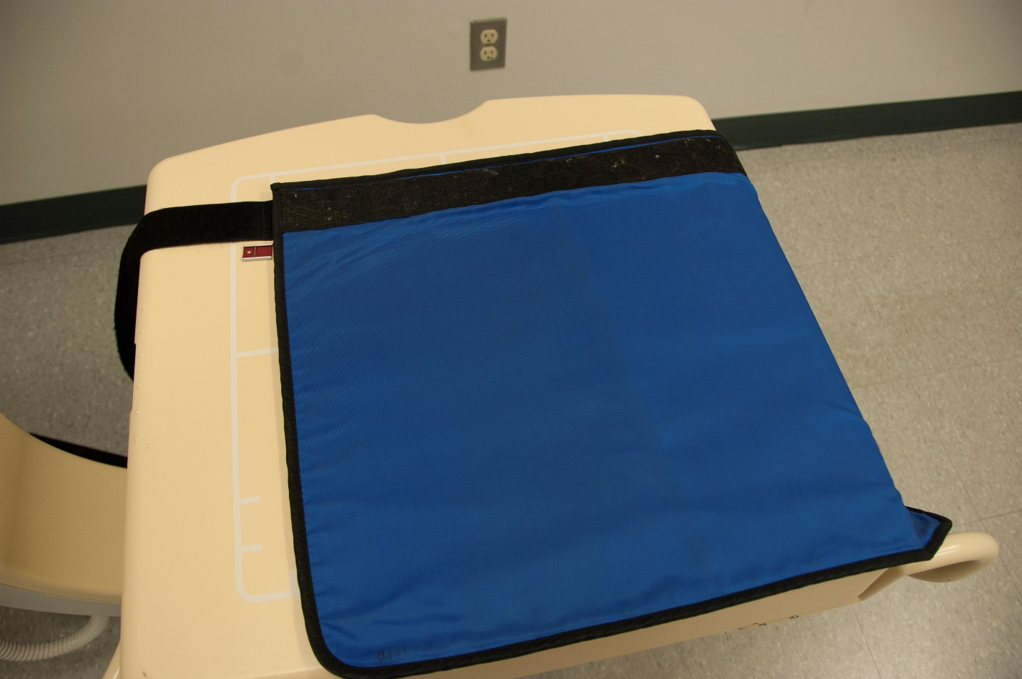

Edenbrook MRT Procedure Steps
- Confirm that all lead apparel (aprons, gloves, thyroid collars, lead curtains, etc.) have an ID number and a permanent label stating the lead equivalency. Note if any information is missing and record.

- Centre the tube over the table, using a 110 cm SID. Use the largest field size appropriate to cover as much of the lead apparel as possible. Start in one corner and position subsequent exposures to ensure overlap.

- Label the images using the lead markers (numbers or letters) ensuring that the area underneath the marker has been imaged and the marker is not obscuring any crack or hole.

- Expose apparel using 80 kVp and 5 mAs.

- Take exposures until the entire article of lead apparel has been imaged with overlap.

- Expose apparel using 50 kVp and 4 mAs.

