Activity: Test 17 Maximum Fluoroscopic Exposure Rate Procedure

Purpose
This activity will help you identify the procedure steps for this test.

Instructions
- Review the images below of the equipment and materials used at Edenbrook for this test.
- Review the procedure steps from the Edenbrook MRT lab.
- Compare this procedure, the textbook reading and your practicum site QA manual for similarities and differences between a C-arm and dedicated fluoro unit.

Equipment
- Dosimeter
- Lead sheets
- Calculator

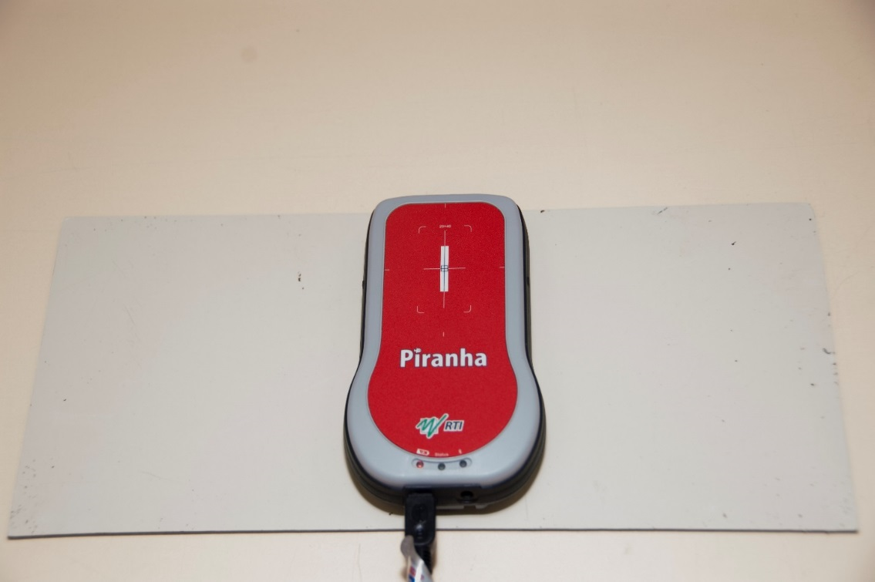

Edenbrook Procedure Steps (Note: using C-arm at EDENBROOK is limited by equipment)
- Position the C-arm with the image intensifier under the table.

- Centre the X-ray tube over the dosimeter and collimate appropriately. Set the dosimeter to measure exposure rate (R/min).

- Use the crosshairs to align the dosimeter, ensuring it is in the centre of the image.

- This test will be done using the continuous fluoro, pulse and low dose settings.

- Place a lead sheet under the dosimeter. Ensure the beam is completely attenuated by the lead.

- Fluoro until the ABC/AIC stabilizes.

- Continue adding lead sheets until the exposure rate no longer changes (minimum is 6 mm of lead thickness).

- Record the results.

