RADP 215 – Radiation Protection
Activity – Entrance Skin Exposure/Entrance Skin Dose Calculations – ANSWER KEY

Activity: Entrance Skin Exposure/Entrance Skin Dose Calculations
Purpose:
To apply the correct formulas to calculate entrance skin exposure/entrance skin dose calculations.
Instructions:
- Refer to the following chart to answer the questions below.
- If you would like feedback on your work, email your instructor. Compare your answers with the answer key.
mG ImAs 110 cm SID
 |  |  mG ImAs
50 |  | 0.01
60 |  | 0.02
70 |  | 0.025
80 |  | 0.03
90 |  | 0.035
100 |  | 0.04
110 |  | 0.045
120 |  | 0.05
1 . At 70kVp what is the output according to the chart?
0.025 mGy/mAs
- At 120 kVp what is the output according to the chart?
0.05 mGy/mAs
- How does output change as the kVp increases?

kVp is increased, x-ray intensity would increase

- What is the intensity using an output of 60 kVp @ 2 mAs?
0.02 mGy/mAs x 2mAs = 0.04 mGy
- What is the intensity using an output of 100 kVp @ 100 mAs?
0.04mGy/mAs x 100mAs = 4.0 mGy
- What is the formula for the inverse square law?
^{Z}
Tl _(dJ

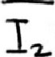 -(äjz
7. Using the table above, what is the approximate entrance skin exposure for a 15 cm
AP hip produced at 80 kVp @ 20 mAs? Patient distance from IR is 8cm. SIO-2i\O
TS.L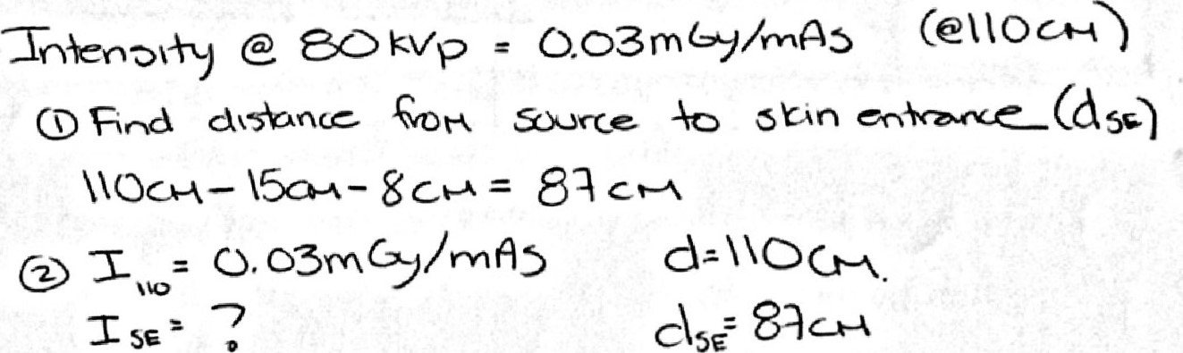
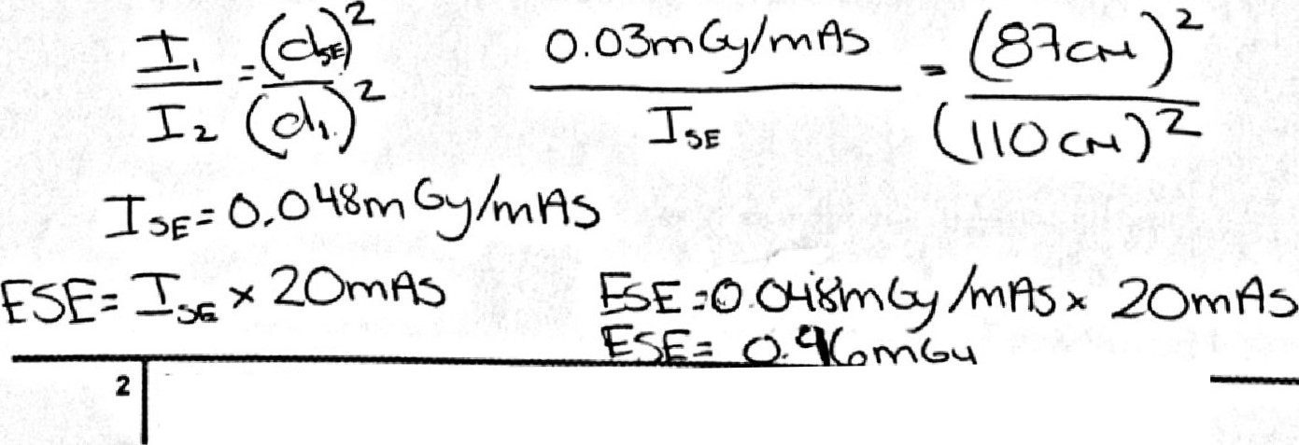

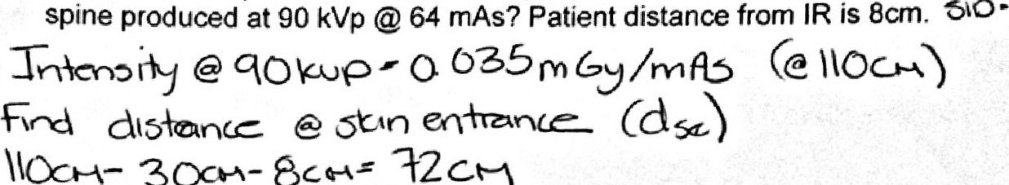
8. Using for a 30 cm lateral Lspine
the
table
provided,
what
is
the
approximate
ESE
300-4-
Oct-v
72CM
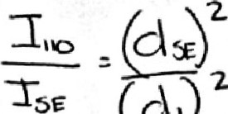
0 oa5-nCy/mPö -€2 co
^{L}
(31)
Q \0ct-4)
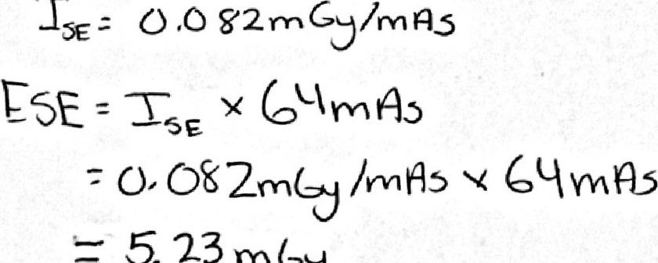
5.23mCy
g. Using the table provided, what is the approximate ESE for a 25cm PA chest produced at 110 kVp @ 2.0mAs and an SID of 180cm? Patient distance from IR is 8cm.
Tn\en4y
=
A3mGy
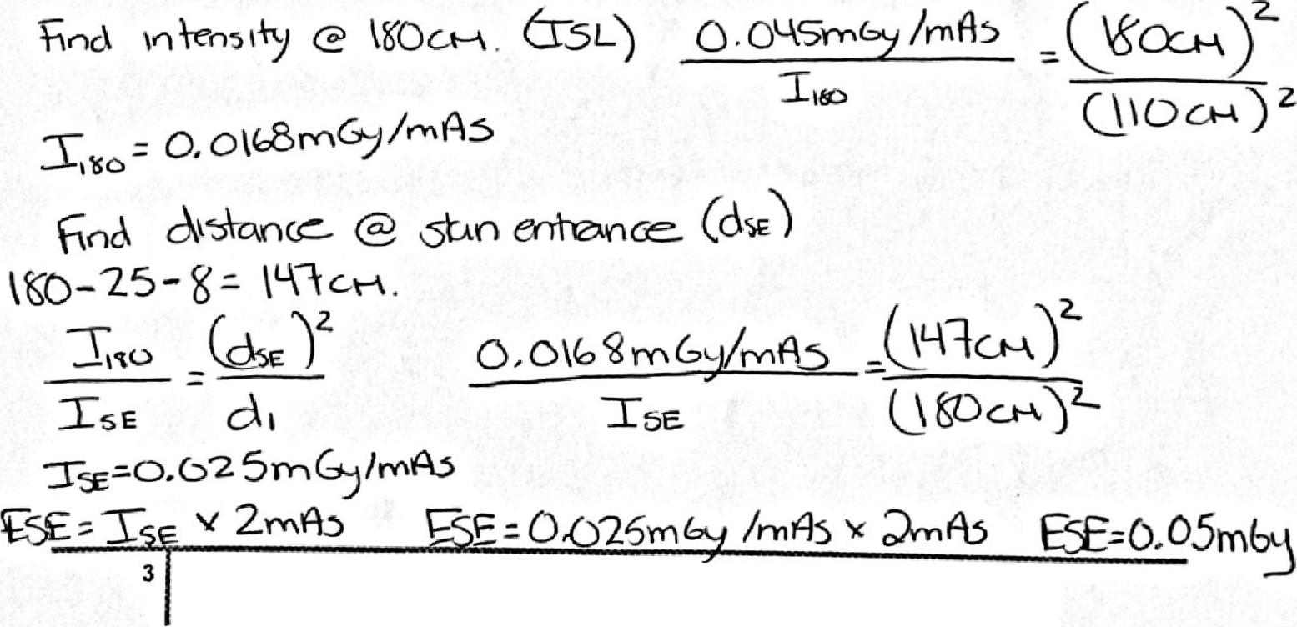

Using the nomogram on pg. 570 in Bushong textbook answer the following questions:
10. Estimate the ESE from an AP shoulder x-ray using IOOcm. The technical factors used were 80 kVp @ 12.5mAs. The unit has 3.0 mm filtration

mGy1100mAs (read from chart)
5 mGy/100 mAs x (12.5/100) mAs = 0.625.mGy

Total ESE= 0.625mGy for the AP shoulder xray
I l . Estimate the ESE from a PA hand x-ray using 100cm SID. The technical factors used were 60kVp @ 2mAs. The unit has 2.5 mm filtration
3.5 mGy/100mAs (read from chart)
3.5 mGy/100 mAs x (2/100) mAs = 0.07 mGy

Total ESE* 0.07 mGy for the PA hand x-ray

