Activity: Test 19 Fluoroscopic Line Pair Resolution Procedure

Purpose
This activity will help you identify the procedure steps for this test.

Instructions
- Review the images below of the equipment and materials used at Edenbrook for this test.
- Review the procedure steps from the Edenbrook MRT lab.
- Compare this procedure and your practicum site QA manual for similarities and differences between a C-arm and dedicated fluoro unit.

Equipment
- Line pair test tool

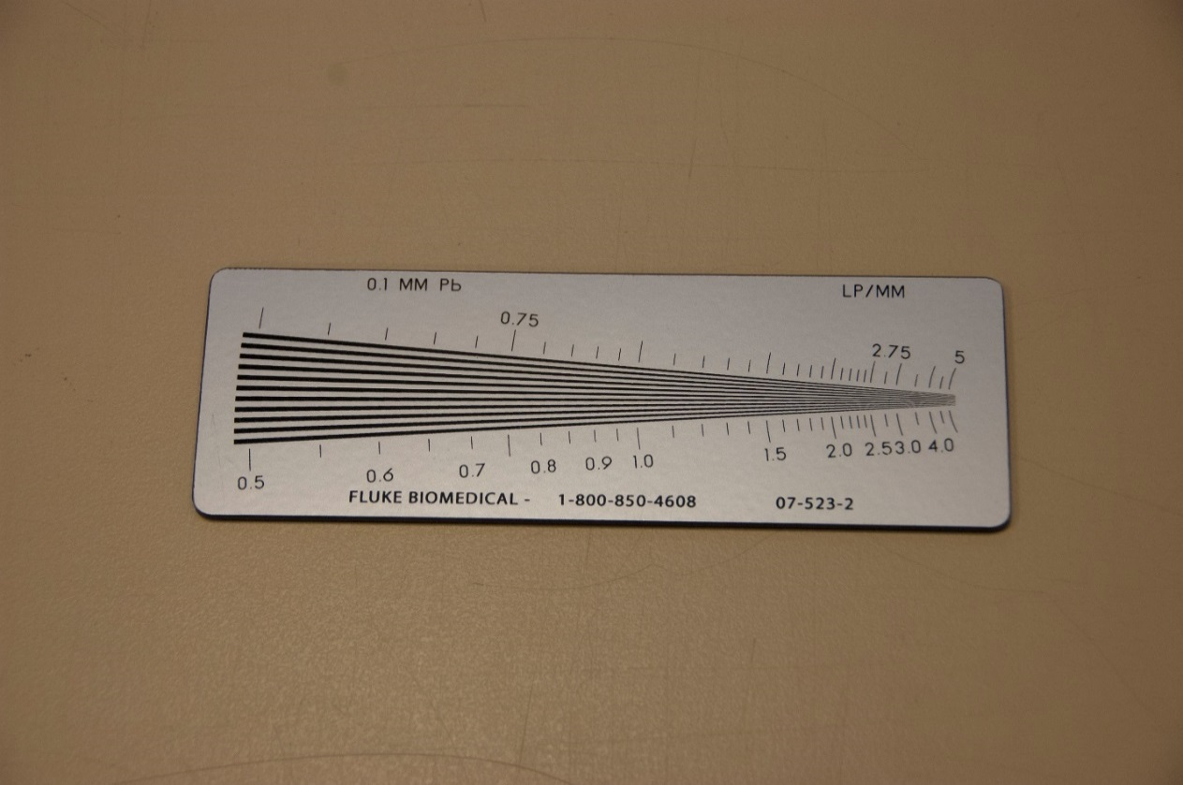

Edenbrook MRT Procedure Steps (Note: using C-arm is limited by equipment)
- Position the C-arm with the image intensifier on the bottom.

- Centre the line pair test tool on the image intensifier and collimate appropriately to include the entire test tool.

- Using 90 kVp on the continuous fluoro setting, expose for 2 seconds and determine how far down the test tool the differences between the lines and spaces can be clearly visualized. Record the results.

The resultant image will look like this:
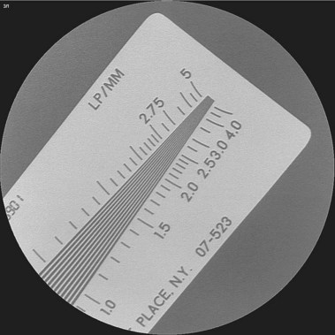
Source: Clinical Gate. Reproduced and used in accordance Fair Dealing Policy (Schedule A, Copyright of External Materials Procedure AC.2.12.1); further distribution may infringe copyright. Retrieved from http://clinicalgate.com/wp-content/uploads/2015/02/B9781437715293000373_f037-004-9781437715293.jpg

- Repeat step 3 on both magnification settings and record the results.

- Change the fluoro setting to low dose and repeat steps 3 and 4. Record the results.

