INFC 215: Infection Prevention and Control- Summary Sheet
Module One: Characteristics of Microorganisms

Topic 1.1: Microorganisms
- too small to be seen without the aid of a microscope
- <0.1 mm
- usually unicellular
- also called “germs”, “microbes“, “bugs”
Groups of Microorganisms
In order of decreasing size:
- Protozoa: unicellular animals; move - flagella or ameboid motion;
e.g., microbe Giardia that causes “beaver fever“


- Fungi: primitive plants
- yeasts – unicellular


e.g., Candida – oral “yeast” infections, yeast vaginitis, skin infections, yeast diarrhea following antibiotic therapy
- molds – multicellular
e.g., microbe that causes ringworm and athlete’s foot
- Bacteria: unicellular; no organized nucleus cell wall
e.g., causative agent of strept throat, staph infections, salmonella infections
- Viruses: a bit of DNA or RNA surrounded by protein coat and sometimes lipid coat; grow only in other living cells; e.g. influenza virus, mumps, measles, rubella
Size of Microbes
- unit of measurement = micrometer = 1/1000 mm
Topic 1.2: Bacteria
Shapes of Bacteria
 | 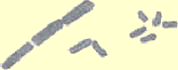 |  | Average Size 1 μm.
round = cocci  (coccus) | rectangular = rods/bacilli  (bacillus) | spiral/curved = spirilla  (spirillum)
Figure 1.4
Gram Reaction of Bacteria
- Bacteria stained with Gram's staining procedure, appear dark blue (Gram positive) or red (Gram negative); determined by cell wall structure
∴ possibilities: Gram + cocci; Gram - cocci, Gram + rods, Gram - rods, Gram + spirilla, Gram – spirilla
- Why the Gram reaction is important:
- first step in identifying bacteria (look at shape and Gram reaction)
- determines effectiveness of antibiotics
- determines effectiveness of disinfectants
Bacterial Endospores
- only a few bacteria (some gram positive bacilli such as tetanus, gangrene, botulism, anthrax) can form these under adverse conditions (too dry, too cold, lack of nutrients).
- Spores vegetate (start growing) when growth conditions become good
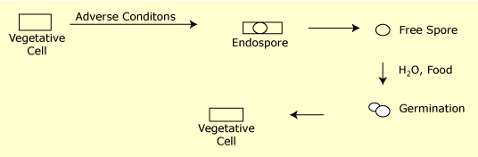
Figure 1.5
- spores resist drying, heat and disinfectants (i.e. hard to kill)
- heat: may take 121°C to kill
- disinfectants: require high level disinfectant and long exposure time
Bacterial Growth
- Reproduce by binary fission:
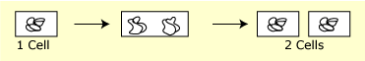
Figure 1.6
Time for this to occur (for population to double) = generation time = 15-30 minutes for rapidly growing bacteria, under ideal conditions (enough food, H₂0, correct temperature)
- In lab, grow bacteria on culture media
- Colony = visible mass of bacteria that forms on surface of solid culture media; usually takes 18-24 hours to form from 1 original cell; each colony is a clone - all descendants of a single bacterial cell.
Bacterial Growth Curve
- 4 phases:
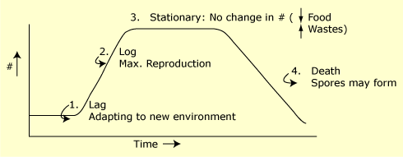
Figure 1.7
- Relating growth curve to infection:
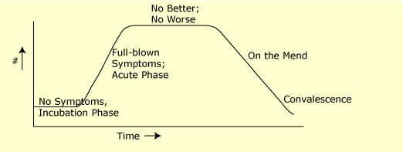
Figure 1.8
Topic 1.3: Viruses
Viral Characteristics
- distinctive features:
- metabolically inert - can multiply only in living host cells
- contain DNA or RNA, not both
- have protein coat that surrounds nucleic acid ± lipid envelope
Strangely, lipid viruses are generally easier to destroy than those with only a protein coat. (exception Hepatitis B – lipid virus survives 7 days on surfaces)
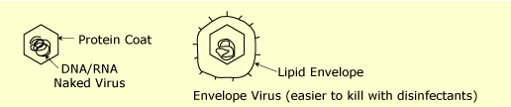
Figure 1.9
Multiplication of Animal Viruses
- Attachment to complementary site on host cell membrane
- Penetration
- Viral nucleic acid → nucleus: takes command of host cell and directs synthesis of new viral components
- Synthesis of viral components:
- nucleic acid - in nucleus
- protein coat - in cytoplasm
- Assembly of viral components
- Release from host cell
Effects of Viruses on Host Cell
- Usually host cell dies (lysis; diversion of metabolic pathways; destroyed by host's own lymphocytes)
- Host cell may be transformed into tumor cell
Control of Viruses
- Antibiotics have NO effect
- Antiviral drugs : acyclovir; ZDV etc
- More and more anti virals being developed. Problem is that viruses are inside host cells – have to develop drugs which will destroy viruses without destroying host cells.

