Image Critique Questions

Module 4
- Use the 5 evaluation criteria categories when critiquing the following images to determine if they are diagnostic:

- Is all the required anatomy included in the radiograph?
Lateral wrist @ 65 kVp

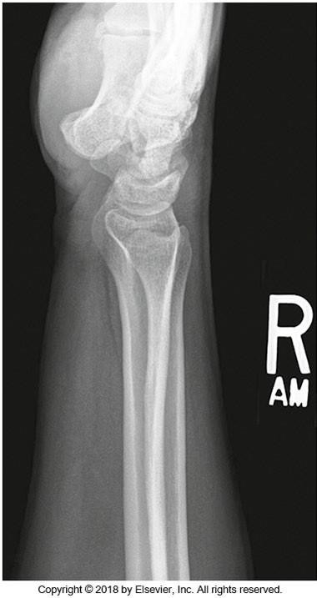
Yes No
*If no, explain what is required

- Does the anatomical appearance in the radiograph correlate to what is expected from a lateral projection?
Yes No
*If no, explain how the appearance of this radiograph is different compared to the ideal radiograph

- Identify if the appropriate amount of radiation was used to form the image. 
Acceptable, Overexposed, Underexposed
  - Is motion present in the image?
Yes  No

- Identify if the collimated light field was: Acceptable, Too Small, Too Large
  - Was the CR close to the middle of the required
anatomy? Bontrager 9th Ed. pg. 175 Fig. C4.161
Yes No

- Does the marker placement follow Edenbrooki Marker Rules?
Yes No

  - Are there artifacts in the image?
Yes No
*If yes, could they have been removed?
Is this image diagnostic? Yes No

- Use the 5 evaluation criteria categories when critiquing the following images to determine if they are diagnostic:
- Is all the required anatomy included in the radiograph?
Yes No

*If no, explain what is required

- Does the anatomical appearance in the radiograph correlate to what is expected
from a PA projection?
Yes No
*If no, explain how the appearance of this radiograph is different compared to the ideal radiograph

- Identify if the appropriate amount of radiation was used to form the image. Acceptable, Overexposed, Underexposed
  - Is motion present in the image?
Yes No
- Identify if the collimated light field was: Acceptable, Too Small, Too Large
  - Was the CR close to the middle of the
required anatomy?
Yes No
PA Wrist @ 65kVp
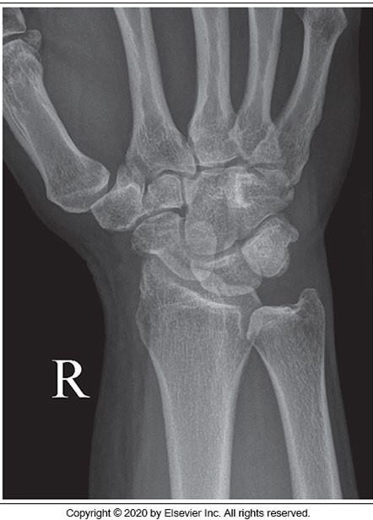
McQuillen Martensen 5th Ed. pg. 192 Fig. 4.69

Is this image diagnostic? Yes No

- Does the marker placement follow Anderson’s Marker Rules?
Yes No
  - Are there artifacts in the image?
Yes No
*If yes, could they have been removed?

- Use the 5 evaluation criteria categories when critiquing the following images to determine if they are diagnostic:

- Is all the required anatomy included in the radiograph?
Oblique wrist @ 60 kVp

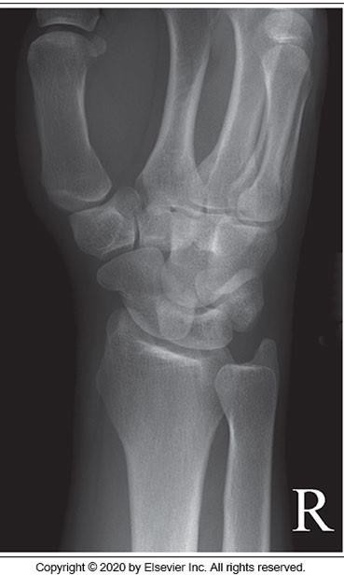
Yes No
*If no, explain what is required

- Does the anatomical appearance in the radiograph correlate to what is expected from an oblique projection?
Yes No
*If no, explain how the appearance of this radiograph is different compared to the ideal radiograph

- Identify if the appropriate amount of radiation was used to form the image.
Acceptable, Overexposed, Underexposed
  - Is motion present in the image?
Yes No

- Identify if the collimated light field was: Acceptable, Too Small, Too Large
  - Was the CR close to the middle of the required
anatomy?
Yes No

McQuillen Martensen 5th Ed. pg. 199 Fig. 4.89

Is this image diagnostic? Yes No

- Does the marker placement follow Anderson’s Marker Rules?
Yes No 
  - Are there artifacts in the image?
Yes No
*If yes, could they have been removed?

- Use the image below to answer the next five questions:

- Which routine projection of the wrist is displayed?

- What positioning error(s) occurred?

- If the image was repeated, how would you correct the positioning error(s)?

- How did you identify the positioning error(s)?
59 kVp
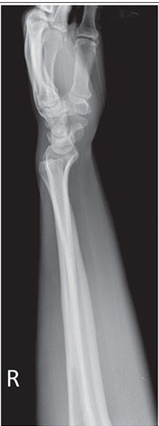
McQuillen Martensen 5th Ed. pg. 206 Fig. 4.105

- If the image had to be repeated, would you make any other adjustment(s)? Explain your rationale.

- Use the image below to answer the next five questions:

- Which routine projection of the scaphoid is displayed?

- What positioning error(s) occurred?

- If the image was repeated, how would you correct the positioning error(s)?

- How did you identify the positioning error(s)?
69 kVp

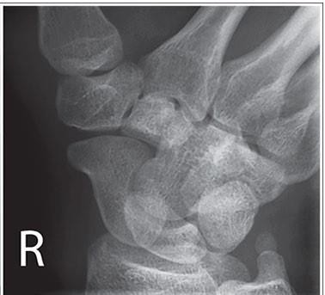
McQuillen Martensen 5th Ed. pg. 211 Fig. 4.112
150

- If the image had to be repeated, would you make any other adjustment(s)? Explain your rationale.

- Use the 5 evaluation criteria categories when critiquing the following images to determine if they are diagnostic:

  - Is all the required anatomy included in the radiograph?
Yes No
*If no, explain what is required

  - Does the anatomical appearance in the radiograph correlate to what is expected from a 15⁰ PA Axial projection?
PA 150 Axial Scaphoid @ 66kVp

Yes No
*If no, explain how the appearance of this radiograph is different compared to the ideal radiograph

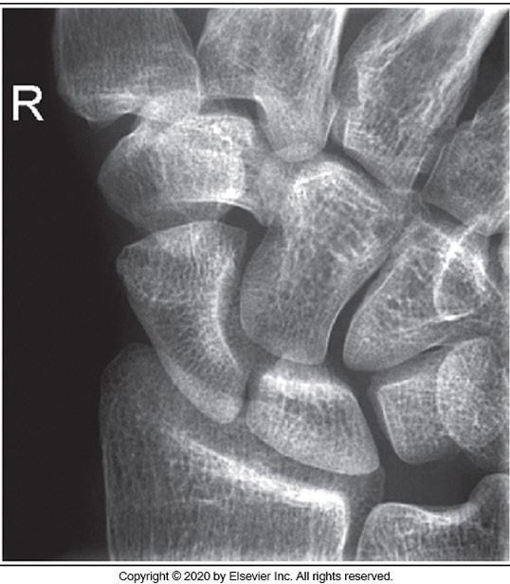
McQuillen Martensen 5th Ed. pg. 212 Fig. 4.114

  - Identify if the appropriate amount of radiation was used to form the image.
Acceptable, Overexposed, Underexposed
    - Is motion present in the image?
Yes No

  - Identify if the collimated light field was:
Acceptable, Too Small, Too Large
    - Was the CR close to the middle of the required anatomy?
Yes No

Is this image diagnostic? Yes No

  - Does the marker placement follow Anderson’s Marker Rules?
Yes No
    - Are there artifacts in the image?
Yes No
*If yes, could they have been removed?

- Use the 5 evaluation criteria categories when critiquing the following images to determine if they are diagnostic:
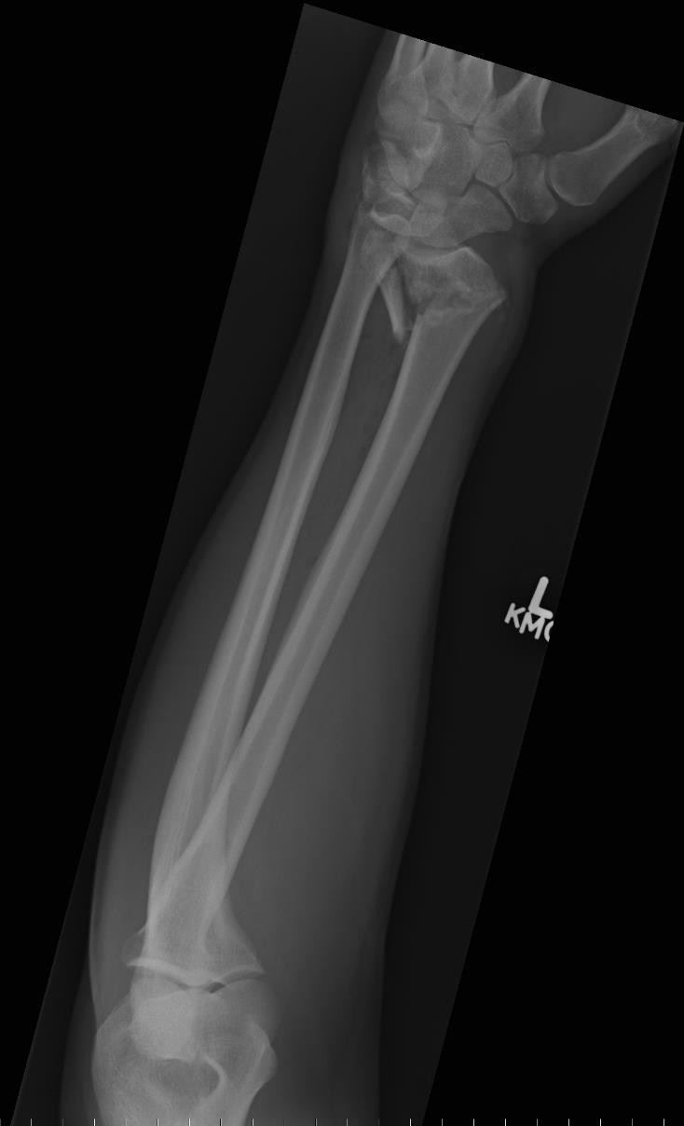
AP Forearm @ 66kVp
- Is all the required anatomy included in the radiograph?
Yes No
*If no, explain what is required

- Does the anatomical appearance in the radiograph correlate to what is expected from an AP projection?
Yes No
*If no, explain how the appearance of this
radiograph is different compared to the ideal radiograph

- Identify if the appropriate amount of radiation was used to form the image.
Acceptable, Overexposed, Underexposed
  - Is motion present in the image?
Yes No
- Identify if the collimated light field was: Acceptable, Too Small, Too
Large
  - Was the CR close to the middle of the

- Does the marker placement follow Anderson’s Marker Rules?
Yes No
  - Are there artifacts in the image?
Yes No

SAIT imaging library

Is this image diagnostic? Yes No

- Use the image below to answer the next five questions:

- Which routine projection of the forearm is displayed?

- What positioning error(s) occurred?

- If the image was repeated, how would you correct the positioning error(s)?

- How did you identify the positioning error(s)?
60 kVp

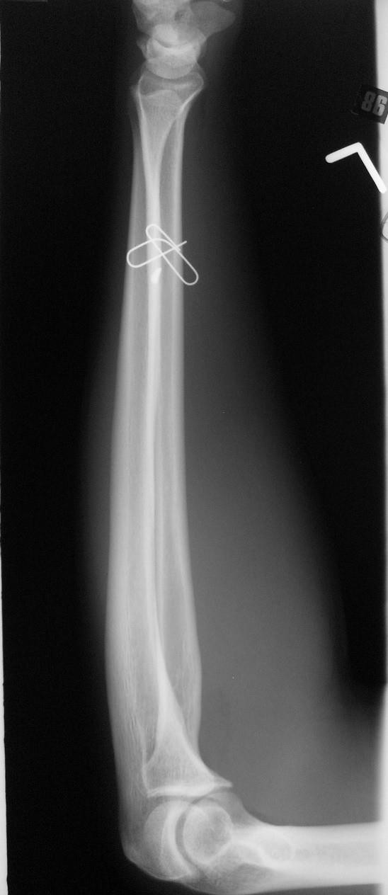
SAIT imaging library

- If the image had to be repeated, would you make any other adjustment(s)? Explain your rationale.

