CT Imaging of the Neck CT Imaging of the Chest

Part 1 – Anatomy

- What are the 3 sections of the pharynx, superior to inferior? Nasopharynx, Oropharynx, Laryngopharynx

- What are the 3 pieces of cartilage that make up the larynx? Epiglottis, Thyroid cartilage, Cricoid cartilage

- Which is anterior, the trachea or the esophagus? Trachea

- At what vertebral level does the trachea bifurcate? T5

- What is this bifurcation called, and what does it bifurcate into? Carina; right and left primary bronchi (or mainstem bronchi)

- What is the structure that joins the right and left lobe of the thyroid gland? Isthmus

- Name the 3 pairs of salivary glands. Sublingual, parotid, submandibular

- Where are the parotid glands located? Posterior to the rami of the mandible

- From left to right, name the arterial branches off the aortic arch. Left subclavian, Left common carotid, Brachiocephalic

- The artery branches into the right subclavian artery and the right common carotid artery.
Brachiocephalic

- The carotid arteries sit to the jugular veins. Medially

- The external carotid arteries sit (anterior/posterior) to the internal carotid arteries. Anterior

- Just above the level of bifurcation, the external carotid artery is (medial/lateral) to the internal carotid arteries.
Medial

- As it ascends the neck, at a higher level, the external carotid artery is (medial/lateral) to the internal carotid arteries.
Lateral

- What arteries travel through the transverse foramina of the cervical vertebrae? Vertebral arteries

- What are typically the largest blood vessels in the neck? Internal jugular veins

- The internal jugular veins sit to the carotid arteries. Laterally

- What vessels appear circled on the image?
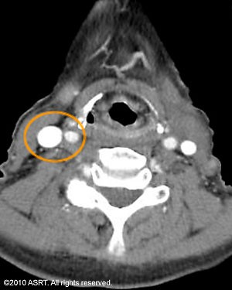 Common carotid artery & internal jugular vein

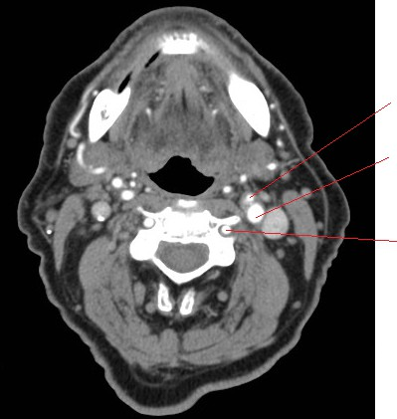
- Label the anatomical structures on the image below:
  - Left external carotid artery
  - Left internal carotid artery
  - Left vertebral artery

- Describe the differences between the right and left lungs.

Right lung –3 lobes, primary bronchus divides into 3 segments, veins drain into azygos v.
Left Lung –2 lobes, primary bronchus divides into 2 segments, veins drain into hemiazygos or intercostal veins.

- List the fissures and segments of each lung.

Right lung – oblique fissure separating superior & inferior lobes. Horizontal fissure segmenting the middle lobe.
Left lung – oblique fissure separating superior & inferior lobes.

- What is the pleura? List and describe the 2 pleural layers.

Serous membrane lining of the pleural cavity, in 2 layers. Visceral layer is internal and insensitive to pain, parietal layer is external and insensitive to pain.

- What is the hilum? List some of the structures that pass through the hilum.

Medial, concave opening within the “notch” of the lungs. Also called the “root” of the lung. Allows passage of bronchi, vessels and nerves.
- What structures are contained within the mediastinum?

Aortic arch, vessels, veins, a portion of the thymus, trachea, esophagus and nerves.

- List and describe the 4 chambers of the heart.

Right Atrium
  - Thin-walled, receives venous blood from coronary and systemic circulation
  - Openings include the SVC and IVC which return venous blood from systemic circulation; and the tricuspid valve.

Right Ventricle
  - Triangular shaped, receives blood from the right atrium via the tricuspid valve and sends the blood into the pulmonary trunk for oxygenation.
  - Openings include the pulmonary semilunar valve

Left Atrium
  - Most posterior aspect of the heart
  - Thick-walled, receives oxygenated blood from the lungs via the 4 pulmonary veins (2 on each side)
  - Openings include the bicuspid or mitral valve.

Left ventricle
  - Thick-walled and strong, acts as the main pump
  - Receives oxygenated blood from the left atrium via the bicuspid valve, and sends the blood throughout the body via the aorta.
- The aortic arch lies superiorly to the pulmonary arteries.

- The aortic arch corresponds to approximately which vertebral level? T3

- The thoracic aorta sits anteriorly and to the left of the vertebral column.

- The pulmonary trunk arises from which chamber of the heart? Right ventricle

- The IVC enters which chamber of the heart? Right atrium

- Name the 3 branches of the aortic arch. Brachiocephalic trunk, left common carotid artery, left subclavian artery

- The brachiocephalic trunk divides into which two arteries? Right common carotid artery and right subclavian artery.

- The right brachiocephalic veins are forms by the union of the: subclavian veins and the internal jugular veins

- The left brachiocephalic vein sits anteriorly to the branches of the aorta.

- The right and left brachiocephalic veins unite to form the SVC .

- Label the image below:
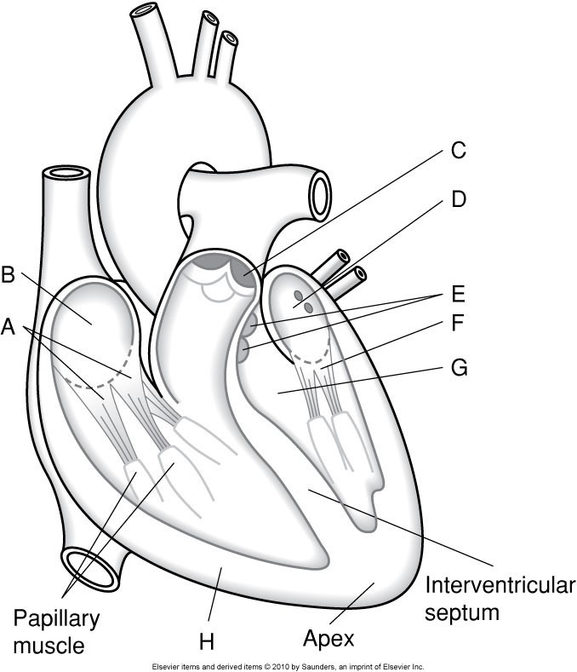

- Tricuspid Valve
- Right Atrium
- Pulmonary semilunar valve
- Left pulmonary veins
- Aortica semilunar valves
- Bicuspid Valve
- Left Ventricle
- Right Ventricle

- Label the image below:

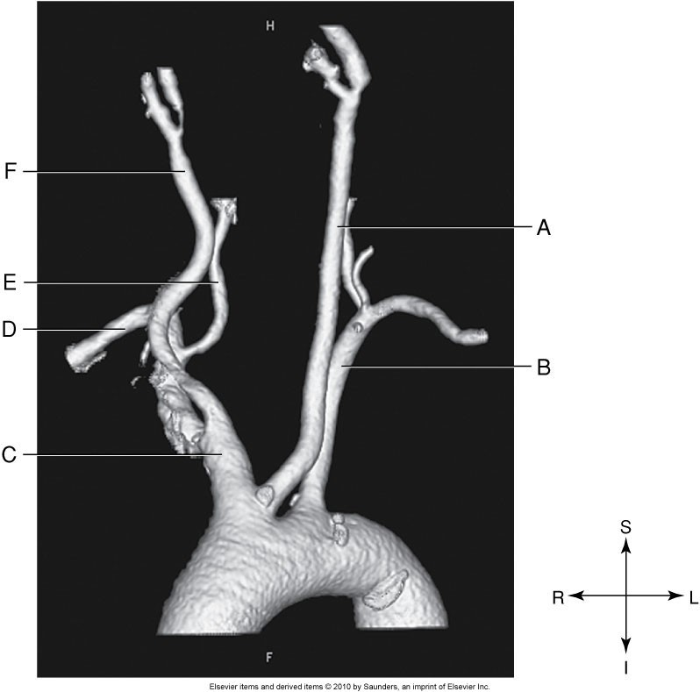
- Left Common Carotid Artery
- Left Subclavian Artery
- Brachiocephalic Artery
- Right Subclavian Artery
- Right Vertebral Artery
- Right Common Carotid Artery

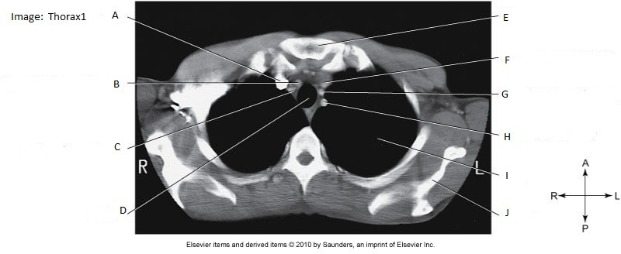
- Label the image. What vertebral level is this slice taken at? How can you tell?

A. Right brachiocephalic Vein B. Right Common Carotid Artery
C. Right Subclavian Artery D. Trachea
E. Sternum F. Left Brachiocephalic Vein
G. Left Common Carotid Artery H. Left Subclavian Artery
I. Left Lung J. Scapula
Slice is taken above the heart and above the aortic arch (T2T3). Can tell because SC joints and superior border of the scapula are visible.

29. Label the image. What vertebral level is this slice taken at? How can you tell?
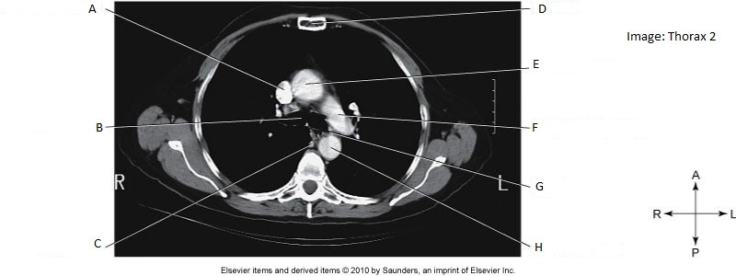

A. Superior Vena Cava B. Right bronchus
C. Azygos Vein D. Sternum
E. Ascending Aorta F. Left Pulmonary Artery
G. Esophagus H. Descending Aorta
This slice is taken just below the level of the sternal angle and aortic arch (T5 T6). Can tell because the image is just inferior to the pulmonary tree, the pulmonary artery is seen.

Part 2 – Imaging Procedures

- What window width & window level are commonly used to display standard (soft-tissue) algorithm of the neck?
WW 160 WL 140

- What is the advantage of using a soft algorithm for a CECT neck?
Used for low-contrast areas, with small differences in tissue attenuation, and reduces noise.
- List at least 3 indications for a CECT neck. Thyroid assessment
Neck mass
Vascular abnormality Lymphadenopathy

Cysts Abscess

- List one indication for a NECT neck. Salivary stones

- Describe the most common type of stroke
Iscehmic stroke, 80% of strokes. Deficiency of oxygen to brain tissue. Can be thrombotic (blood clot forms within an artery, or embolic, travelling clot gets lodged within an artery.

- List 5 clinical indications for stroke / TIA that would prompt a CT neck/head scan.
Vision loss, paralysis, speech problems, tingling, numbess, unilateral symptoms, confusion, pain in left arm, dizziness, loss of consciousness, headache, nausea, vomiting, difficulty swallowing, weakness in extremities.

- What anatomy should be included on a CECT neck? mid-orbit -> Clavicles (T2 T3)

- What is the approximate kVp / mA used for a CECT neck? 120 kVp, 150 mA (auto mA)

- Describe the contrast protocol for a CECT neck.
Split bolus = 50 ml at 1.5 ml/sec, 2 min delay, 75 ml at 1.5ml/sec. Scan 20-30 sec following second injection.

- What anatomy should be included on a CTA neck CoW & Carotids? Aortic Arch -> Just above frontal sinus

- What is the approximate kVp / mA used for a CTA neck? 120 kVp, 500 mA

- CTA CoW and Carotids usually include MIP reconstructions.
  - Describe MIP Maximum Intensity Projection. Thin slices. MIP looks at each vosel along a line, and selects the voxel with the highest CT number in that data set to be displayed. Results in bright contrast-filled structures, and lower attenuation structures are ignored and not displayed well.
  - What is the appropriate WW and WL? WW 800 WL 200
- What is the contrast protocol for CTA Cow & Carotids?
80 ml at 4ml/sec. Use Bolus Tracking software, with ROI on the carotid artery at the level of C4.

- How does an emboli appear on CT? Filling defect

- List 2 challenges in scanning the patient’s chest, and how you as the technologist could manage this challenge.
Motion (cardiac or respirtation). Manage by selecting the shortest scan time possible, or scan caudal-cranial.
Patient unable to raise arms above head – Use immobilization, or can scan with patient’s arms at sides.

- What is an appropriate lung window width & window level? WW 1500, WL -700

- List 3 indications for a NECT chest.
Screening, detection and evaluation of lung nodule, primary lung diseases like emphysema or fibrosis.

- When is contrast indicated for a CT scan of the chest?
Differentiate between vascular and avascular structures, characterize vascular structures, evaluate vessels and lesions. Infection, mass, empyema, correlate with chest x-ray, congenital abnormalities, trauma, lung ca.

- What anatomy should be included for a CECT chest? Above lung apices -> below costophrenic angles

- For Chest CT, a pitch of greater than 1 may be used. What are the advantages and disadvantage of this setting?
Adv – single breath hold
Disadv – diagnostic accuracy decline, greater chance of partial volume effect if some anatomy is not covered by the scan.

- What is the contrast protocol for CECT chest? 80 ml at 3.0 ml/sec. Scan delay, 35 sec.

- What filter/algorithm can be applied to NECT chest for lung nodule reformats? Edge-enhancing

- What 3 scans are often done as part of a HRCT chest protocol? Supine Inspiration, Supine expiration, prone inspiration.

- Describe the difference between using a timing bolus and bolus tracking for a CTA chest for PE. Timing Bolus – inject 20 cc of contrast, use an ROI on the pulmonary artery and watch for peak enhancement of the vessel. Calculate the time, and use that as your scan delay when injecting remaining contrast.

Bolus Tracking – Use an ROI on the pulmonary artery and initiate scan when optimal enhacement is reached.

- What anatomy should be included for a CTA chest for PE? Below hemidiaphragm - > lung apices

- How does a technologist reduce respiratory motion artifact when scanning CTA chest for PE? Scan caudo-cranial (greater motion at lung bases)

- What is the purpose of following a bolus contrast injection with a saline flush when performing a CECT or CTA chest?
Dilute contrast to reduce beam hardening artifact in the SVC, which could compromise diagnostic quality of the great vessels.

- Describe the advantages and disadvantages of incremental vs. helical HRCT exams? Incremental: Advantages – fast acquisition, lower dose. Disadvantages – small sampling, not all of the lungs are imaged, only provides representative areas of disease.
Helical: Advantages – better representation of lung disease and a more complete assessment, less motion artifact/misregistration due to single breath hold. Disadvantage: high dose.

