MRAD 360 – Clinical Integration 2
CT Review – Case Studies

Case Study 1
A 22 year old female arrives from Emergency for a routine Abdomen/Pelvis CT scan. The patient’s history is RLQ pain for the past 48 hours, the physician is querying appendicitis.
The patient’s chart indicates her blood creatinine level is normal; she is non-diabetic and a non-smoker; her pregnancy test is negative; she weighs 60 kg.

- A) What is a normal blood creatinine range?
B) Does this patient have any contraindications for IV contrast?
C) What is the oral contrast protocol (if any) for this type of scan?

- Describe the patient position on the table.

- What projection is the scout image for a routine Abdomen/Pelvis?

- What anatomy needs to be included on a routine Abdomen/Pelvis scan?

- Describe the IV contrast protocol.
A) What type of contrast should be used, ionic or non-ionic?
B) What is the contrast volume?
C) What is the contrast injection rate?
D) What is the scan delay, post contrast injection?

- What are the appropriate kV and mA settings for this type of scan?

- What are the breathing instructions for this type of scan?

- What reconstruction planes are used?

- What is an appropriate WW and WL for an Abdomen/Pelvis scan?

- Describe the radiographic appearance of appendicitis on a CT scan.

Case Study 2
A 71 year old male arrives from Emergency for a Head CT scan. The patient’s history is LOC (loss of consciousness), disorientation, headache and slurred speech; the physician wants to rule out a bleed or mass in the brain.
- What type of head scan will the Radiologist choose, enhanced or non-enhanced? Explain why.

- Describe the patient position on the table.

- A) Describe the difference between conventional and helical CT scans.
B) List one advantage of a helical scan over a conventional scan.
C) List one advantage of a conventional scan over a helical scan.

- What anatomy needs to be included on a CT head?

- What is an appropriate scan field of view?

- What are the appropriate kV and mA settings for this type of scan?

- What algorithm(s) are used for acquisition and reconstruction?

- What is the reconstruction thickness and increment for this type of scan?

- What is an appropriate WW and WL for a CT head scan?

- The following image is from this patient’s CT scan.
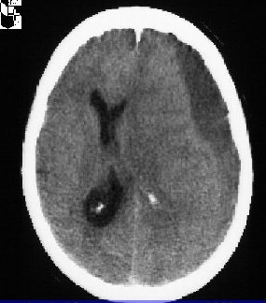

- What plane is this image in?
- What pathology is seen?

