ANPH 252 – Worksheet – Respiratory System – ANSWER KEY
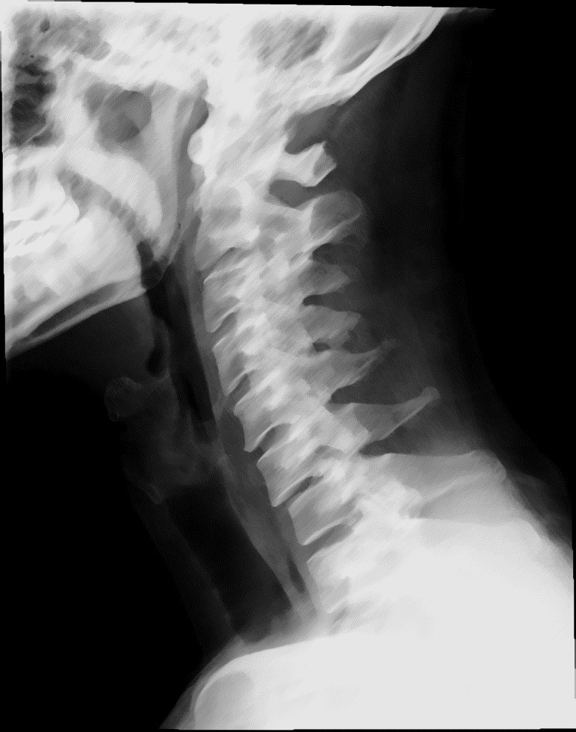

.Label the following on
1
“
image
one”
above.
A

B

C

G

E

F

D

Image On
e

H

- Nasal Cavity
- Oropharynx C. Epiglottis
D Laryngopharynx
- Hyoid Bone
- Laryngeal prominence
- Esophagus
- Trachea
- “The structures in image one above are all part of the upper respiratory tract” T F
- List four functions of the respiratory system.
  - air distribution b) gas exchange c) humidification d) enabling a sense of smell
- The external openings of the nose are known as the external nares
- The nasal cavity is divided midline by the nasal septum
- What structures are responsible for humidifying, warming, and cleaning air in the nasal cavity? respiratory mucosa, blood vessels, and nasal conchae
- The thyroid cartilage is inferior to the pharynx and is commonly known as the adam’s apple.
- The laryngeal prominence is the prominent point on the thyroid cartilage, and it is an exterior landmark for C5 of the cervical spine.
- Place the following anatomy in order, starting with “1” to designate the first structure where air enters the lungs, and finishing with “7” to designate the last structure.
Bronchioles (< 1 mm) | 4
Lobar (secondary) bronchi | 2
Alveolar ducts | 6
Tertiary bronchi | 3
Terminal bronchioles (< 0.5 mm) | 5
Alveolar sacs | 7
Right and left primary bronchi | 1
- All of the following structures maintain patency through the support of cartilaginous tissuesexcept:
  - trachea
  - external nares
  - primary bronchi
  - alveoli
- A pneumothorax is a condition characterized by air in the pleural cavity. It may occurspontaneously, or as a result of trauma or pathology. In the case of a trauma such as a crush injury, what two membranes of the body may be compromised in the case of a pneumothorax? a. visceral pleura
b. parietal pleura
- The primary bronchi, pulmonary vessels, nerves, and lymphatics enter the lung at the hilum
- A substance that reduces surface tension is known as a/an surfactant (eg. Detergent)
- What structures of the respiratory system secrete the “anti-surface tension” substances described above, and what respiratory structures are kept inflated as a result? Produced by alveolar cells, keeps alveoli inflated
From the following list, circle the statements that are true.
- The diaphragm is the main muscle responsible for human respiration
- The diaphragm relaxes the as lungs inflate
- The diaphragm contracts as the lungs inflate
- The diaphragm forms the base of the lungs
- If a child inhales a small toy, which lung is it most likely to end up in, and why? The right lung as the right bronchus is more vertical
- “Under duress, the body employs alternate muscles in the neck and chest to help maintain adequate tissue oxygenation” T F
- On inspiration, the volume of the thoracic cavity (increases/decreases) and air pressure within the lungs (increases/decreases)
- The connective tissue area contained within the blue circle in image two below, would bestbe described as the mediastinum.
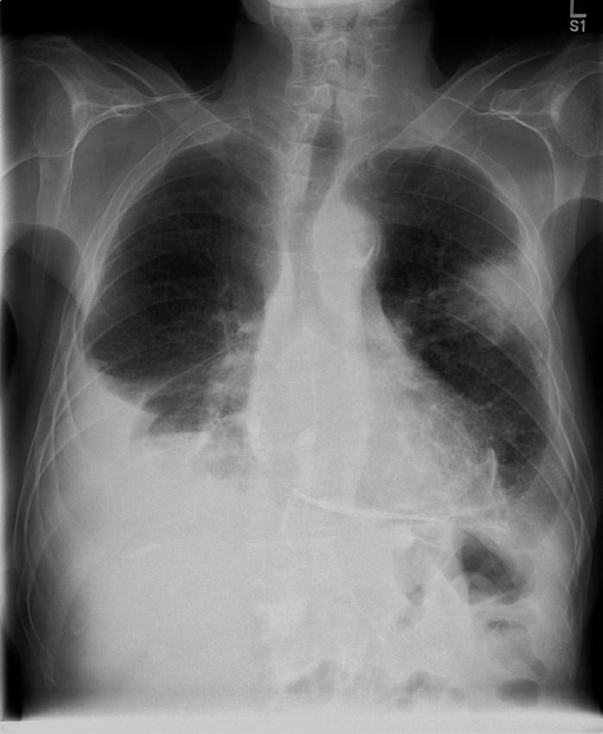
Image Two
A

B

F

E

D

C

G
- Select from the list of anatomical terms below to label image two above.
Stomach air G Trachea F Esophagus
Apex A | Pleura | Carina C
Base D | Left Bronchi E | Lobar fissure B
- The lungs receive their oxygen supply from the pulmonary arteries. T F

