Activity: Test 12 Collimator Light/X-ray Field Congruence and Perpendicularity Calculations

Purpose
This activity will provide you with practice in evaluating the equipment by calculating data, using formulas and determining if results fall within acceptable limits.

Instructions
- Review the diagram and image below for Collimator Light/X-ray Field Congruence and Perpendicularity Tests.
- Complete the calculations below.
- Answer the questions after the calculations.

Evaluation A – Collimator Light/X-ray Field Congruence
- Calculate 2% of SID.

0.02 x _________cm = ________cm × 10 = _______mm

- On each side, measure and record the distance between the light field and X-ray image.

X

B
A Y
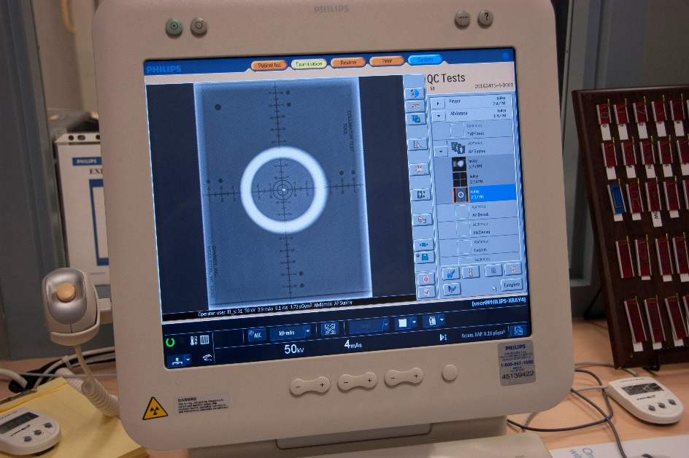

A = ______mm X = _____mm

B = ______mm Y = _____mm

- Take the sum of the distances of opposite sides found in Step 2 and compare to the results of 2% SID found in Step 1.

A + B = _______ mm X + Y = ______mm

A + B + X + Y = _______mm

Conclusion: Pass ______________ Fail ________________

Acceptance Criteria:
According to SC 35, the measured misalignment of the visually defined field and the X-ray field along the length and width of the X-ray field shall not exceed 2% of the SID.

Evaluation B – Perpendicularity
Referring to the chart below, compare and record which alignment appears most similar to the results provided.

~0.5 degrees | ~1.5 degrees |  |  | ~3 degrees
Results:

Acceptance Criteria:
According to SC 35, the X-ray beam axis should be within 3 degrees of the perpendicular to the image receptor plane. Using this test tool, the upper bead should be within the outer circle to pass.

Conclusion: Pass ______________ Fail ________________

Critical Thinking Questions

- What could cause the collimation to be off from what is set?

- Describe an alternate test that can be used to test collimator/X-ray field congruence if a collimator test template is not available.

- What could cause the beam perpendicularity to be off from 90 degrees?

