Clinical Integration 1 Final Exam Comprehensive Review
- Matching question. Please see question #1 of this exam. Large bowel labelling for: transverse colon, ascending colon, sigmoid colon
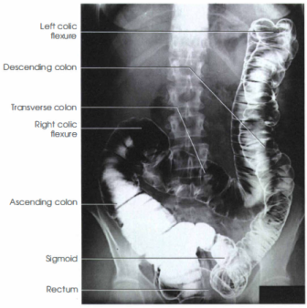

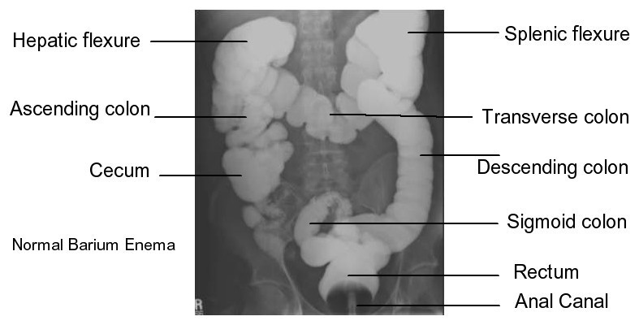

- An excessive intravenous infusion rate could lead to an accumulation of extravascular fluid in the lungs known as Pulmonary edema
- To increase resolution on skull radiographs, we should select a ( ) focal spot. Small
- What pathology is indicated by the "apple core" sign? Colon cancer
- When a patient is supine, barium will pool in the ( ) of the stomach. Fundus
- A fracture of the growth plate is known as a ( ). Salter Harris
- How much more memory storage space would be required with a 1000 x 1000 size matrix compared to a 500 x 500 size matrix? 4 times
- If there is an increased OID because the patient cannot sit next to the IR, how will the radiographic contrast be affected? It will increase it
- Which of the following is the most common place that a renal calculi will lodge? Ureterovesical junction
- Which of the following are signs that a patient needs suctioning? Answers: Profuse vomiting, audible rattling or gurgling sounds, signs of respiratory distress
- Which of the following structures are found within the mediastinum? Aortic arch, pulmonary arteries, main bronchi, thymus gland
- Where are the ethmoid sinuses demonstrated on a 15-degree posteroanterior projection? Medial border of the orbits.
- What is the name of the malignant renal tumor occurring in adults which causes hematuria? Hypernephroma
- Which position will best demonstrate a barium filled esophagus between the shadows of the heart and vertebral column? 40 degree right anterior oblique
- Select from the following which projections/views best demonstrate the dorsum sellae. Answer is 1 and 3.
1. 30-degree frontooccipital
2. 15-degree occipitofrontal
3. Lateral
4. Submentovertical
- Select from the following which projections would the technologist take to demonstrate the zygomatic arches bilaterally in profile. Answer is 2 and 3.
1. 30-degree parietoacanthial
2. Submentovertical
3. 30-degree frontooccipital (Townes)
4. Submentovertical oblique axial
- A patient arrives at a radiology department for treatment of an arthritic condition of the right shoulder. The radiologist orders AP internal/external rotation projections as well as an inferosuperior axiolateral projection of the scapulohumeral joint. However, the patient cannot abduct the arm for this projection. Which other projection will best demonstrate the scapulohumeral joint space? AP oblique projection
- Which of the following would require the widest window width? Chest x-ray ( not skull, L-spine nor C spine)
- Which of the following actions would result in a decrease in radiographic density? An increase in collimation.
- How does the use of radiological contrast agent influence subject contrast? Produces an artificial difference in atomic number or density of tissues.
- What premedication may be administered if a patient's history suggests a high risk of allergic response to intravenous pressure? Benadryl
- Identify an image of 15 degrees Caldwell projection Skull, AP
- If Caldwell taken PA, raise the patient’s chin would clear the petrous ridges from the orbits.
- Waters image for sinuses
- You are working with a new digital fluoroscopy unit. It is a quad field intensifier with input screen diameters of 25/20/15/10. When using the largest field of view the input screen diameter would be: 25
- An AP radiograph of a shoulder was exposed using 12 mAs, 65 kVp, 40-inch SID and a 400 speed IR. Which of the following mAs values would be required to maintain radiographic density using a 48 inch SID, and 75 kVp? 8.6 mAs
- An AP radiograph of the knee was exposed using the following parameters: 3.2 mAs; 60 kVp; 40 inch SID; and a 400 speed IR. The examination was performed with the patient on the stretcher. The image is repeated using 70 kVp and an 8:1 grid. The SID will remain the same. Which of the following mAs values would be required to maintain radiographic density? 6 mAs
- What condition demonstrates bone spurs in joint spaces? Osteoarthritis
- What does110 represent in a blood pressure reading of 150/110? Diastolic pressure
- What are the characteristics of a barium sulphate suspension? Answer is 1, 3 and 5.
1. High atomic number
2. Soluble
3. Insoluble
4. Easily expelled
5. Chemically inert
6. Chemically active
- Immediately following the injection of ionic contrast media during an IVU, the patient develops a severe case of urticaria. What medication should the technologist have ready to administer? Antihistamine
- Under which of the following conditions would quantum mottle be more apparent? Answer is 1 and 3.
1. 400 speed IR
2. 100 speed IR
3. 100 kV, 50 mA, 0.1 second
4. 72 kV, 200mA, 0.1 s
- What examination may be done to demonstrate the ductal system in a jaundiced patient? Percutaneous transhepatic cholangiography
- Hirschsprung's disease is characterized by a marked distention in the: Sigmoid colon.

